# Todo

搭建模拟GXPack输入输出环境

网页(浏览器)能下下来，HttpWebRequest下载不下来

## Table

## ui

## 2018.4.16

### GameBox Hellowworld参考

### 查看其他人提交的接口

### 了解GXPack代码

### VS测试样本

public void TestMethod1()

{

Console.WriteLine("===============================TestMethod1()==============================");

int a = 1, b = 3, expect = 3;

int real = a + b;

Assert.**AreEqual**(real, expect);

}

## submodule:

# \*\*\*\*\*解决问题\*\*\*\*\*

1官方文档

2 google

3寻找类似的开源代码、框架、文档 （比如laravel、assetbundlegraph&类红警项目、ai&lua书籍） （github上找排名靠前的项目）

4

# c#

## 事件和委托

<https://www.cnblogs.com/chengxingliang/archive/2013/05/21/3051912.html>

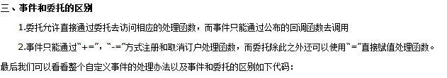

## delegate可以直接用+= 或=初始化

+= 可以赋值多个函数 =只能赋值一个函数

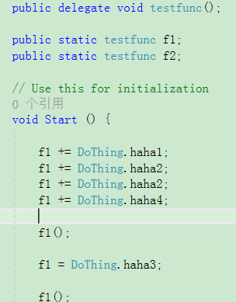 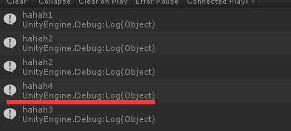

# golang

set GOPATH=F:\project\zeus;F:\project\server

go install Login

go install Center

go install IDIPServer

go install Lobby

go install Match

go install Room

go install Gateway

Lobby.exe.infolog.2017.11.14.23

## net/http

### 处理浏览器的输入

输入：<http://localhost:9090/?url_long=333&url_long=444&wahaha=1234&p4=%2212345%22>

go接收到的：map[url\_long:[333 444] wahaha:[1234] p4:["12345"]]

r.Form

字典

for k, v := range r.Form {

fmt.Println("key:", k)

fmt.Println("val:", strings.Join(v, ""))

}

r.URL.Path

/favicon.ico

r.URL.Scheme

scheme

获取参数

r.Form[“zoneID”]

r.FormValue("url\_long")

### 给浏览器的返回

返回json: 

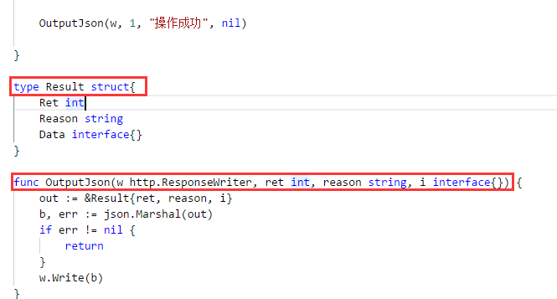

转跳：

http.Redirect(w, r, "/login/index", http.StatusFound)

## HttpServer

<https://yq.aliyun.com/articles/46439>

## 控制台日志：

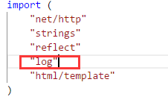

log.Println("loginHandler")

# Js

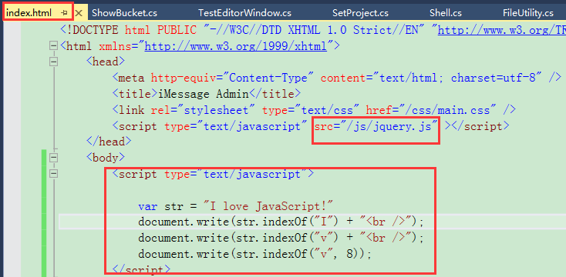

Vue.js

Vue是一套用于构建用户界面的**渐进式框架**

# Css

Sass

Stylelint

LESS

网页引用css:

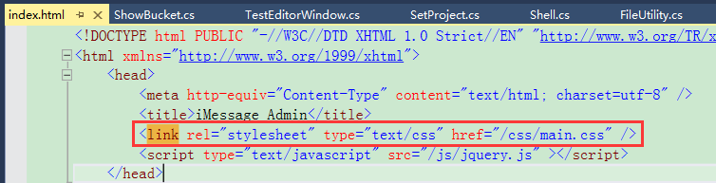

# Mysql

<http://stading.mysql.gxpack.io/>

gxpack

ztgame@gxpack

## 安装

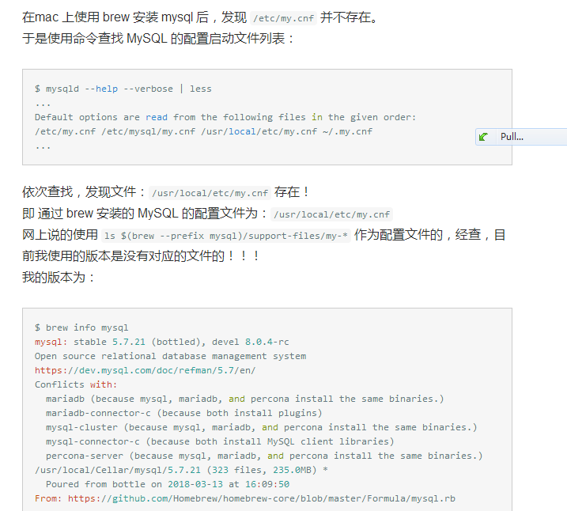

We've installed your MySQL database without a root password. To secure it run:

mysql\_secure\_installation

MySQL is configured to only allow connections from localhost by default

To connect run:

mysql -uroot

To have launchd start mysql now and restart at login:

brew services start mysql

Or, if you don't want/need a background service you can just run:

mysql.server start

NAVH-WK6A-DMVK-DKW3



## 用户认证

Windows版sql：启用5.x的验证方式

root:ztgame@123

laoguai:ztgame@123

## 客户端软件

EMSSQL ManagerforMySQL

Navicat

phpMyAdmin

MySQL-Front

SQLyog

copy /Y "$(TargetDir)$(TargetName).dll" F:\@@@@@@@@@@@\GameBox\TestNewBucket\Assets\GameBox\Editor\GameBox.Bucket

## 命令行

**mysql.server start**

mysql -u root –p

SELECT User,Host FROM mysql.user;

## 允许root远程连mysql

update user set host='%' where user = 'root';

select host from user where user = 'root';

flush privileges;

grant all privileges on \*.\* to root@'%' identified by 'ztgame@123';

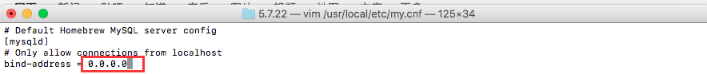

# Git

git.exe push --progress "origin" 12-gxpack:12-gxpack

git.exe pull -v --progress "origin"

## submodule:

git.exe submodule add -- "http://gitlab.ztgame.com/tech/Client/GameBox.ThirdLib/Releases/SemVer.git" "lib/test1"

# GameBox

NodeJS

NodeJS.dll

## DLL

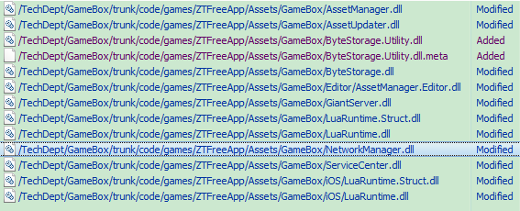

# GameBox.Bucket

报错的时候是不会动态加载的，只有重启Unity才起作用

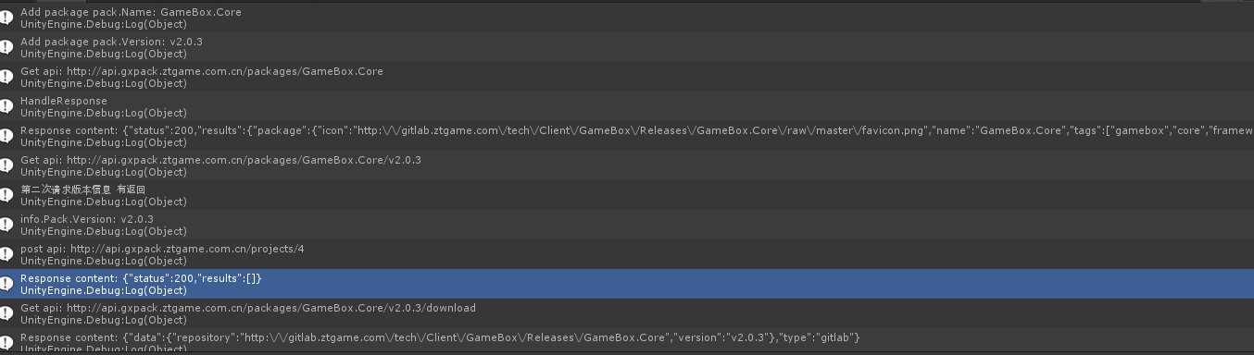

copy /Y "$(TargetDir)$(TargetName).dll" F:\@@@@@@@@@@@\Saturn\code\client\Assets\GameBox\Vendor\GameBox\Bucket\net35\Editor

copy /Y "$(TargetDir)$(TargetName).pdb" F:\@@@@@@@@@@@\Saturn\code\client\Assets\GameBox\Vendor\GameBox\Bucket\net35\Editor

## todo

发现有任何dll更新后重新解析，bucket代码都会重新再执行一次

## 发布

Token

ID

UnityPackage

Host文件

打印192.168.150.221/Gaint

## 遍历更新文件列表计算校验码看要不要更新

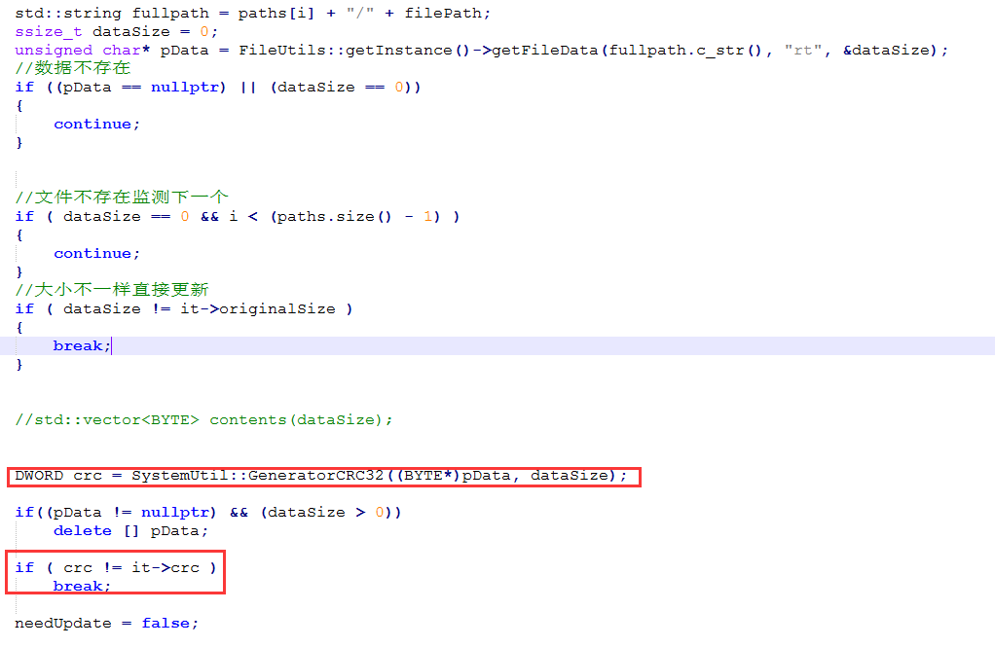

## 自更新

从OnEnter处会重新执行

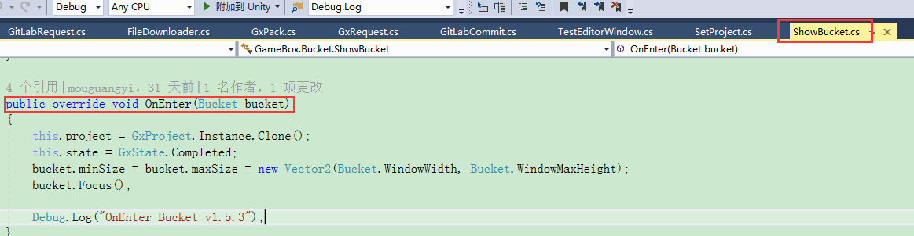

## 获取gitlab指定tag下的所有文件

<http://gitlab.ztgame.com/api/v4/projects/tech%2FClient%2FGameBox%2FReleases%2FGXPack.TestProject.Dep/repository/tree?ref_name=v1.6.2&recursive=true> (**ref\_name XXX**)

[http://gitlab.ztgame.com/api/v4/projects/tech%2FClient%2FGameBox%2FReleases%2FGXPack.TestProject.Dep/repository/tree?**ref**=v1.5.2&recursive=true](http://gitlab.ztgame.com/api/v4/projects/tech%2FClient%2FGameBox%2FReleases%2FGXPack.TestProject.Dep/repository/tree?ref=v1.5.2&recursive=true) （用这个，不要用上面那个）

bucket.ShowNotification(new GUIContent("XXXYYYZZZ"));

private const string BucketJson = @"

{

'status': 0,

'results': {

'name': 'GameBox.Bucket',

'version': '1.0.0',

'url': 'http://gitlab.ztgame.com/tech/Client/GameBox.ThirdLib/Releases/SemVer.git',

'homepage': 'www.google.com',

'files': {

'README.md' : 'GameBox/Editor/test/README.md',

'net35/SemVer.dll' : 'GameBox/Editor/test/SemVer.dll',

},

'require': {

}

}

}

## 项目名 （用的id..）



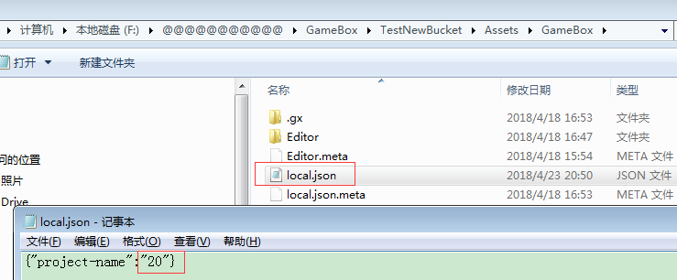

## 配置token:

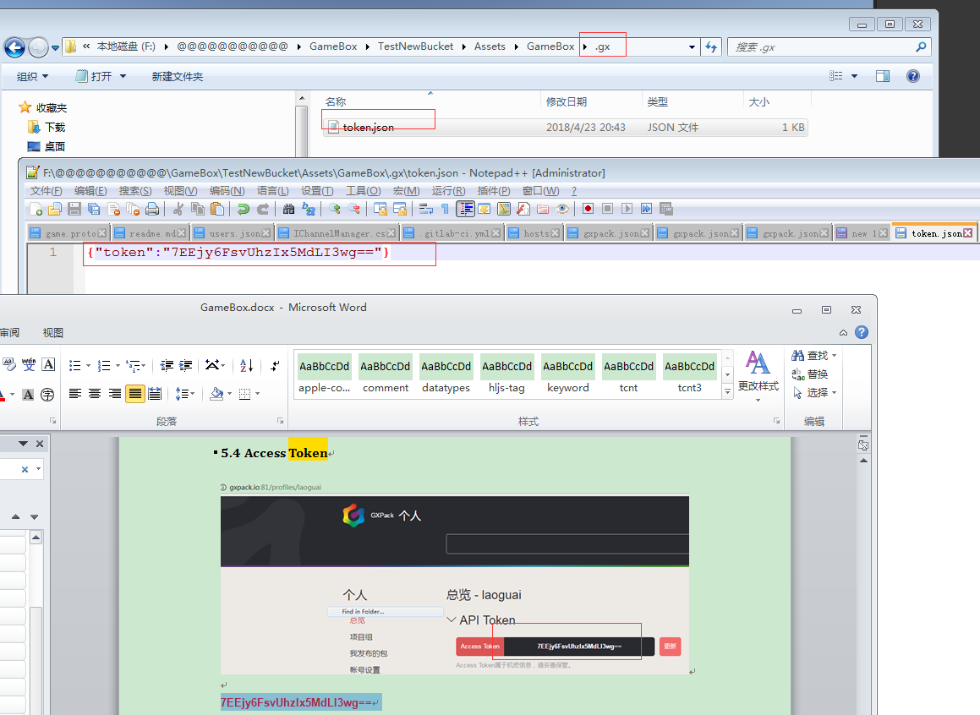

## seq

Host = <http://api.gxpack.io>

GetPack = "/packages/";

BucketModuleName = "GameBox.Bucket"

<http://api.gxpack.io/packages/GameBox.Bucket>

## gitsubmodule add

## 第三方库

SemVer

Newtonsoft.Json

VS工具-》扩展和更新—》所属NuGet下载安装 (2017好像自带不用下载安装)

VS工具—》NuGet控制台

PM> Install-Package Newtonsoft.Json

git.exe submodule update –init

copy /Y "$(TargetDir)$(TargetName).module" F:\@@@@@@@@@@@\GameBox\TestBucket\Assets\Editor

copy /Y "$(TargetDir)$(TargetName).pdb" F:\@@@@@@@@@@@\GameBox\TestBucket\Assets\Editor

copy /Y "$(TargetDir)$(TargetName).dll" F:\@@@@@@@@@@@\GameBox\TestBucket\Assets\Editor

copy /Y "$(TargetDir)$(TargetName).pdb" F:\@@@@@@@@@@@\GameBox\TestBucket\Assets\Editor

copy /Y "$(TargetDir)$(TargetName).dll" F:\@@@@@@@@@@@\GameBox\TestBucket\Assets\Editor

copy /Y "$(TargetDir)$(TargetName).pdb" F:\@@@@@@@@@@@\GameBox\TestBucket\Assets\Editor

copy /Y "$(TargetDir)$(TargetName).module" F:\@@@@@@@@@@@\GameBox\TestNewBucket\Assets\GameBox\Editor\GameBox.Bucket

copy /Y "$(TargetDir)$(TargetName).pdb" F:\@@@@@@@@@@@\GameBox\TestNewBucket\Assets\GameBox\Editor\GameBox.Bucket

## URL

api = <http://api.gxpack.io/packages/GameBox.Bucket/1.1.0>

api = "http://api.gxpack.io/packages/Newtonsoft.Json/>=1.0.0"

result = "{\r\n \"status\": 0,\r\n \"results\": {\r\n \"name\": \"GameBox.Bucket\",\r\n \"version\": \"1.1.0\",\r\n \"url\": \"http://192.168.183.174:81/GameBoxAssets/Test.git\",\r\n \"homepage\": \"www.google.com\",\r\n \"files\": {\r\n \"impl...

### http://api.gxpack.io/packages/GameBox.Bucket/list

### token

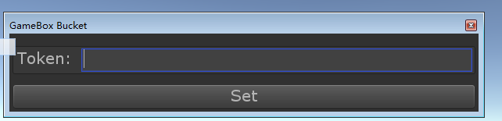

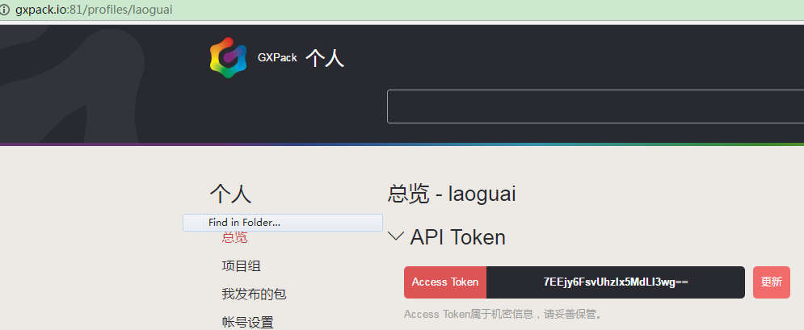

**7EEjy6FsvUhzIx5MdLI3wg==**

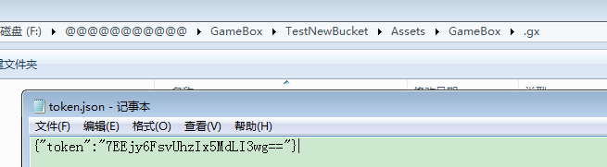

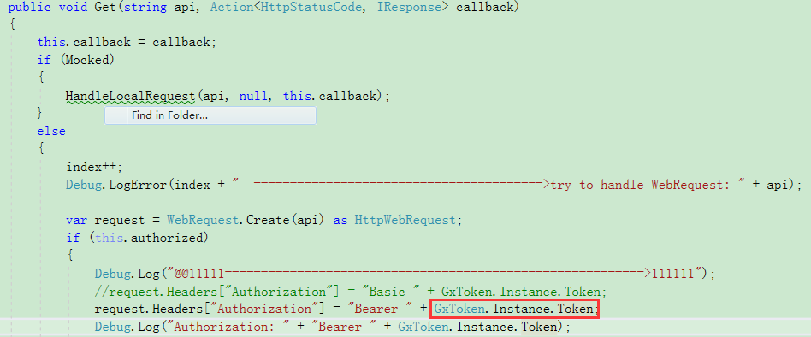

\*\*\*\*\*别跟HookToken混淆了，HookToken直接在gitlab上配置，更新的时候用来调用gxpack上的脚本：

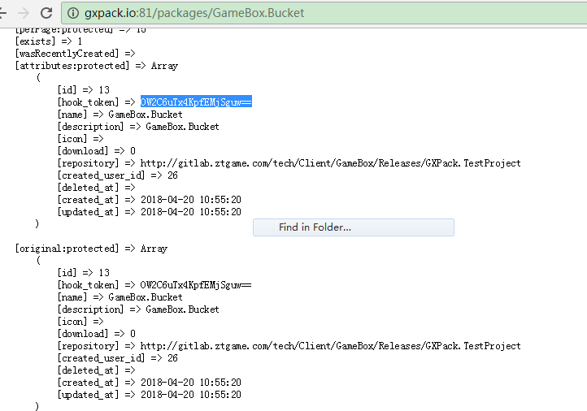

### Project

**get**

<http://api.gxpack.io:81/projects/20>

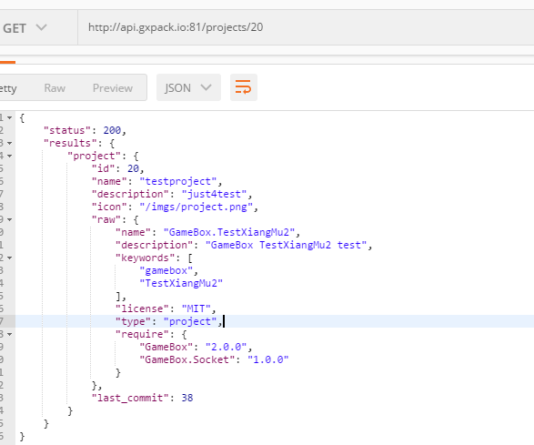

**Post:**

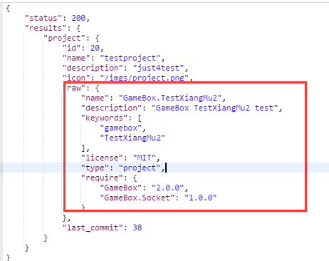

### Profile

[**http://api.gxpack.io:81/profiles**](http://api.gxpack.io:81/profiles)

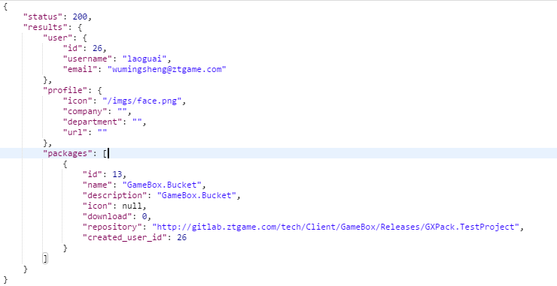

### Recommend

http://api.gxpack.io:81/recommend

## GitLab下载

Api全路径 = <http://192.168.183.174:81/api/v4/projects/GameBoxAssets%2FTest/repository/commits?path=impl-net35-unity2017.2.0-editor%2FGameBox.Bucket.Shell.dll&ref_name=v1.1.0>

Host = "http://192.168.183.174:81";

GetFileCommit = "/api/v4/projects/{0}/repository/commits?path={1}&ref\_name={2}";

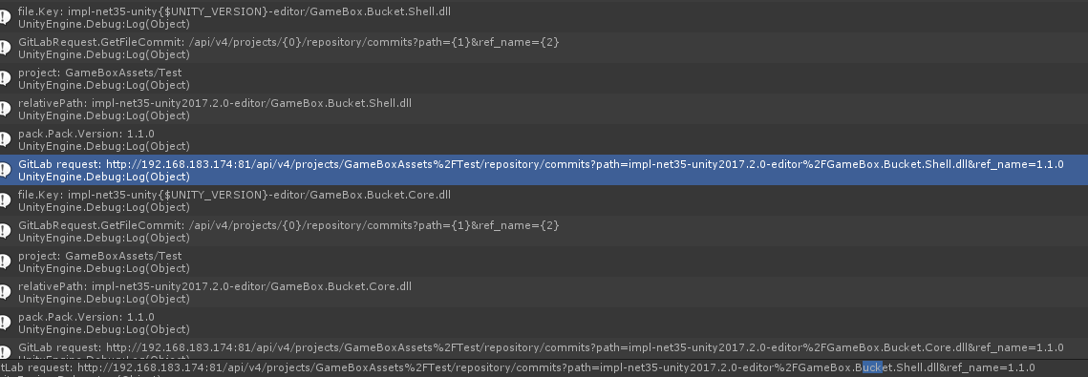

令牌：

qzBx3gzzjXRRkcfoddsh

<http://gitlab.ztgame.com/api/v4/projects/12/repository/files?private_token=qzBx3gzzjXRRkcfoddsh&file_path=mydir/myfile&ref=master>

<http://gitlab.ztgame.com/api/v4/users?private_token=qzBx3gzzjXRRkcfoddsh>

[http:// gitlab.ztgame.com:tech/Client/GameBox.ThirdLib/SemVer](http:// gitlab.ztgame.com:tech/Client/GameBox.ThirdLib/SemVer/api/v4/users?private_token=qzBx3gzzjXRRkcfoddsh)

[/api/v4/users?private\_token=qzBx3gzzjXRRkcfoddsh](http:// gitlab.ztgame.com:tech/Client/GameBox.ThirdLib/SemVer/api/v4/users?private_token=qzBx3gzzjXRRkcfoddsh)

**返回所有的项目信息：**

http://gitlab.ztgame.com/api/v4/projects?private\_token=qzBx3gzzjXRRkcfoddsh

<http://gitlab.ztgame.com/api/v4/projects/97/repository/commits?path=SemVer.dll>

<http://gitlab.ztgame.com/api/v4/projects/97/repository/files?private_token=qzBx3gzzjXRRkcfoddsh>&file\_path=builder.json&ref=master

file\_path=myfolder/myfile.txt&ref=master'

<http://gitlab.ztgame.com/api/v3/projects/97/repository/commits?path=build%2FSemVer.dll>

**查看提交记录:**

<http://gitlab.ztgame.com/api/v4/projects/97/repository/commits?path=build%2FSemVer.dll>

&ref\_name=1.1.0

**ref\_name就是tag**

**ref分支**

tech/Client/GameBox.ThirdLib/Releases/SemVer

tech%2FClient%2FGameBox.ThirdLib%2FReleases%2FSemVer

[http://gitlab.ztgame.com/api/v4/projects/**tech%2FClient%2FGameBox.ThirdLib%2FReleases%2FSemVer**/repository/commits?path=net35%2FSemVer.dll](http://gitlab.ztgame.com/api/v4/projects/tech%2FClient%2FGameBox.ThirdLib%2FReleases%2FSemVer/repository/commits?path=net35%2FSemVer.dll) [OK]

json = "[{\"id\":\"07c744fdc44d51d2021ccaafabfd9c49e13825c8\",\"short\_id\":\"07c744fd\",\"title\":\"tool update\",\"created\_at\":\"2018-04-10T17:23:40.000+08:00\",\"parent\_ids\":[\"064d7e6b49a3465736ef23b20dee7e5786a1a7ce\"],\"message\":\"tool update\\n\",\"author...

http://gitlab.ztgame.com/tech/Client/GameBox.ThirdLib/Releases/SemVer/raw/1.0.0/ net35/SemVer.dll

<http://gitlab.ztgame.com/tech/Client/GameBox.ThirdLib/Releases/SemVer/raw/1.0.0/net35/SemVer.dll>

## Token&Project



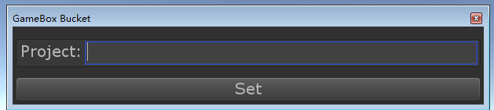

**YiBKOjpDMISIWWf2TG7ylA==**

## GxRequest顺序

1==>try to handle: api.gxpack.io/packages/GameBox.Bucket

2==>try to handle: api.gxpack.io/packages/GameBox.Bucket/1.0.0 （Preload-）CollectPackInfo）

3==>try to handle: api.gxpack.io/projects/testproject (SetProject-> OnUpdate)

4==>try to handle: api.gxpack.io/profiles

(ShowBucket🡪OnupdateGxRequest.Compose(GxRequest.GetUser)

5==>try to handle: **api.gxpack.io/recommend (推荐包)**

**C:\Users\wumingsheng\Desktop\gitllab**

## 个人访问令牌

qzBx3gzzjXRRkcfoddsh

2kxfrnoQVn61ZJxtPZL6

## 自更新

替换完dll后还会执行如下代码： (this.project数据**也会清理掉**？很神奇！！)

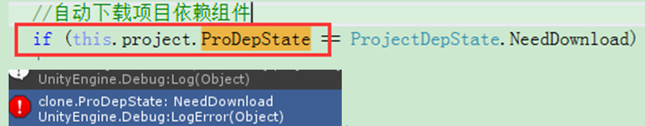

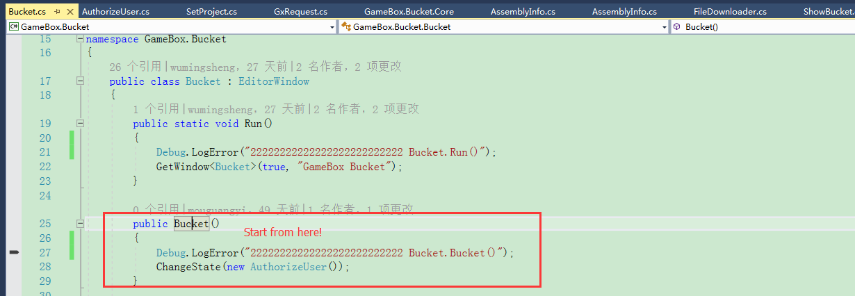

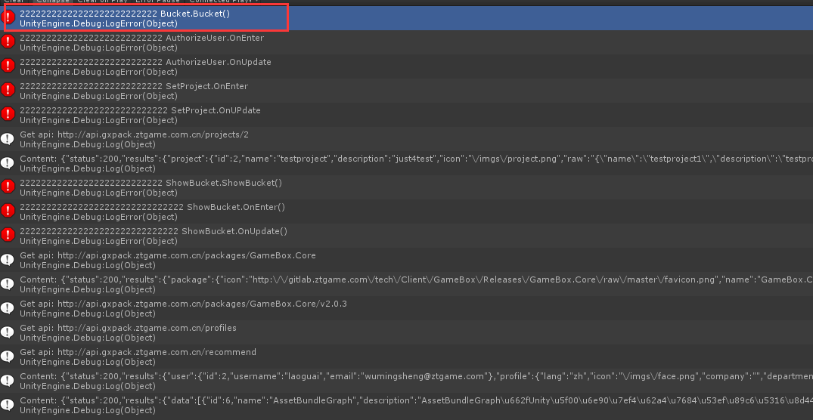

## 项目信息

有一份全局的

GxProject.Instance

还有一份在ShowBucket状态上用来临时操作的

this.project

GxProject.Instance🡺 this.project (进入showbucket)

this.project🡺 GxProject.Instance (各种操作成功后)

# PHP

## String array dictionary?

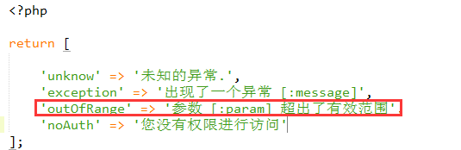

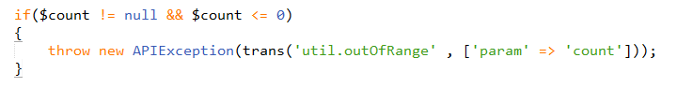

## Namespace&lib

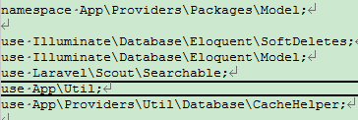

## 继承(实现？)

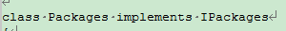

class Packages implements IPackages

## 默认参数



## 返回JSON

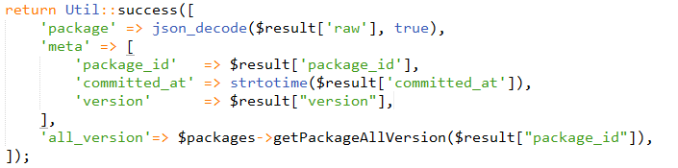

# GXPack

<http://gitlab.ztgame.com/api/v4/projects/tech%2FClient%2FGameBox%2FReleases%2FGXPack.TestProject/repository/tree?&ref=v0.0.13&recursive=true&per_page=1000000>

<http://gitlab.ztgame.com/api/v4/projects/tech%2FClient%2FGameBox.ThirdLib%2FReleases%2FAssetBundleGraph/repository/tree?&ref=v1.4.1&recursive=true>

<http://gitlab.ztgame.com/api/v4/projects/tech%2FClient%2FGameBox%2FReleases%2FGXPack.TestProject/repository/tree?&ref=v0.0.3&recursive=true>

使用说明：

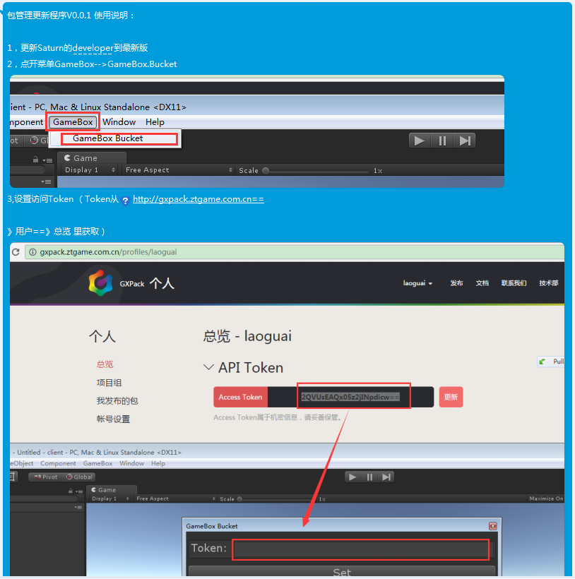

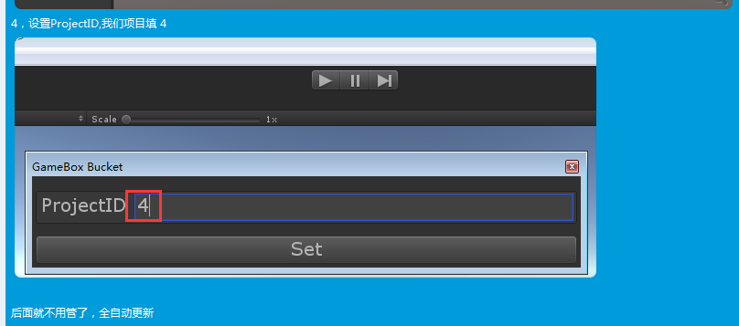

192是牛B机子

193弱鸡

## yb macmini

ip: 192.168.93.64

密码: af7e25b7YB

sudo vi /usr/local/etc/nginx/nginx.conf

sudo nginx restart

sudo nginx -s reload

399 php-fpm

400 php-fpm -v

401 sudo ps -ef |grep php-fpm

cd /usr/local/gxpack-deploy/

cd /usr/local/walle-web/

452 ls

453 ./yii walle/setup

454 vi .env

455 sudo vi .env

456 ./yii walle/setup

457 sudo vi config/local.php

458 ./yii walle/setup

459 ./yii walle/setup

460 ./yii walle/setup

461 ls

462 ls -l

463 vi config/web.php

## walle

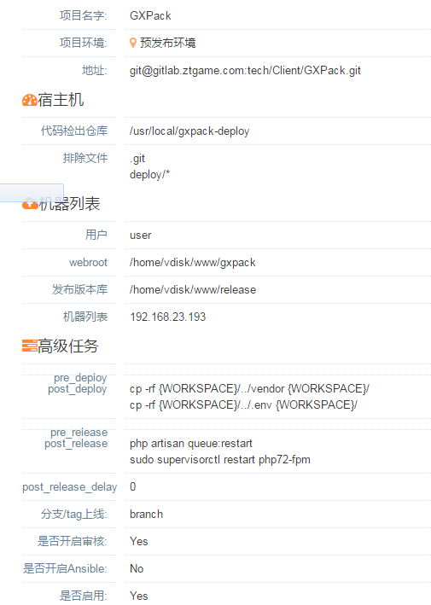

## auth路由

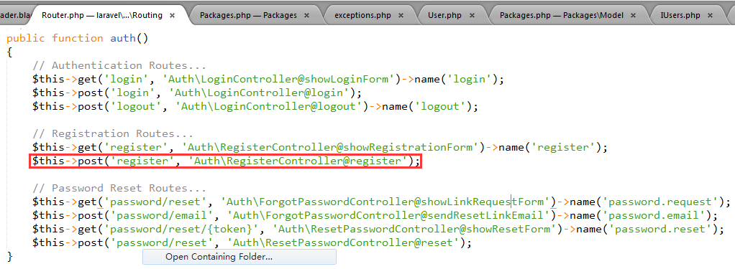

## 发布

walle.gxpack.io

walle 重启 （在mac机上）

nginx和mysql和php-fpm

[wumingsheng@ztgame.com](mailto:wumingsheng@ztgame.com)

ztgame@123

## 监控

<http://stading.cesi.gxpack.io/>

admin:admin

gxpack:gxpack

## webhook

<http://api.gxpack.ztgame.com.cn/webhook>

http://192.168.93.247

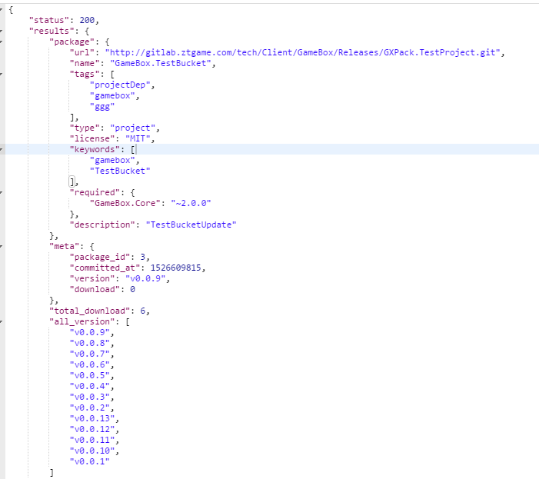

## Eloquent ORM & cache

### 创建(添加)

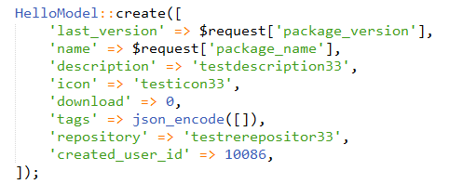

### 修改 where好像返回的集合类型，不能只能调用trashed()接口，但好像可以直接调用restore()接口

$package = $this->update($data);



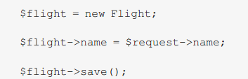

### 删除

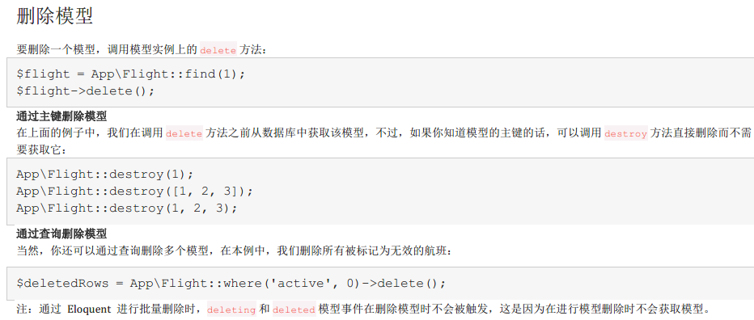

### 软删除

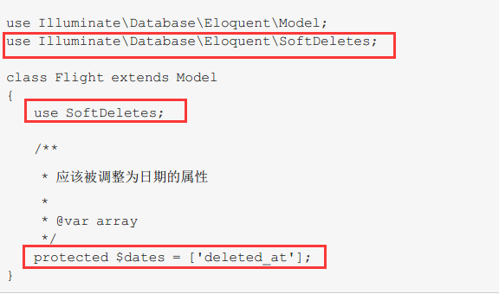

* 之前没使用软删除后来又追加软删除，数据表中需要添加deleted\_at字段

添加字段可以通过php的数字迁移来完成

php artisan make:migration alter\_posts\_deleted\_at --table=hellomodel

会生成AlterPostsDeletedAt文件，修改如下：

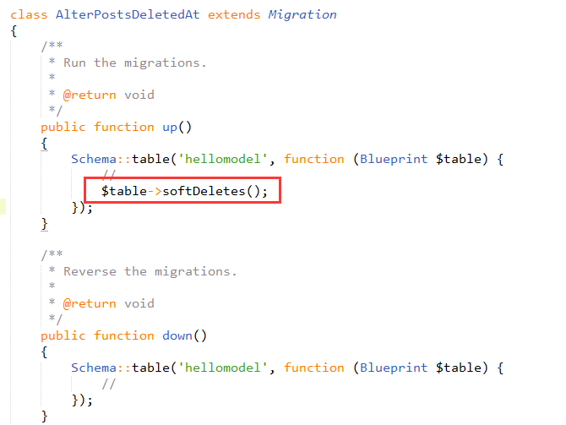

最后执行php artisan migrate 完成数据表的结构修改

REF：<https://www.cnblogs.com/ghjbk/p/6638125.html>

{{ Auth::user()->username }}

### 恢复

HelloModel::withTrashed()->where ('last\_version', $request['package\_version'])->restore();

### 强制删除

forceDelete

## Mark

### 路径

Namespace设置成文件夹的路径



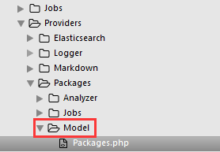

调用只能用相对路径？？

### Php self和static

PHP官方也说过，大概意思是说self调用的就是本身代码片段这个类，而static调用的是从堆内存中提取出来，访问的是当前实例化的那个类，那么 static 代表的就是那个类，例子比较容易明白些。

### 埋点

dispatch(new Buried(Buried::$webHook, […

dispatch(new Buried(Buried::$webHookFaild, […

### 数组

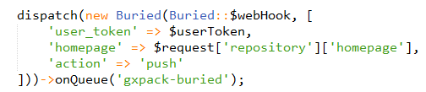

protected $fillable = [

'name', 'description', 'created\_user\_id', 'icon', 'repository' , 'download', 'last\_version', 'tags' , 'visitor'

];

### 获取客户请求信息

头信息：

$request->headers->get("X-Gitlab-Token")

Body信息：

$request['repository']['homepage']

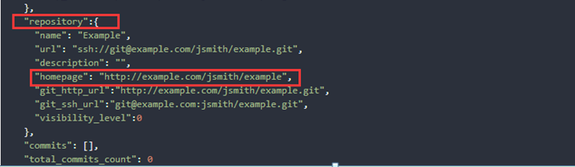

{

"object\_kind": "tag\_push",

"ref": "refs/tags/v1.0.0",

"project\_id": 1,

"repository":{

"url": "ssh://git@example.com/jsmith/example.git",

"homepage": "http://example.com/jsmith/example",

"git\_http\_url":"http://example.com/jsmith/example.git",

"git\_ssh\_url":"git@example.com:jsmith/example.git",

"visibility\_level":0

},

"commits": [],

"total\_commits\_count": 0

}

### 软删除

use SoftDeletes, Searchable;

### Package相关

数据字段：

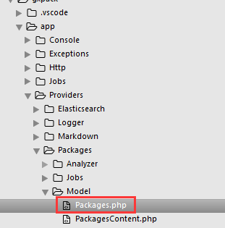

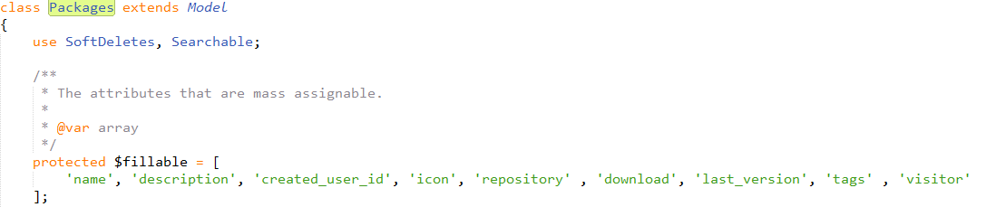

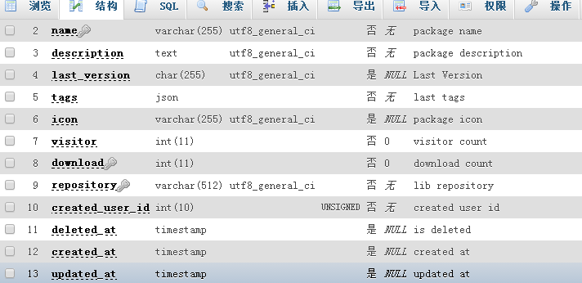

## 功能模块

### 注册

Validator🡺 create🡺 guard()->login 🡺registered

$users->register

users.php

public function register($username, $password, $email)

mode/users.php

public static function register($username, $password, $email)

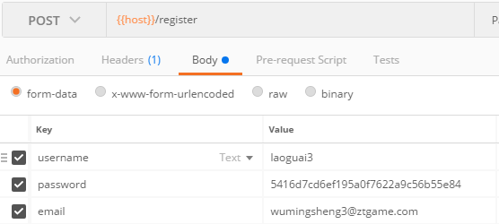

RegisterController.showRegistrationForm🡺

RegisterController. makeNav🡺

RegisterController. Validator🡺

RegisterController.Create

### 登录

AuthenticatesUsers.login🡺

LoginController.validateLogin🡺

LoginController.attemptLogin

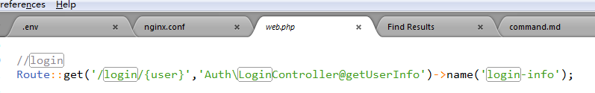

protected function **attemptLogin**(Request $request)

密码用md5(32位)加密:

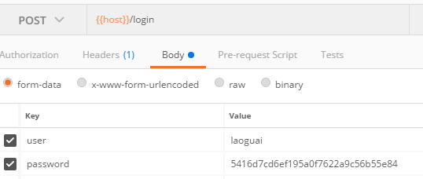

### 获取AccessToken

get

{{host}}/profiles/token

### 更新AccessToken

post

{{host}}/profiles/token

### 创建项目组

post

{{host}}/projects/create

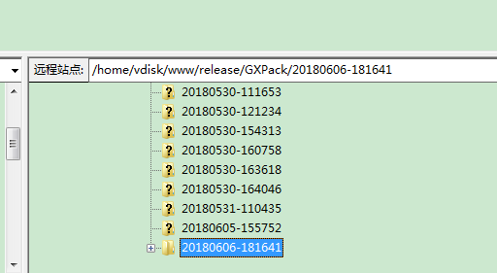

{\"name\":\"test25\",\"description\":\"hello description\"}

{

"name": "testproject",

"description": "testproject haha"

}

//$raw = '{\"name\":\"' . $data['project\_name'] . '\",\"description\":\"' . $data['project\_description'] . '\"}';

### 获得项目操作日志

{{host}}/projects/{{project\_id}}/logs/0

### 创建tag时webhook

WebHookController.php

public function onWebHook(Request $request)

获取http头部的token:

$userToken = $request->headers->get("X-Gitlab-Token");

https://docs.gitlab.com/ee/user/project/integrations/webhooks.html

X-Gitlab-Token HTTP header.

X-Gitlab-Event: Push Hook

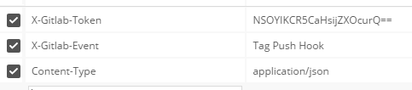

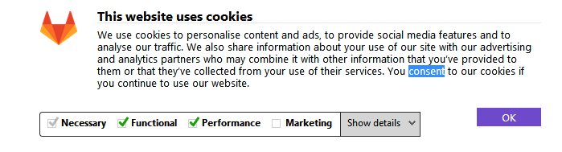

### 删除tag时webhook、埋点

### create package

public function submitPackage($userId, $repository)

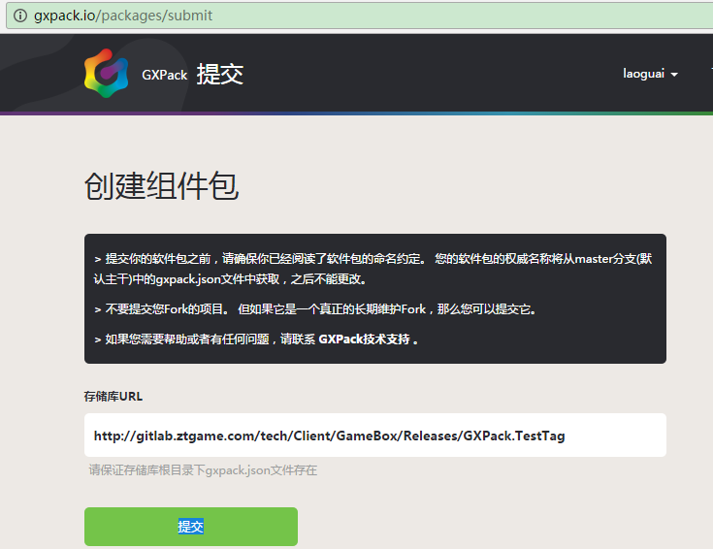

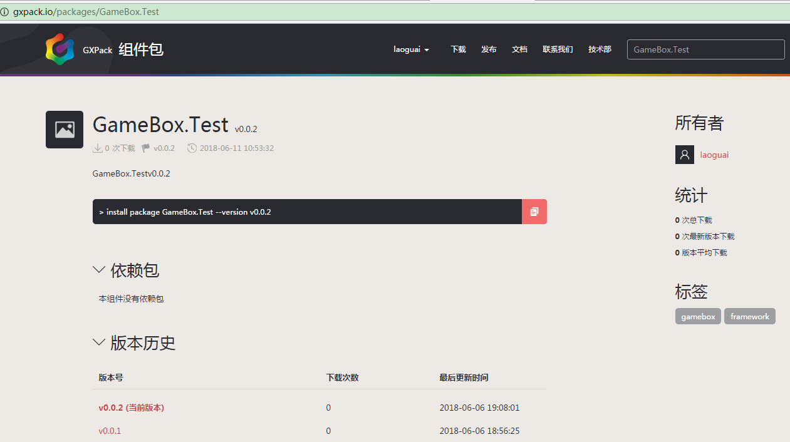

http://gxpack.io/imgs/project.png

### create project

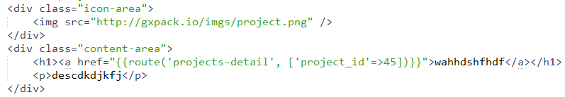

### 包管理

发起

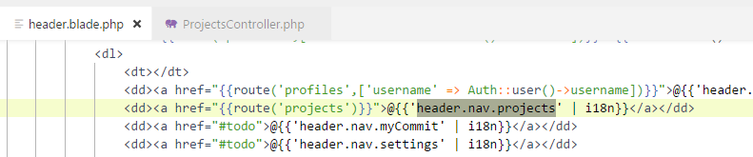

### 设置

Auth::user()->email

Auth::user()->username

### 邮件功能

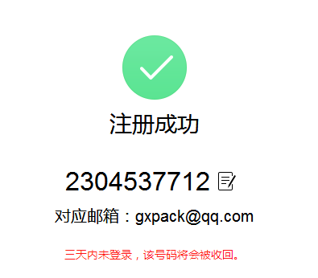

php artisan make:mail ForgetPassword

**kiksdehfeoaocabd**

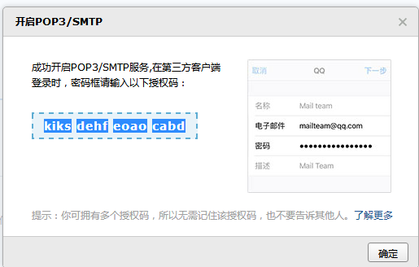

<https://www.jianshu.com/p/8ccb2820df23>

php artisan make:controller MailController

### 密码找回

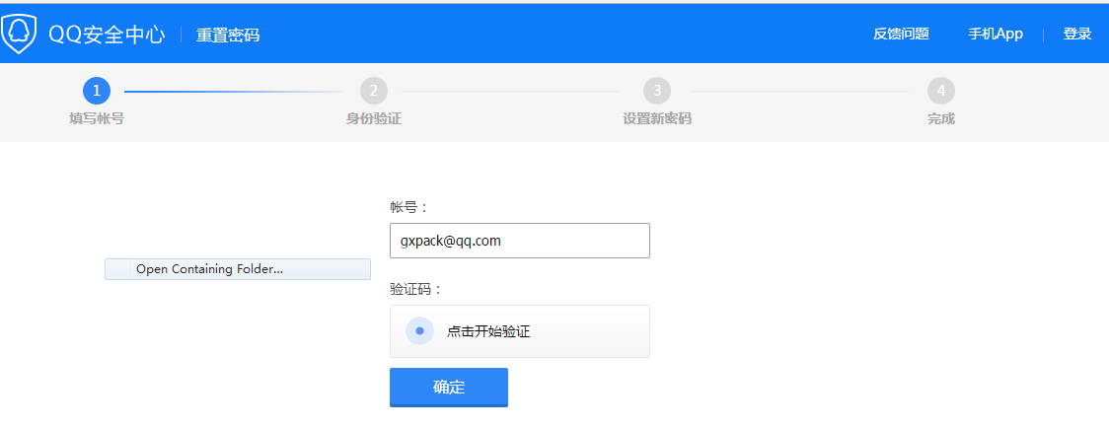

<p style="margin-left:260px;"> <a href="{{route("register")}}">@{{'auth.login.forgetPassword'|i18n}}</a></p>

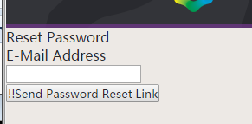

**pass = md5(this.inputPass);**

**$encryptPass = bcrypt($password);**

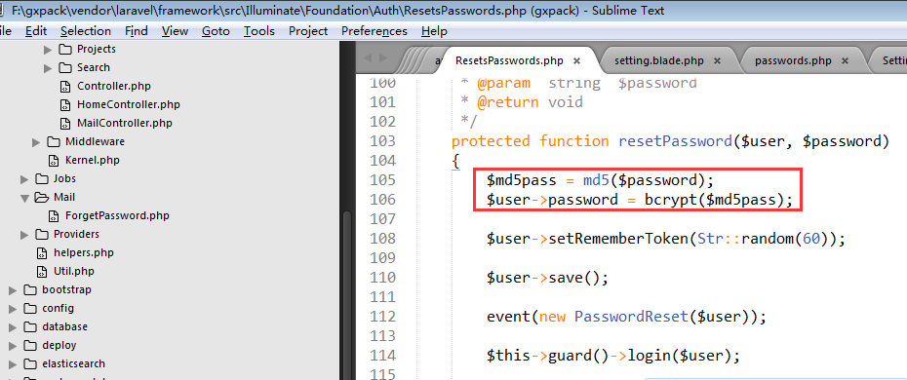

### 删除组件

Packages: (Packages表有UserID跟用户关联)

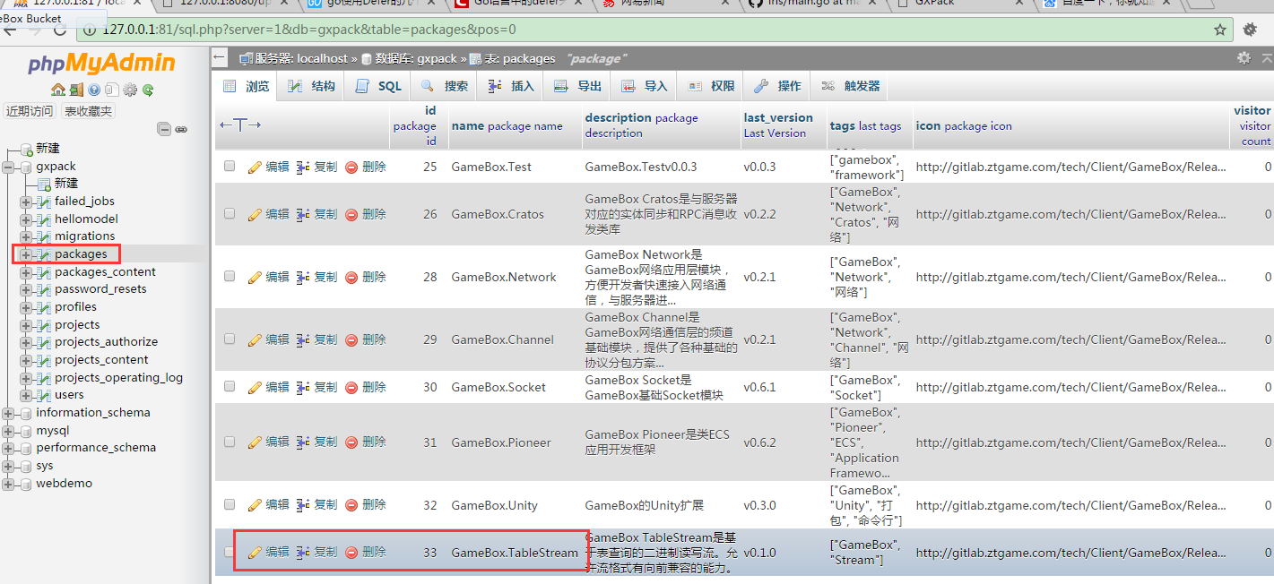

Packages\_content:

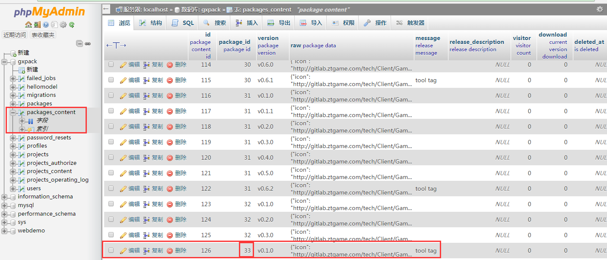

## 备用监控

192.168.23.193:9001

gxpack:gxpack

## 压力测试

ab -n 30000 -c 20 <http://gxpack.ztgame.com.cn/packages/GameBox.Core>

Queue没消费掉

动态加载负载均衡：

SuporVisor?

调整队列消费：

Php-fpm配置里调？

**fpm.sock出错**

那是fpm来不及消费了

**出现大批502错误是fpm队列满了**

**Rabbitmq队列是数据是代码直接传给rabbitmq的**

**访问极限：250次每秒**

**php nginx**

## .env

QUEUE\_DRIVER=sync



## php

入口：？

<http://127.0.0.1:81/public/index.php>

.env

只关注功能的话

**nginx php mysql rabitmq**



**上面对应的配置要打开**

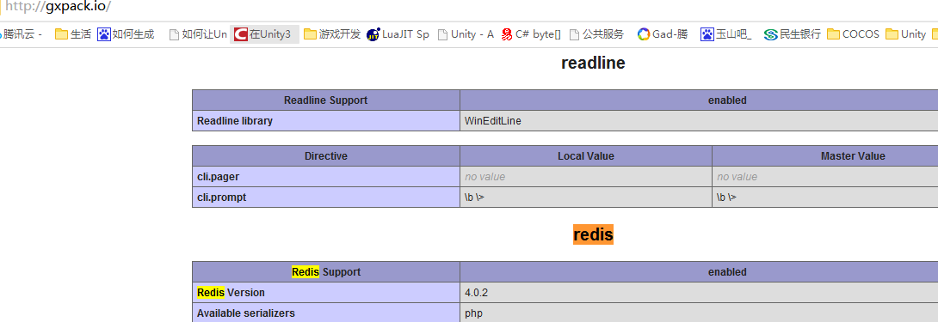

[**http://pecl.php.net/package/redis/4.0.2/windows**](http://pecl.php.net/package/redis/4.0.2/windows)

### 调试：

<h1><a href="{{route('package', ['package\_name'=>$package["name"])}}">{{$package["name"]}}</a></h1>

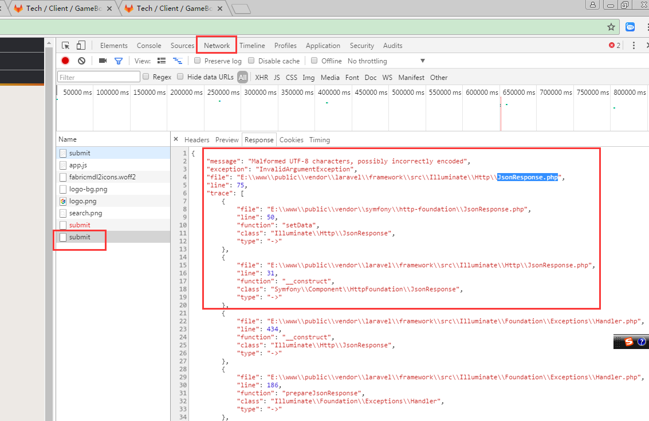

[**如何在sublime+chrome中调试php代码？**](https://www.cnblogs.com/jewave/p/5721103.html)

https://www.cnblogs.com/jewave/p/5721103.html

<http://pecl.php.net/package/xdebug/2.6.0/windows>

**提交组件：**

public function submitPackageAsync($userId, $repository)

### 执行出错代码：

$array =debug\_backtrace();

unset($array[0]);

foreach($array as $row)

{

$html .=$row['file'].':'.$row['line'].'行,调用方法:'.$row['function']."<p>";

}

echo $html;

可以查看出错堆栈

### 数据结构

* 数组 $packageVersionsShow[]

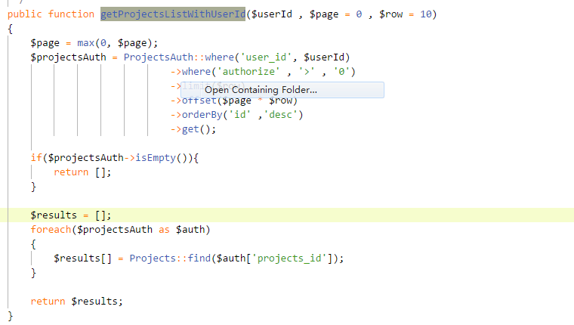

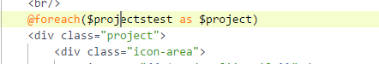

* array



* Collection





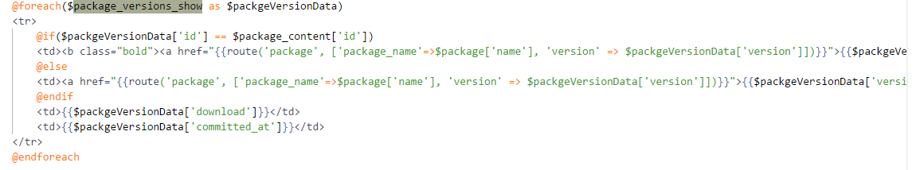

## nginx

tasklist|findstr "nginx"

taskkill /f /t /im nginx.exe

## npm

npm run watch

npm install

npm update

## Node.JS

<http://nodejs.cn/>

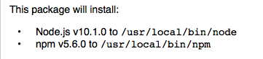

<http://nodejs.cn/download/>

node install

## Composer

安装好后在根目录 （代码的根目录，配置文件composer.json所在的目录）

composer install

更新的依赖包在vendor目录下

composer config -g repo.packagist composer <https://packagist.phpcomposer.com>

composer update

## Laravel

### 开发环境

<http://laravelacademy.org/?p=8016>

### 奇怪的路由

Validator🡺 create🡺 guard()->login 🡺registered

$users->register

RegisterController@registertest==>RegisterUsers@registertest

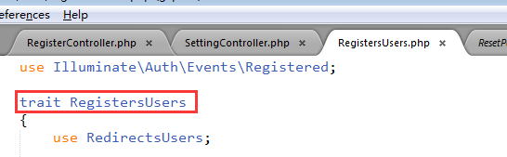

Trait可以看做类的部分实现 (RegisterUsers可以看做是RegisterController的一部分)

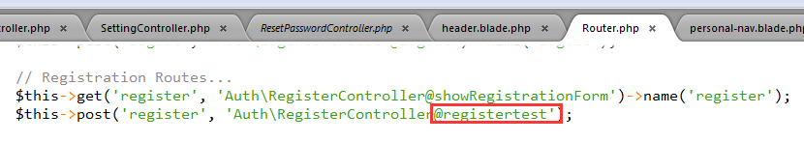

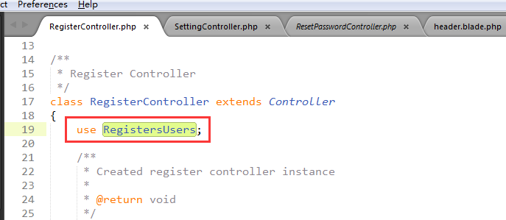

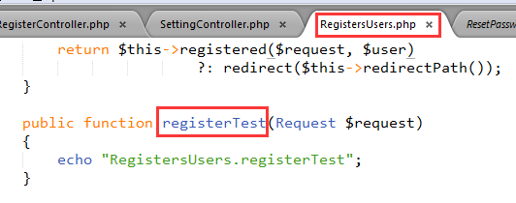

## Blade

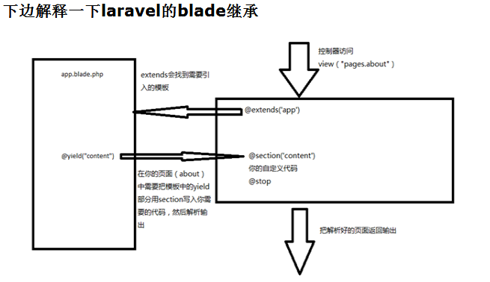

### 参数传递：

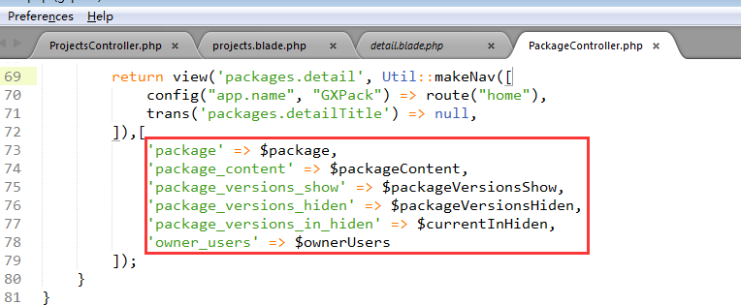

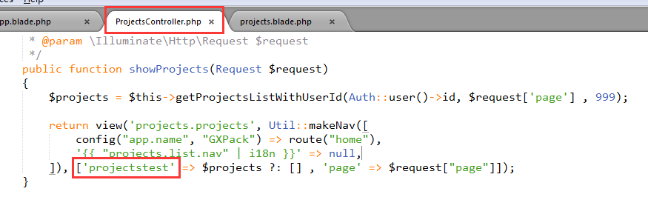

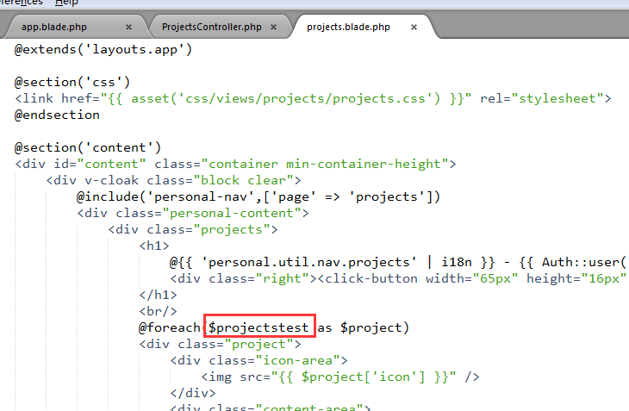

### 调用跳转？

**1 href**

* <click-button width="130px" height="20px" **href="{{route("register")}}"**
* <p style="margin-left:300px;" class="memory-user"> <a **href="{{route("reset-password")}}"**>@{{'auth.login.forgetPassword'|i18n}}</a></p>

**2 v-on:click**

* color="button-color-compared" v-on:click="register"></click-button>

**3 form post**

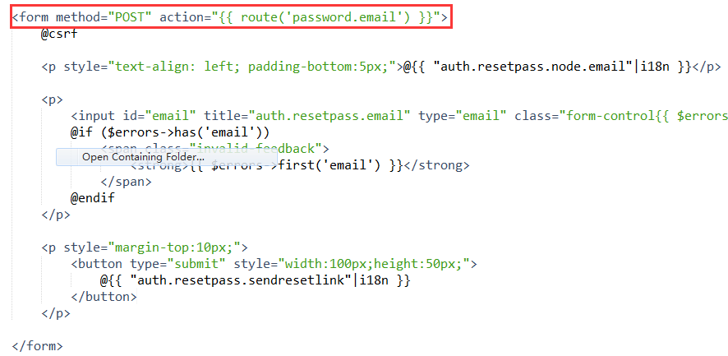

## CSS

直接跳转位置的大小：

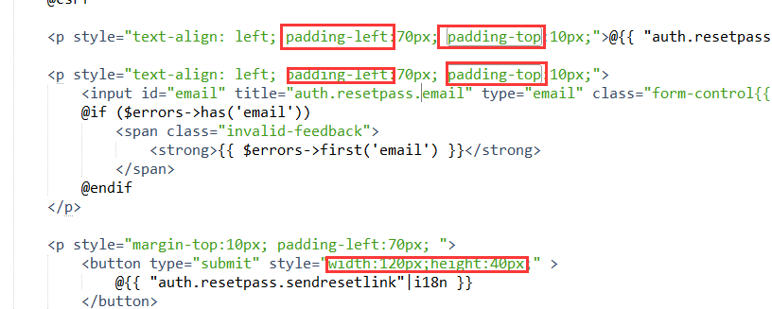

### 编译sass (.scss)

npm run dev

### 实例

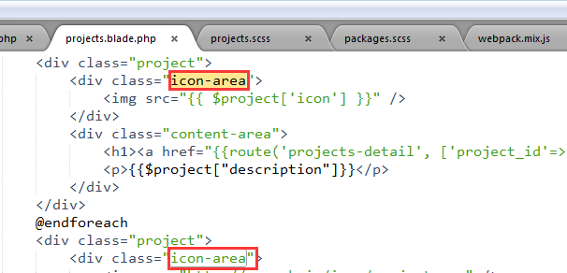

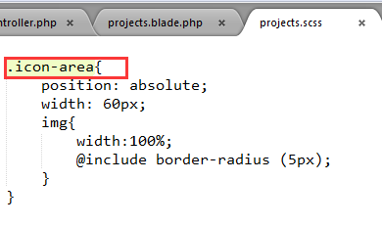

## Html

### foldable-area





### 标签

thead

tbody

## Vue

### Vbind

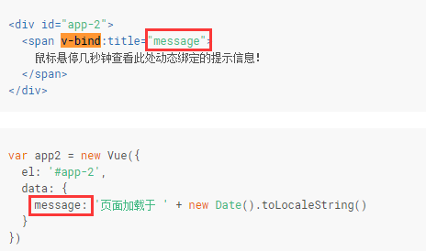

### v-model (输入)

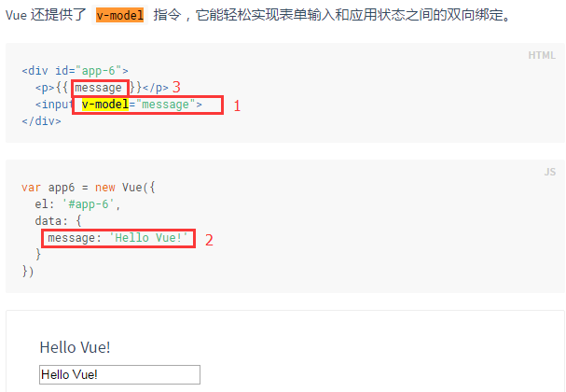

### v-on (事件处理)

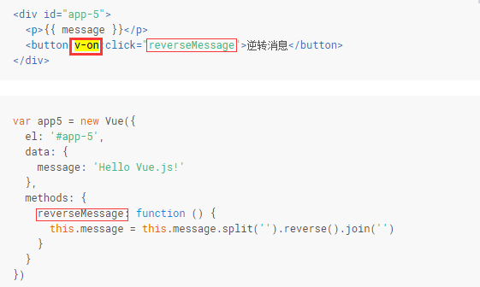

### v-show (根据条件展示元素的选项)



### 实例



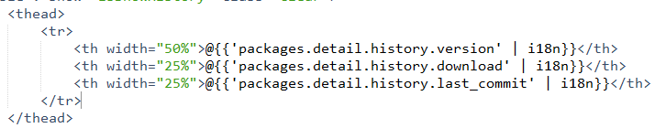

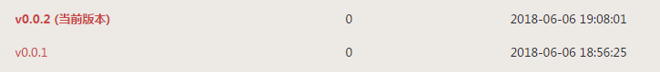

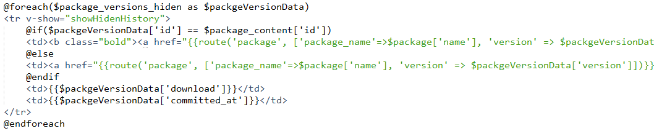

## Rabbitmq

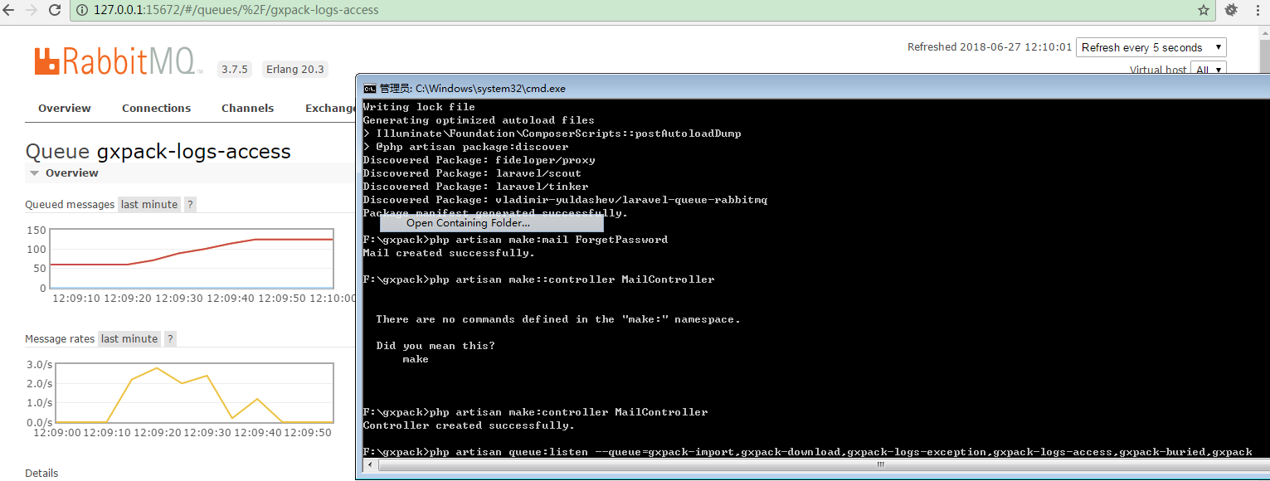

同步模式测完要异步模式测试，请求访问者的信息这些信息在异步都是没有的

**启用队列：**

.env

QUEUE\_DRIVER=sync 🡺

QUEUE\_DRIVER=rabbitmq

**消费队列：**

php artisan queue:listen --queue=gxpack-import,gxpack-download,gxpack-logs-exception,gxpack-logs-access,gxpack-buried,gxpack

## Redis

Mac下用如下指令启动：

sudo redis-server /etc/redis.conf

进入redis:

 redis-cli -p 6379

查询当前redis有没设置密码:

 redis-cli -p 6379

设置密码：

config set requirepass ztgame@123

**auth 123**

**配置文件路径：**

/etc/redis.conf

重启：

brew services restart redis

**查询：**

keys \*

193 redis

ztgame@gxpack

## Kibana

/usr/local/Cellar

/usr/local/Cellar/kibana/6.2.3

## Sentinl

1，下载与kibana相同版本的sentinl压缩包

2，

/usr/local/Cellar/kibana/6.2.3/bin/kibana-plugin install file:///Users/Shared/Jenkins/Downloads/sentinl-v6.2.3.zip

## grafana

stading.grafana.gxpack.io

用户名和密码

gxpack:gxpack

安装：

brew reinstall grafana

/usr/local/etc/grafana/grafana.ini

/usr/local/var/log/grafana/grafana.log

/usr/local/var/lib/grafana/plugins

/usr/local/var/lib/grafana(sqlite db)

初始用户名和密码:

admin

admin

日志：

/usr/local/var/log/grafana/grafana.log

**Ubuntu193:**

1023 grafana-cli plugins install raintank-worldping-app

1024 sudo ./grafana-cli plugins install raintank-worldping-app

1027 sudo ps -ef | grep grafana

1030 sudo nohup bin/grafana-server start &

1081 cd grafana-5.1.2/

1082 sudo vi /etc/supervisor/conf.d/grafana.conf

1083 sudo ps -ef | grep grafana

1093 sudo vi /etc/supervisor/conf.d/grafana.conf

1123 sudo vi grafana.conf

1678 sudo chown user:user -R grafana-5.1.2/

## supervisor

/etc/supervisor/conf.d

改了**grafana**(/etc/supervisor/grafana.conf)的配置后执行下面两条命令就生效了

sudo supervisorctl reread

sudo supervisorctl reload

## filebeat

Mac：

查看filebeat信息：

brew info filebeat

安装路径：

/usr/local/Cellar/filebeat/6.2.4

配置文件：

/usr/local/etc/filebeat/ filebeat.yml

## MetriBeat

Mac:

curl -L -O https://artifacts.elastic.co/downloads/beats/metricbeat/metricbeat-6.2.4-darwin-x86\_64.tar.gz

tar xzvf metricbeat-6.2.4-darwin-x86\_64.tar.gz

/Users/Shared/Jenkins/metricbeat-6.2.4-darwin-x86\_64

启动Metricbeat

sudo nohup ./metricbeat -e -c metricbeat.yml &

sudo ps -ef | grep metricbeat

## Logstash

配置文件

/usr/local/Cellar/logstash/6.2.3/libexec/config/logstash.yml

logstash.conf文件要自己创建

~/logstash/logstash.conf

## 服务列表

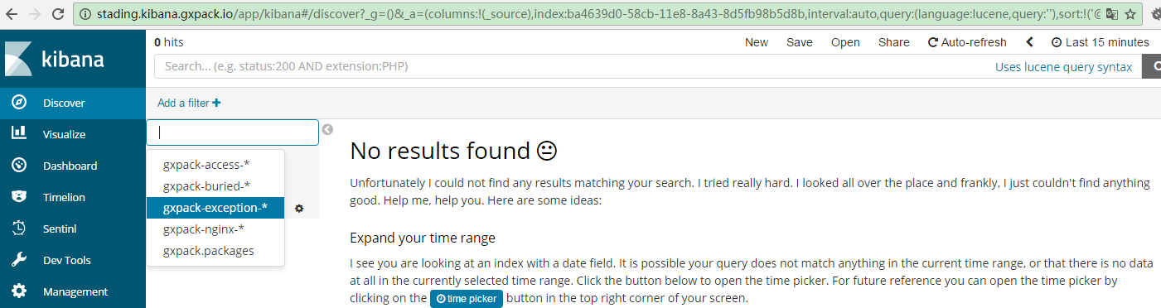

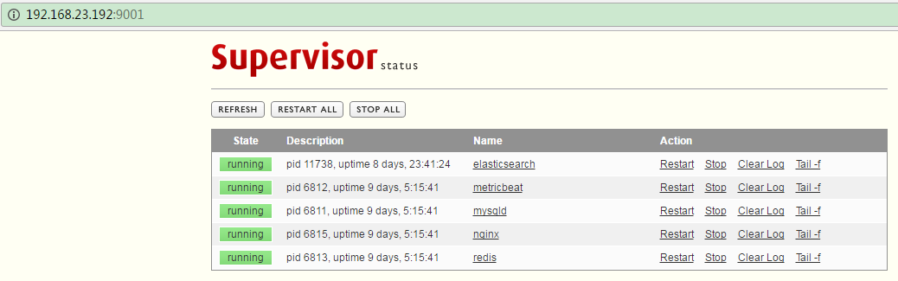

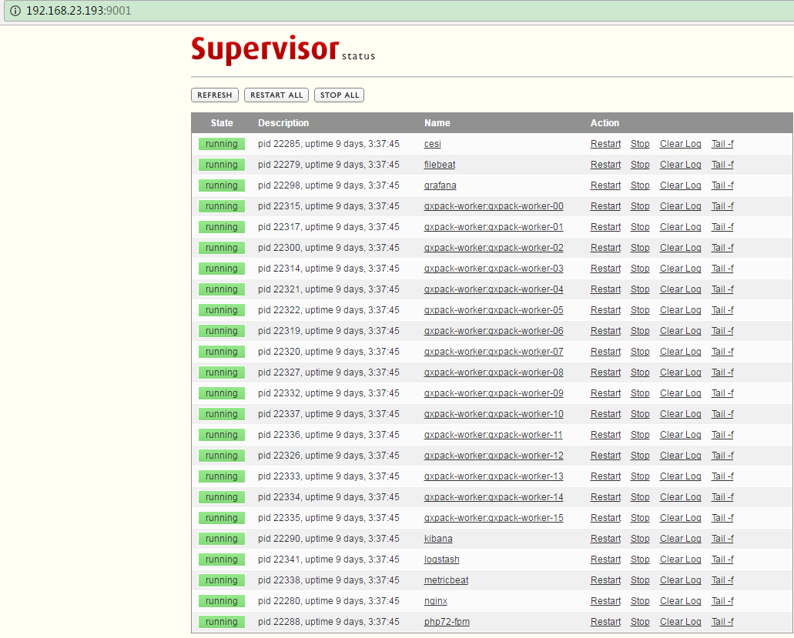

## Elasticsearch

Version: 6.2.3

<http://stading.elasticsearch.gxpack.io>

加了下面的配置会报错：

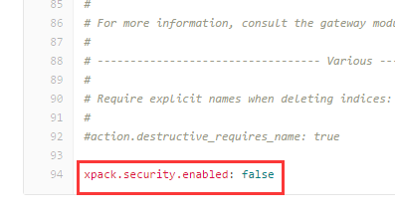

/usr/local/Cellar

配置文件：

/usr/local/etc/elasticsearch/elasticsearch.yml

重启：

brew services restart elasticsearch



### 命令

* 查询Index

GET {{elasticsearch\_host}}/\_cat/indices?v

* 删除Index

DELETE {{elasticsearch\_host}}/gxpack.packages (gxpack.packages是Index名字)

* 创建Index

PUT {{elasticsearch\_host}}/gxpack.packages

* 创建Index的mapping

{{elasticsearch\_host}}/gxpack.packages/\_mapping/gxpack.packages

Header: 

Body:

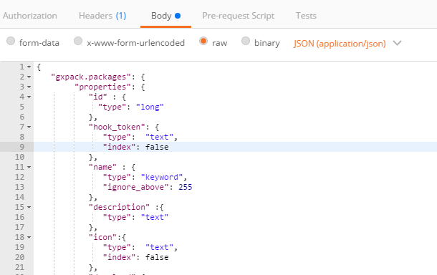

* 获取Index的mapping

GET {{elasticsearch\_host}}/gxpack.packages

* 获取Index的搜索结果(搜索Index)

GET {{elasticsearch\_host}}/gxpack.packages/\_search?q=\*&pretty

### Index索引 192.168.23.192 (牛鸡)

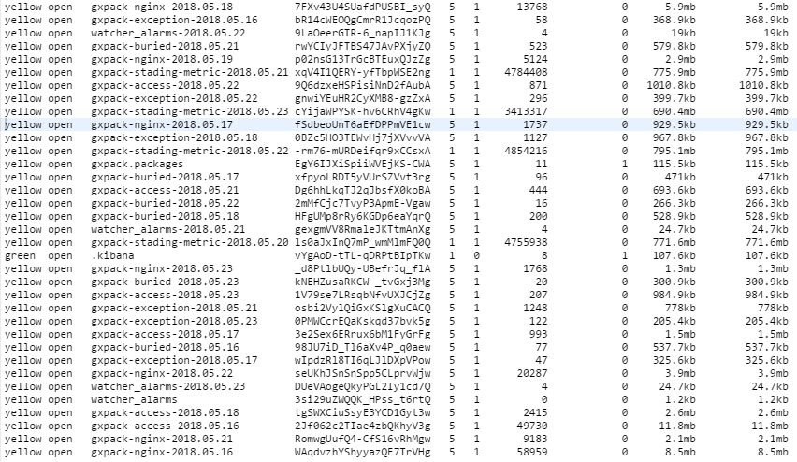

api.gxpack.io

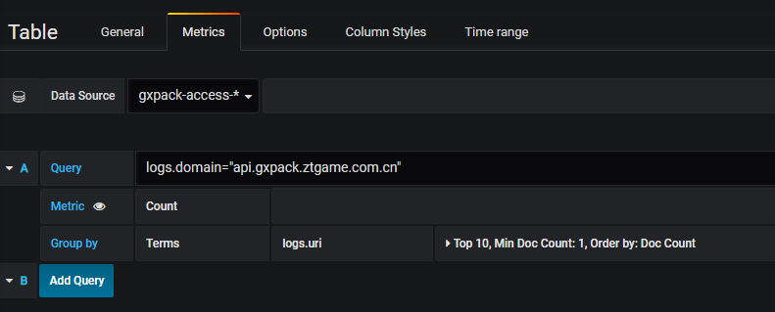

gxpack.io

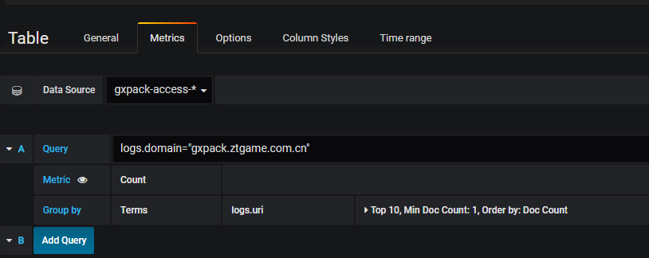

Buried

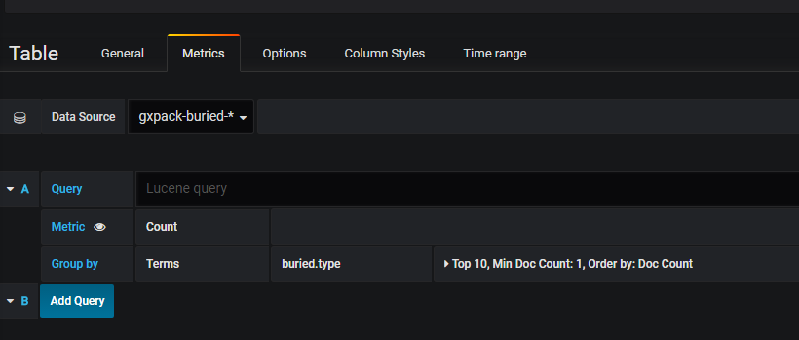

Diskused

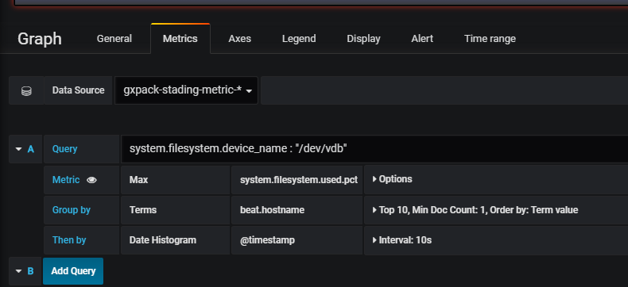

Queue

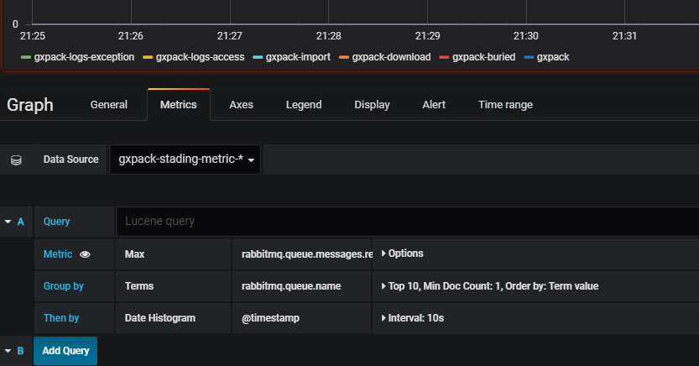

Exception

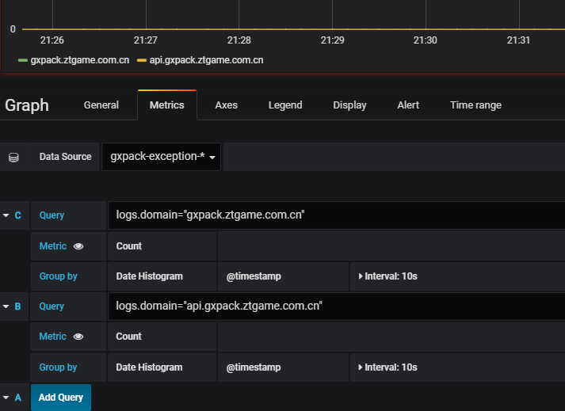

CPU

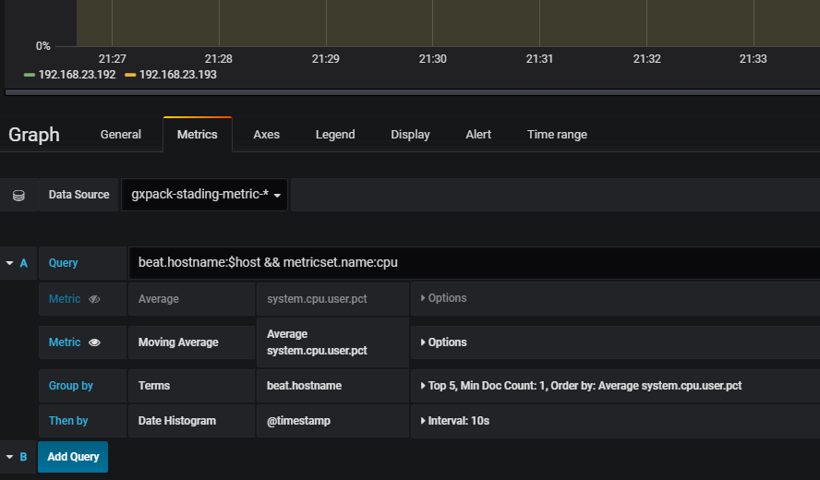

QPM

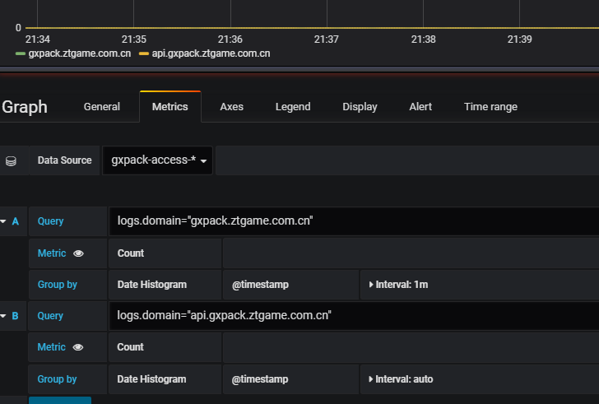

Memory

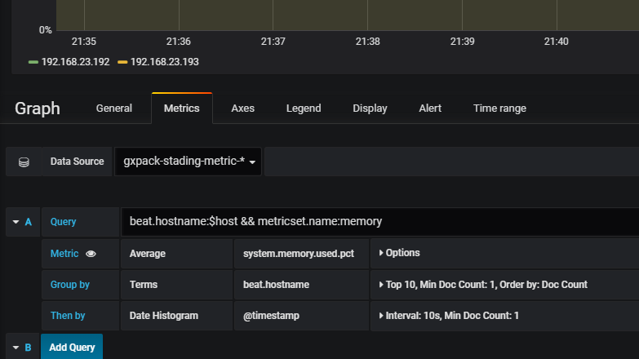

Network

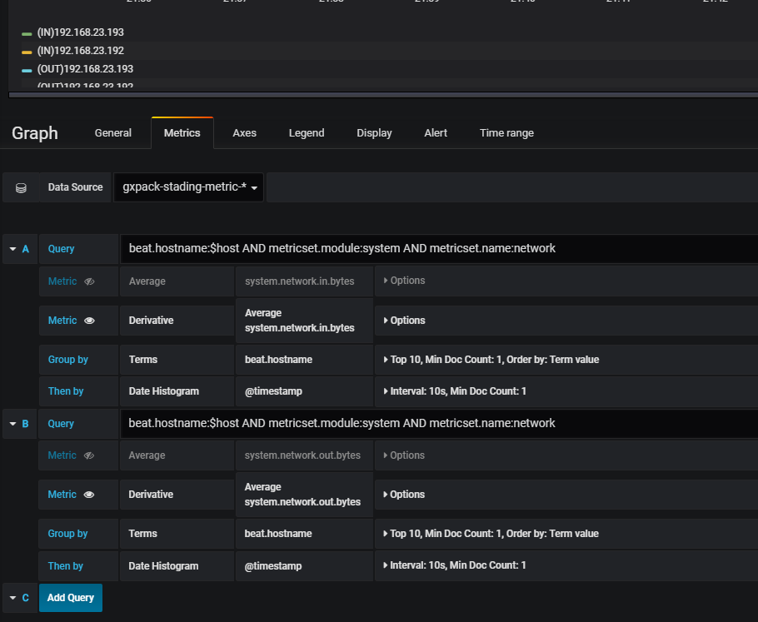

1Min Average load

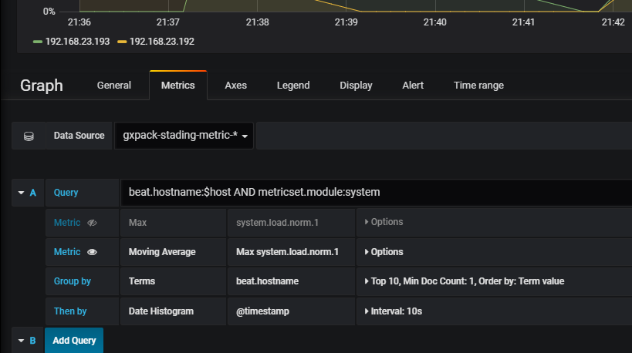

AlertList

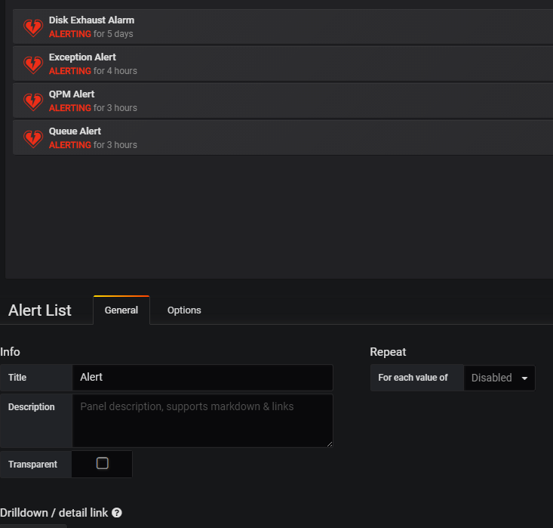

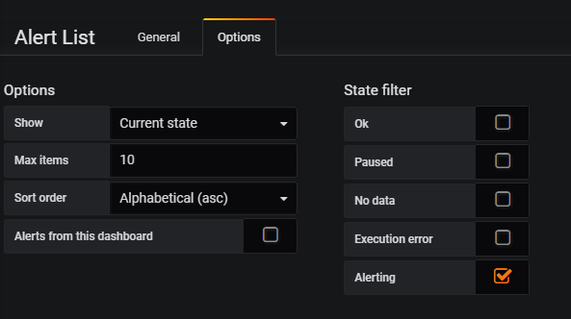

Failed Jobs

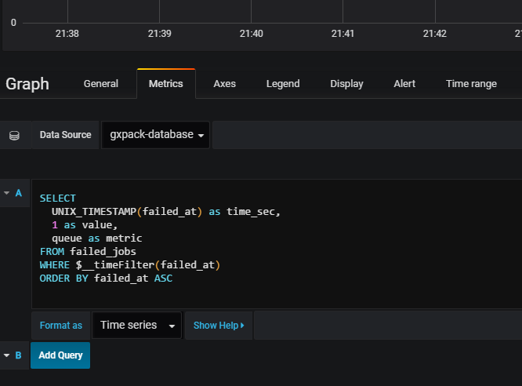

SearchCount

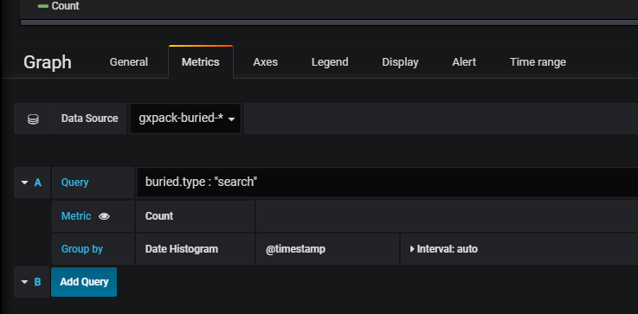

API Access IP

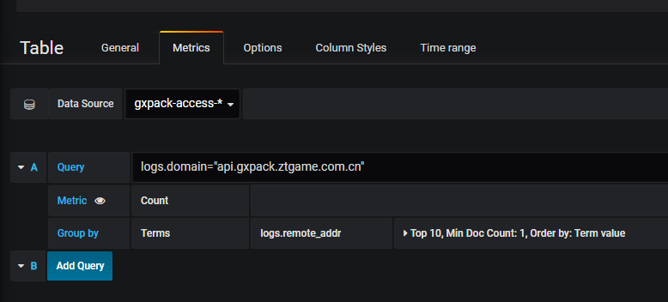

Web Access IP

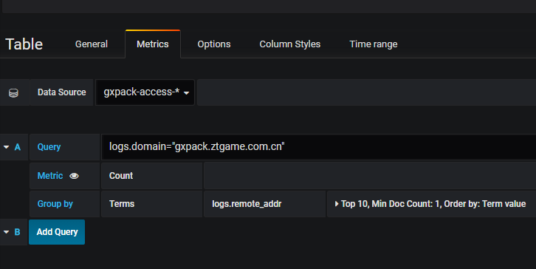

User Count

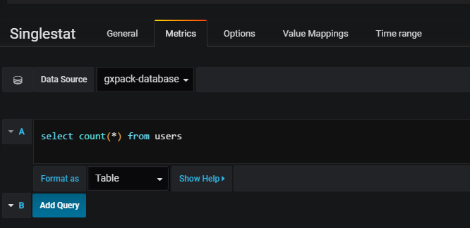

Project Count

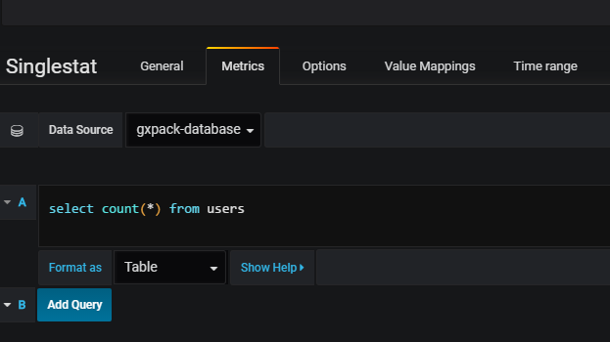

Package Count

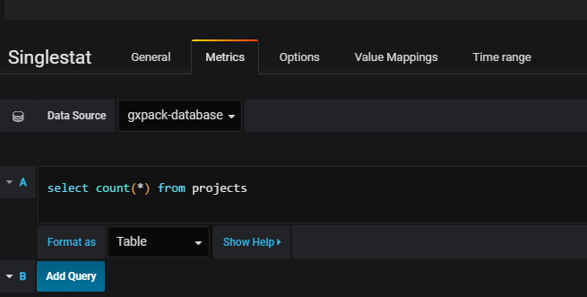

===============================================================================mysql

Aborted Connects

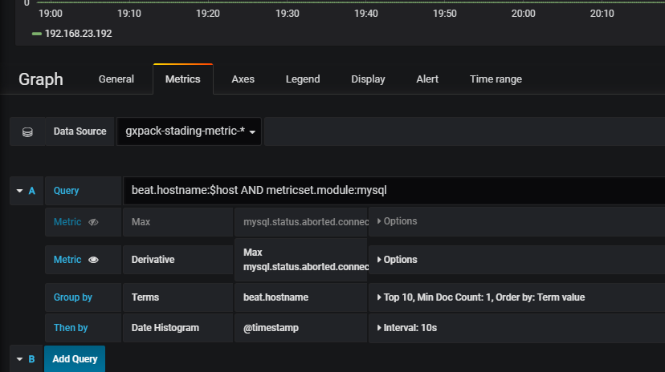

Aborted Clients

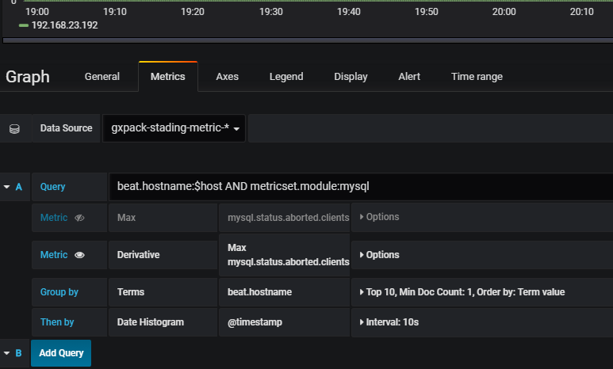

MySQL Net IO

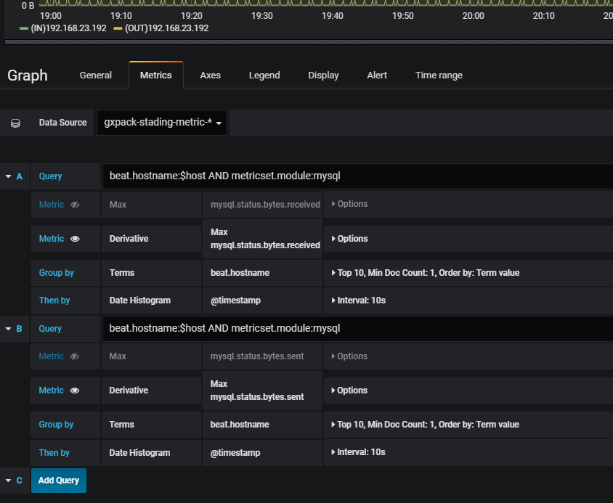

TMP DiskTables

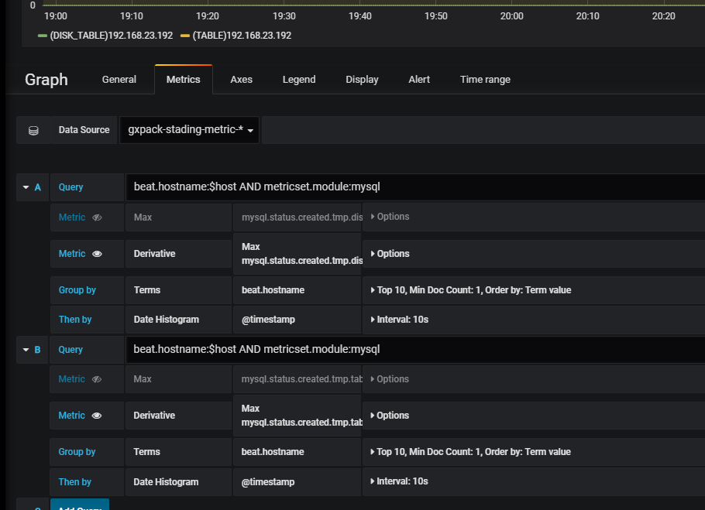

Binlog Disk Use

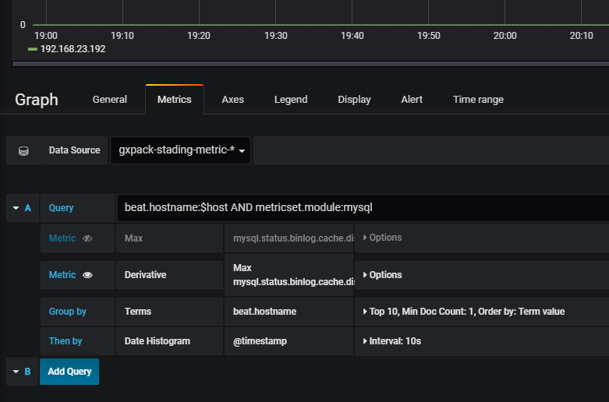

Select Count

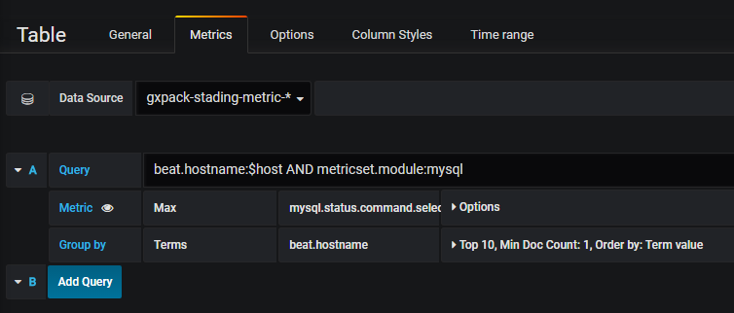

Opened Tables

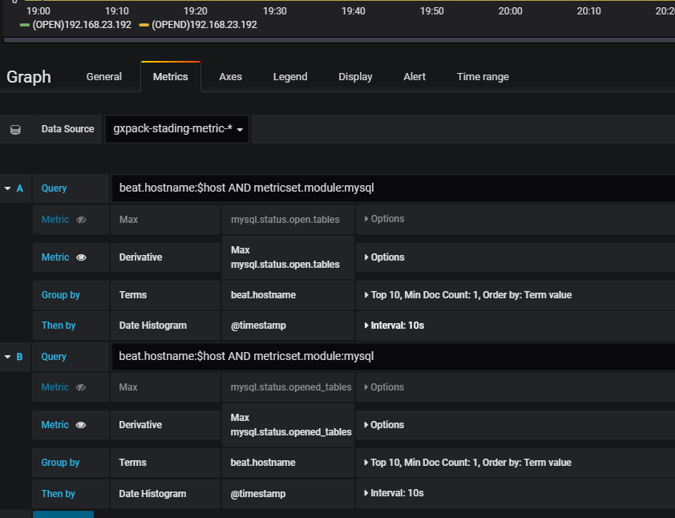

===============================================================================redis

ops

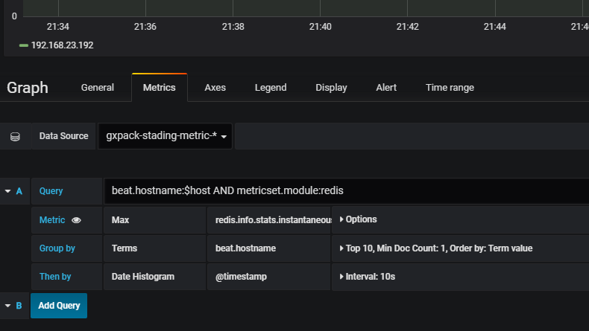

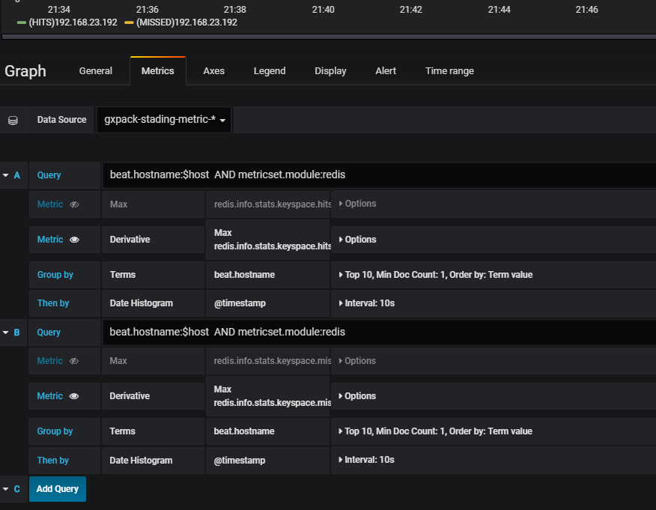

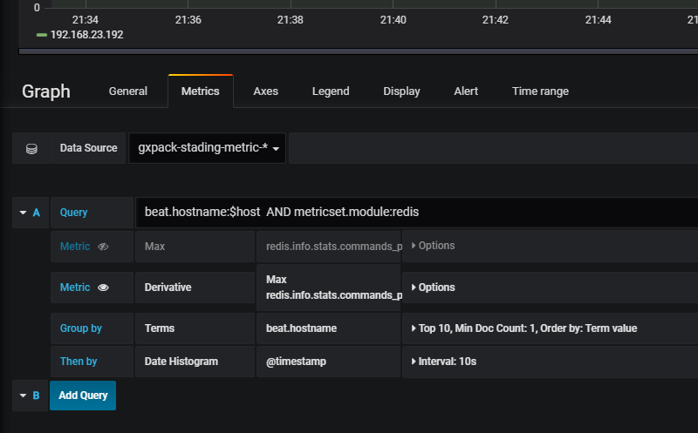

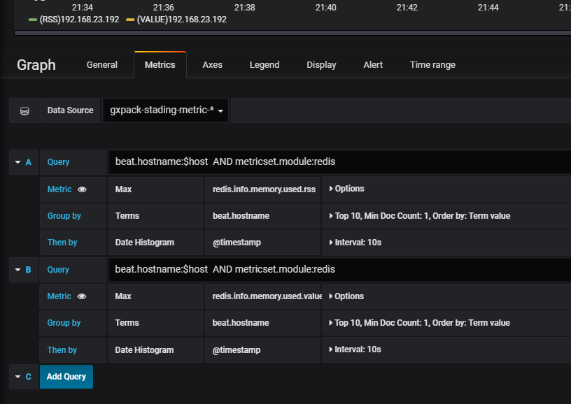

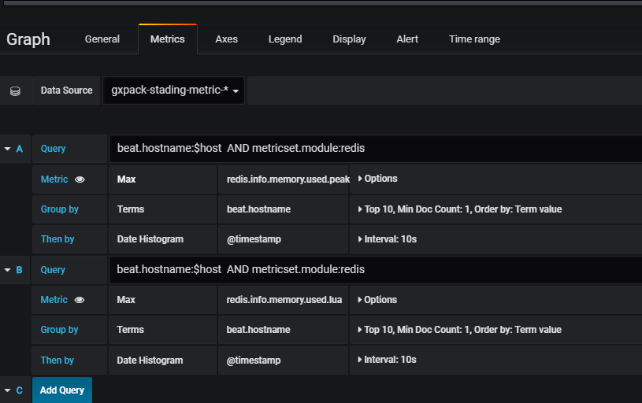

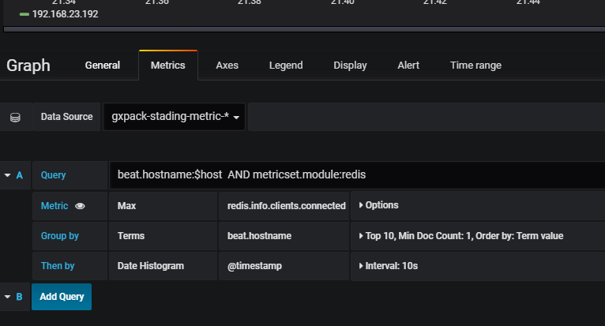

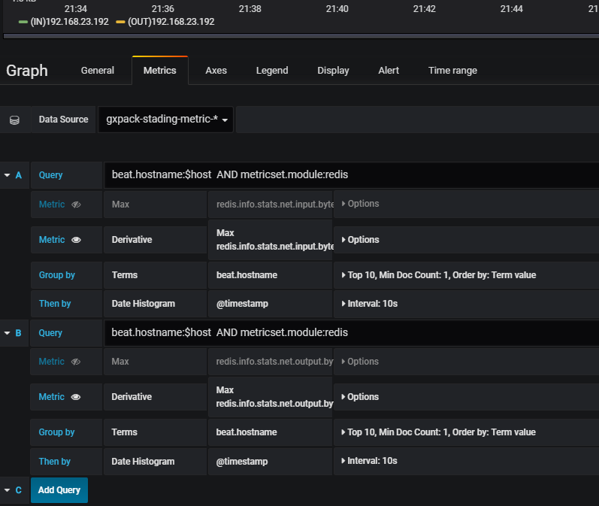

===============================================================================Web Monitor

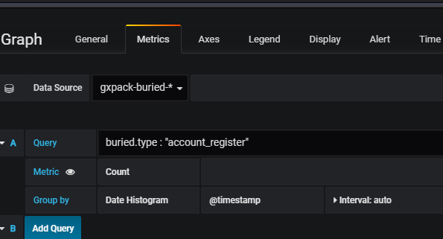

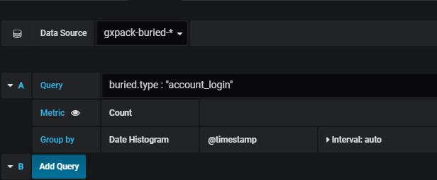

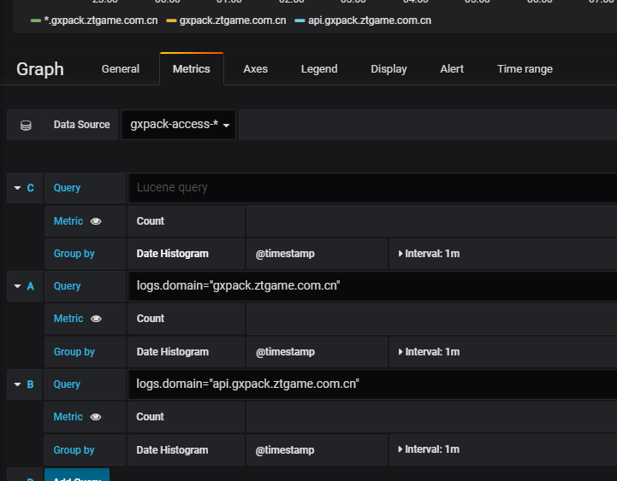

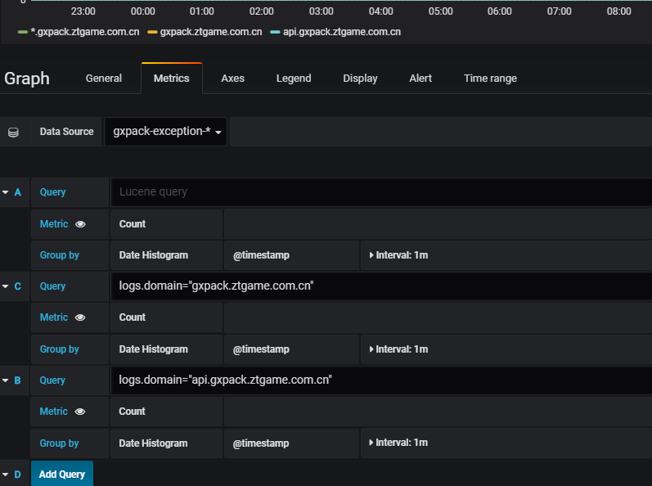

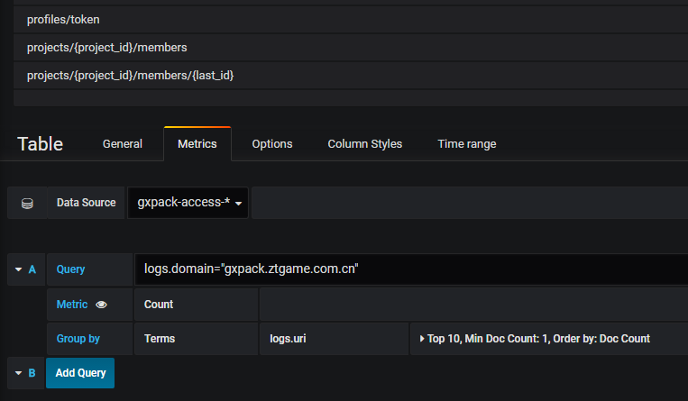

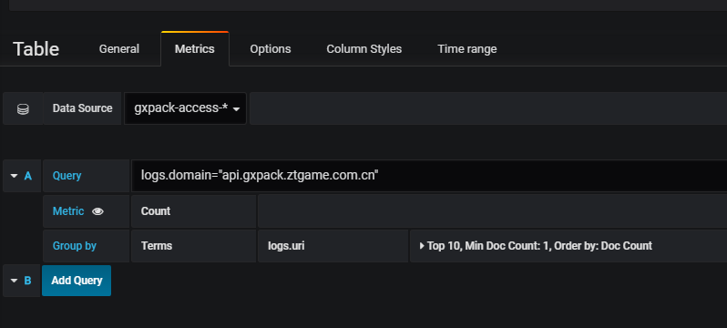

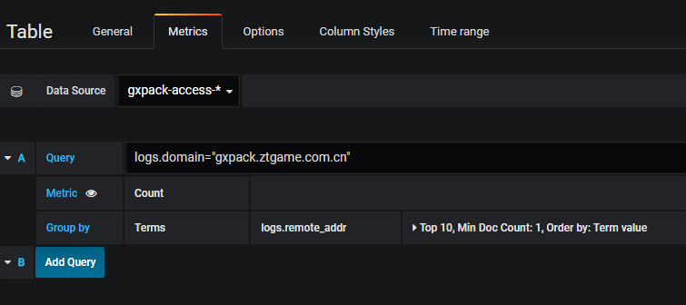

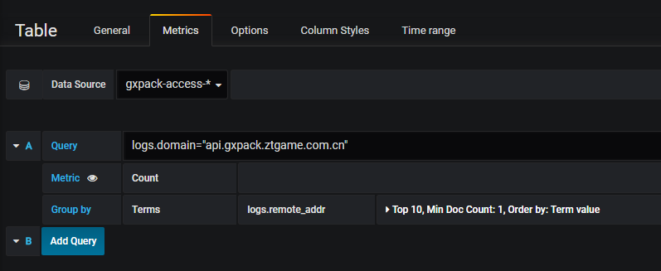

=====================================================================

World Pinghttp://stading.kibana.gxpack.io

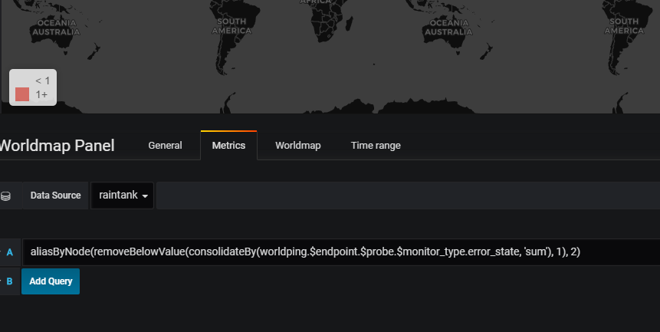

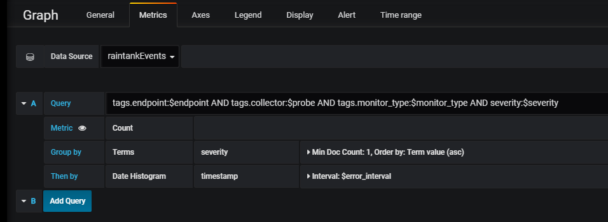

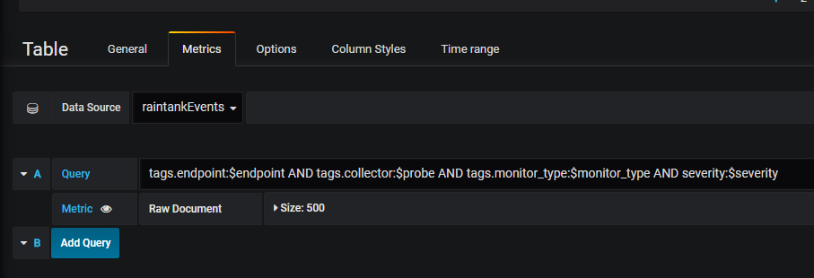

## nginx

**Mac：**

配置文件：

/usr/local/etc/nginx/nginx.conf

重启：

brew services restart nginx

**Note:**

**要用80端口启动nginx必须用sudo起**

## php-fpm

Mac:

查看版本号

php-fpm –version

启动：

php-fpm

寻找配置文件路径：

php-fpm –t

配置文件：

/usr/local/etc/php/7.2/php-fpm.conf

之前碰到系统起的之前版本的情况，把新版的php-fpm加载.bash\_profile的path环境变量里再重启php-fpm就好了:

export PHP72PATH=/usr/local/opt/php@7.2/sbin

## phpMyAdmin

**Mac:**

/Library/WebServer/Documents/phpMyAdmin

## mysql

**Mac:**

启动：

brew services start mysql

brew services stop mysql

连接：

mysql -u root –p

之前出现mac机只有用localhost才能连

解决方案是：

修改配置文件/usr/local/etc/my.cnf如下：

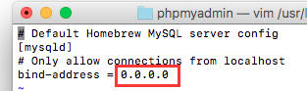

**Windows:**

## apache

**Mac:**

配置：

/etc/apache2/httpd.conf

启动：

sudo apachectl restart

## Apache+PHP+MySQL

<https://blog.csdn.net/cgema/article/details/72457985>

**Apache:**

sudo apachectl start

sudo apachectl stop

sudo apachectl restart

**Php:**

**MySQL:**

**MAMP (集成安装工具 支持apachectl nginx)**

**修改apache配置：**

https://blog.csdn.net/tyyytcj/article/details/78371058?locationNum=10&fps=1

/etc/apache2/httpd.conf

## mac下的php php-fpm

To enable PHP in Apache add the following to httpd.conf and restart Apache:

LoadModule php7\_module /usr/local/opt/php/lib/httpd/modules/libphp7.so

<FilesMatch \.php$>

SetHandler application/x-httpd-php

</FilesMatch>

Finally, check DirectoryIndex includes index.php

DirectoryIndex index.php index.html

The php.ini and php-fpm.ini file can be found in:

/usr/local/etc/php/7.2/

To have launchd start php now and restart at login:

brew services start php

Or, if you don't want/need a background service you can just run:

php-fpm

==> Summary

/usr/local/Cellar/php/7.2.5: 515 files, 78.9MB

===============================================================================

[/usr/local/opt/php@7.2](mailto:/usr/local/opt/php@7.2)

[/usr/local/opt/php@7.2/sbin/**php-fpm**](mailto:/usr/local/opt/php@7.2/sbin/php-fpm)

php-fpm –t

/usr/local/etc/php/7.2/php-fpm.conf

## mac下的nginx

brew install nginx

nginx –t

/usr/local/etc/nginx/nginx.conf

**ps aux | grep nginx**

查找nginx进程

关闭：

**ps -ef|grep nginx**

www访问目录竟然在这里：

/usr/local/Cellar/nginx/1.13.12/html

<https://blog.csdn.net/beyond__devil/article/details/52711328>

<https://blog.csdn.net/beyond__devil/article/details/52711328>

EN.

<https://blog.frd.mn/install-nginx-php-fpm-mysql-and-phpmyadmin-on-os-x-mavericks-using-homebrew/>

http://blog.imqia.me/posts/osx-install-nmp/

brew install nginx

sudo nginx ( 运行)

brew install composer

brew install redis

brew install memcached

brew install autoconf

brew install phpmyadmin

To have launchd start redis now and restart at login:

brew services start redis

Or, if you don't want/need a background service you can just run:

redis-server /usr/local/etc/redis.conf

brew link --overwrite redis

## nginx下设置php-fpm使用socket文件的方法

<https://blog.csdn.net/u011630575/article/details/48287381>

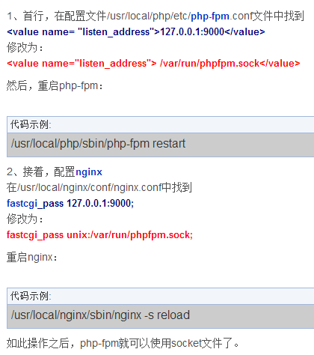

/usr/local/etc/php/7.2/php-fpm.conf

## 部署

Filebeat（文件监控）==>LogStash==>elasticsearch

MetriBeat（性能监控)==> elasticsearch

rabbitmq (请求队列，缓存耗时请求)

Packetbeat (允许您监视应用级协议（如HTTP和MySQL）以及DNS和其他服务的实时网络流量

)

ELK就是指ElasticSearch (OK)、Logstash和Kiabana (OK)

Mac下php nginx 的安装

## 安装路径

filebeat /usr/local/Cellar/filebeat/6.2.4

\*\*\*\*\*大部分工具都在这个路径：\*\*\*\*\*

/usr/local/Cellar/

## 第三方应用

### Metricbeat

## 调用顺序

Routes：api.php

ap

Api.php

==>PackageController.php

==>IPackages.php

==>Packages.php

==>Model\Packages:xxx

==>(static::cache static::select )

Controller调用底层查询完以后 再 以json格式返回结果

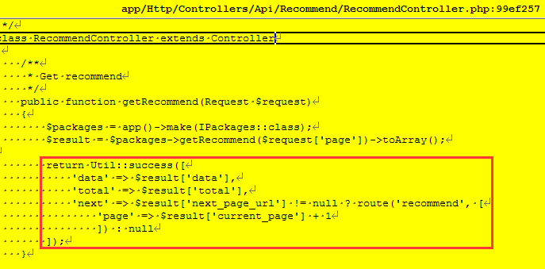

## 排序和分页?



## 安装

tar zxvf redis-4.0.8

cd redis-4.0.8

make

src/redis-server

————————————————————————

Install brew;

/usr/bin/ruby -e "$(curl -fsSL https://raw.githubusercontent.com/Homebrew/install/master/install)"

Brew install mysql

mysql.server start or

brew services start mysql



—————————————————————————

brew install rabbitmq

brew services start rabbitmq

—————————————————————————

brew install logstash

brew services start logstash

—————————————————————————

brew install elasticsearch

brew services start elasticsearch

————————————————————————-

brew install Kibana

brew services start kibana

————————————————————————

brew install Grafana

brew services start grafana

phpMyAdmin

xxfpm "php-cgi.exe -c D:/Software/php7/php.ini" -n 2 -i 127.0.0.1 -p 9000

## php无后缀路径问题

比如要访问 gxpack.io/package

在根目录创建package🡺在package下放个index.php

**提交新的远端项目配置**

## 第三方工具

Node.js

Composer Composer是PHP中用来管理依赖关系的工具

## Access Token



**7EEjy6FsvUhzIx5MdLI3wg==**

## URL

Token+**Project**

<http://api.gxpack.io:81/projects>

<http://api.gxpack.io:81/projects/20/>

<http://api.gxpack.io:81/projects/20/versions>

## 提交配置

只能提交raw里面的

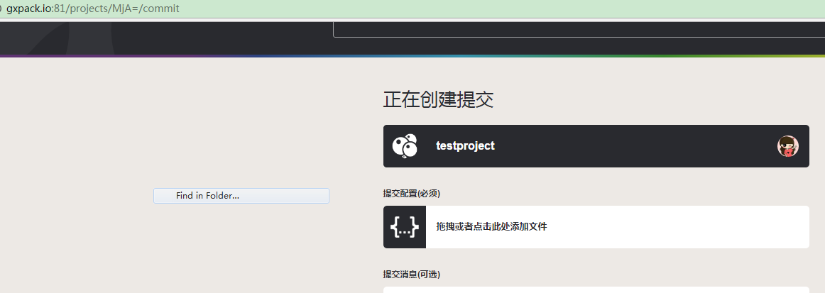

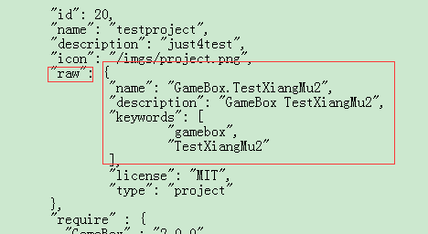

## 项目提交 (通过代码post提交)

提交的是方框里的内容(raw内容)

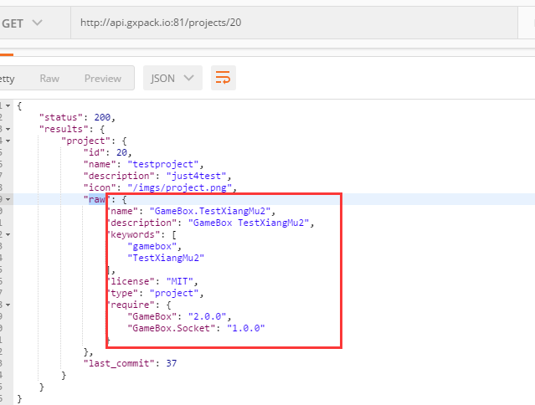

## Post请求

**https://blog.csdn.net/shifeilongsuper/article/details/50493943**

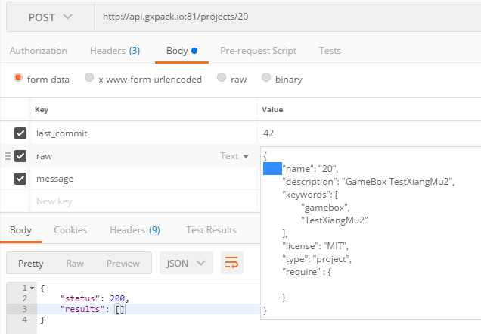

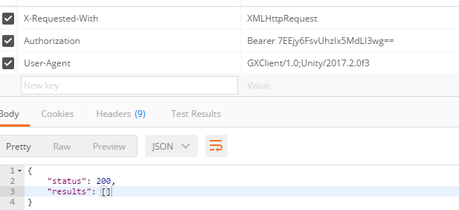

注意发送的 last\_commit必须用服务器上最新的ID：

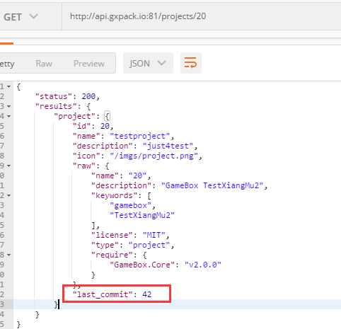

## 抓包工具

**Fiddler**

**Charles (俞斌推荐)**

**正常的请求：**

----------------------------903847255762209719172741

Content-Disposition: form-data; name="last\_commit"

43

----------------------------903847255762209719172741

Content-Disposition: form-data; name="raw"

{

"name": "20",

"description": "GameBox TestXiangMu2",

"keywords": [

"gamebox",

"TestXiangMu2"

],

"license": "MIT",

"type": "project",

"require" : {

"GameBox.Core" : "v2.0.0",

"GameBox.Bucket" : "1.0.8"

}

}

----------------------------903847255762209719172741

Content-Disposition: form-data; name="message"

push\_by\_postman

----------------------------903847255762209719172741--

## 接口

### 包 <http://api.gxpack.io:81/packages/GameBox.Bucket>

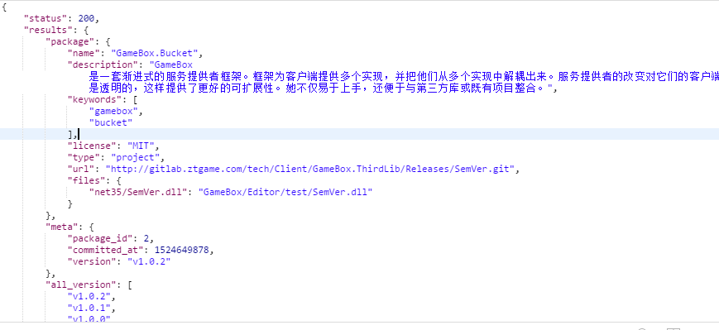

### 包2 <http://api.gxpack.io:81/packages/GameBox.Bucket/v1.0.2>

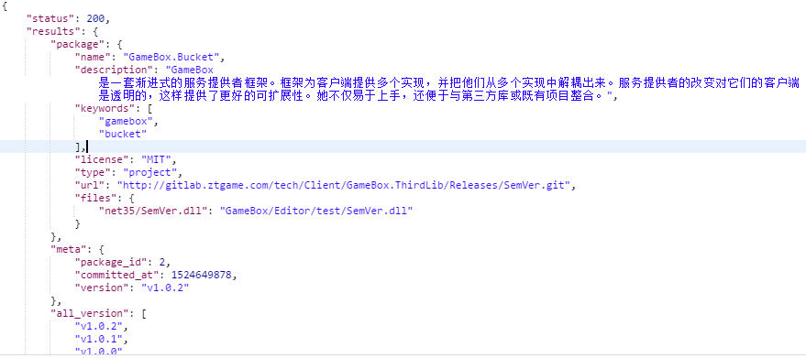

### Project <http://api.gxpack.io:81/projects/20>

GxProjectResult🡺GxProject

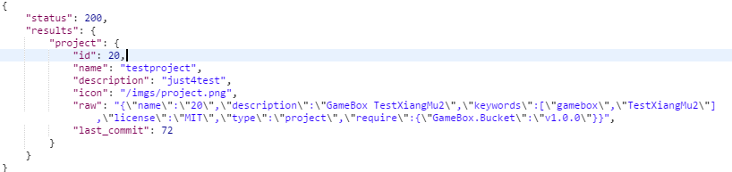

### Recommend <http://api.gxpack.io:81/recommend>

GxPacks🡺GxPackSummary

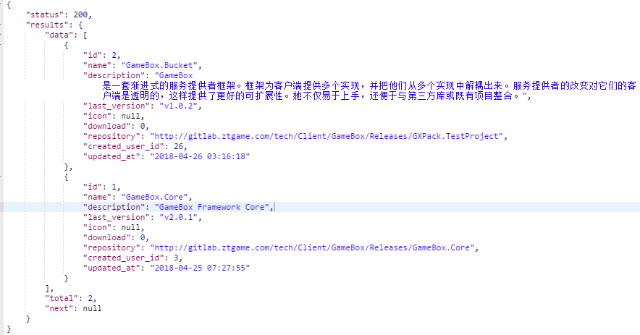

# ToDo

copy /Y "$(TargetDir)$(TargetName).dll" F:\@@@@@@@@@@@\GameBox\TestNewBucket\Assets\GameBox\Vendor\GameBox\TestBucket\net35\Editor

copy /Y "$(TargetDir)$(TargetName).pdb" F:\@@@@@@@@@@@\GameBox\TestNewBucket\Assets\GameBox\Vendor\\GameBox\TestBucket\net35\Editor

copy /Y "$(TargetDir)$(TargetName).dll" F:\@@@@@@@@@@@\GameBox\TestNewBucket\Assets\GameBox\Vendor\\GameBox\TestBucket\net35\Editor

copy /Y "$(TargetDir)$(TargetName).pdb" F:\@@@@@@@@@@@\GameBox\TestNewBucket\Assets\GameBox\Vendor\\GameBox\TestBucket\net35\Editor

## 客户端可以通过指令安装包



## ~2.0.0 ~1.0.0

处理

## Download gitlab处理

## Bucket合成一个动态链接库后自更新如何替换

Simplify & [self-confident](http://www.baidu.com/link?url=J6ISRBRPSPxNJk5BJlniyC7n-aIzcyXTJPpulmKKBiU_f3TiLMbUawRv_Cnq9bg_aSEPyvJRMyxq0-NtpMIiVrzfUHA7DIdsjkuvdKnwoi6WMqTx5uYnqHwlnoXVHzNP)

## 版本号

 null?

SemVer >=2.5.0

var r1 = new Range("1.0.1");

var r2 = new Range("2.0.0");

<0.0.0

-------------------------------------------------

var r1 = new Range("1.0.1");

var r2 = new Range("1.0.2");

<0.0.0

-------------------------------------------------

var r1 = new Range(">1.0.1");

var r2 = new Range(">1.0.2");

>1.0.2

-------------------------------------------------

var r1 = new Range(">v1.0.1");

var r2 = new Range(">v1.0.2");

>1.0.2

-------------------------------------------------

var r1 = new Range(">vv1.0.1");

var r2 = new Range(">vv1.0.2");

>1.0.2

## 启动包和项目依赖包下载

## 整体下载流程

# task

## 20180528-20180601

1解决依赖包下载问题

2权限处理

3 连续安装删除问题

4 服务器无法邀请问题

5 服务器返回profile字段不一致问题

6 GXPACK交接

# Q&A

依赖包下载异常

增加配置

更新GXPack客户端

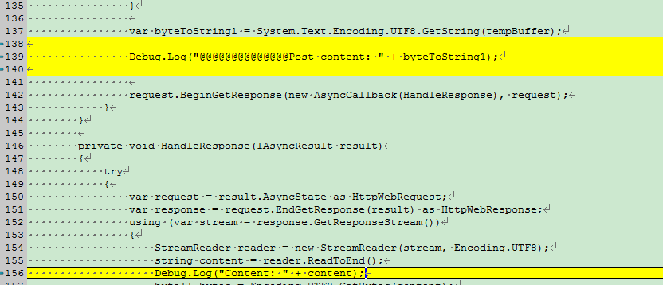

<PropertyGroup>

<PostBuildEvent>copy /Y "$(TargetDir)$(TargetName).dll" F:\@@@@@@@@@@@\Saturn\code\client\Assets\GameBox\Vendor\GameBox\Bucket\net35\Editor

copy /Y "$(TargetDir)$(TargetName).pdb" F:\@@@@@@@@@@@\Saturn\code\client\Assets\GameBox\Vendor\GameBox\Bucket\net35\Editor

</PostBuildEvent>

</PropertyGroup>

## php-fpm不会自动启动

同时装了php-xml php7.2-xml引起的

sudo apt remove php-xml

sudo apt remove php7.2-xml

sudo apt install php7.2-xml

## 查看进程的启动时间及其它信息

ps -p PID -o lstart

查系统时间：

Date

## 192日志

628 libhtsjdk-java - Java API for high-throughput sequencing data (HTS) formats

629 libhtsjdk-java-doc - Documentation for the java HTSJDK library

630 libicu4j-4.4-java - Library for Unicode support and internationalization

631 libicu4j-49-java - Library for Unicode support and internationalization

632 libicu4j-java - Library for Unicode support and internationalization

633 libitext1-java - Java Library to generate PDF on the Fly

634 libjboss-common-java - The JBoss Common Project

635 libjboss-logmanager-java - implementation of java.util.logging.LogManager

636 libjboss-marshalling-java - alternative serialization API

637 libjson-simple-java - Simple, lightweight and efficient JSON toolkit for Java

638 libjxp-java - Java template engine/script processor

639 libkryo-serializers-java - Kryo serializers

640 libmaven-enforcer-plugin-java - Maven build rule execution framework

641 libnb-javaparser-java - Parser for the Java language which is good for use in tools

642 libpostgresql-jdbc-java - Java database (JDBC) driver for PostgreSQL

643 libpostgresql-jdbc-java-doc - Java database (JDBC) driver for PostgreSQL (documentation)

644 libpracticalxml-java - practical XML handling routines

645 libreoffice - office productivity suite (metapackage)

646 libslf4j-java - Simple Logging Facade for Java

647 libtrove-java - high performance collections for java

648 libtrove-java-doc - high performance collections for java

649 libtrove3-java - high performance collections for java

650 libtrove3-java-doc - high performance collections for java

651 libunsafe-mock-java - Java library providing backported sun.misc.Unsafe class from JDK 8

652 libvisualvm-jni - All-in-One Java Troubleshooting Tool (JNI libraries)

653 libwagon-java - tools to manage Maven artifacts and deployment

654 mauve - free test suite for the Java Class libraries

655 mmake - Makefile generator for Java programs

656 openjdk-8-jre-dcevm - Alternative VM for OpenJDK 8 with enhanced class redefinition

657 openjdk-8-jre-zero - Alternative JVM for OpenJDK, using Zero/Shark

658 openjdk-9-dbg - Java runtime based on OpenJDK (debugging symbols)

659 openjdk-9-demo - Java runtime based on OpenJDK (demos and examples)

660 openjdk-9-doc - OpenJDK Development Kit (JDK) documentation

661 openjdk-9-jdk - OpenJDK Development Kit (JDK)

662 openjdk-9-jdk-headless - OpenJDK Development Kit (JDK) (headless)

663 openjdk-9-jre - OpenJDK Java runtime, using Hotspot JIT

664 openjdk-9-jre-headless - OpenJDK Java runtime, using Hotspot JIT (headless)

665 openjdk-9-source - OpenJDK Development Kit (JDK) source files

666 substance - cross-platform look & feel for Swing applications

667 substance-doc - cross-platform look & feel for Swing applications - documentation

668 testng - testing framework for Java

669 usepackage - utility to manage environment variables from within dotfiles

670 uwsgi-app-integration-plugins - plugins for integration of uWSGI and application

671 uwsgi-plugin-jvm-openjdk-8 - Java plugin for uWSGI (OpenJDK 7)

672 uwsgi-plugin-jwsgi-openjdk-8 - JWSGI plugin for uWSGI (OpenJDK 7)

673 uwsgi-plugin-ring-openjdk-8 - Closure/Ring plugin for uWSGI (OpenJDK 7)

674 uwsgi-plugin-servlet-openjdk-8 - JWSGI plugin for uWSGI (OpenJDK 7)

675 visualvm - All-in-One Java Troubleshooting Tool

676 java-package - Utility for creating Java Debian packages

677 libcolt-java - scalable scientific and technical computing in Java

678 libcolt-java-doc - scalable scientific and technical computing in Java (doc)

679 openjdk-8-jre-jamvm - Transitional package for obsolete JamVM for OpenJDK

680 user@user-KVM:/home/www$

681 user@user-KVM:/home/www$

682 user@user-KVM:/home/www$

683 user@user-KVM:/home/www$

684 user@user-KVM:/home/www$

685 user@user-KVM:/home/www$

686 user@user-KVM:/home/www$ cd /home

687 user@user-KVM:/home$

688 user@user-KVM:/home$

689 user@user-KVM:/home$ sudo mkdir download

690 [sudo] password for user:

691 Sorry, try again.

692 [sudo] password for user:

693 user@user-KVM:/home$

694 user@user-KVM:/home$

695 user@user-KVM:/home$ cd download/

696 sudo useradd elasticsearch -g elasticsearch -p elasticsearch

697 cd ..

698 chown -R elasticsearch:elasticsearch elasticsearch-6.2.4/

699 sudo chown -R elasticsearch:elasticsearch elasticsearch-6.2.4/

700 ls

701 cd elasticsearch-6.2.4/

702 su elasticsearch

703 cd ..

704 ls -l

705 su elasticsearch

706 sudo su elasticsearch

707 sudo mkdir logstash-6.2.4

708 ls

709 chown -R user logstash-6.2.4/

710 sudo chown -R user logstash-6.2.4/

711 ls

712 ls -l

713 if config

714 ifconfig

715 ls

716 rm logstash-6.2.4/

717 rm -R logstash-6.2.4/

718 ls

719 sudo rm -R logstash-6.2.4/

720 ls

721 exit

722 ls

723 cd /home/

724 ls

725 ls -l

726 sudo rm -R download/

727 ls

728 ls -l

729 sudo wget https://artifacts.elastic.co/downloads/kibana/kibana-6.2.4-linux-x86\_64.tar.gz

730 ifconfig

731 exit

732 sudo vi /etc/nginx/sites-available/default

733 sudo systemctl restart nginx

734 ifconfig

735 exit

736 cd /home/elasticsearch-6.2.4/

737 ls

738 cat config/elasticsearch.yml

739 sudo cat config/elasticsearch.yml

740 exit

741 sudo cat /etc/nginx/sites-available/default

742 q

743 ls

744 exit

745 sudo vi /etc/mysql/my.cnf

746 ls

747 cd /etc/mysql

748 ls

749 ls -l

750 cd conf.d/

751 ls

752 sudo vi mysql.cnf

753 sudo vi mysqldump.cnf

754 cd ../

755 ls

756 cd mysql.conf.d/

757 ls

758 vi mysqld.cnf

759 sudo vi mysqld.cnf

760 jobs

761 bg 1

762 fg

763 sudo vi mysqld.cnf

764 sudo systemctl restart mysql

765 sudo systemctl status mysql.service

766 sudo systemctl restart mysql

767 sudo journalctl -u mysql.service

768 sudo vi mysqld.cnf

769 sudo systemctl restart mysql

770 sudo vi mysqld.cnf

771 sudo systemctl restart mysql

772 exit

773 redis -t

774 redis-server -t

775 redis-server -test

776 redis-server -v

777 redis-server -h

778 cat /etc/redis/redis.conf

779 sudo cat /etc/redis/redis.conf

780 sudo vi /etc/redis/redis.conf

781 sudo systemctl restart redis-server

782 exit

783 uanme -a

784 uname -a

785 cat /proc/sys/kernel/hostname

786 sudo vi /proc/sys/kernel/hostname

787 hostname 192.168.23.192

788 sudo hostname 192.168.23.192

789 sudo vi /proc/sys/kernel/hostname

790 pwd

791 ls

792 ifconfig

793 cd /home

794 ls

795 cd metricbeat-6.2.4/

796 ps -ef | grep metricbeat

797 sudo kill -9 21778

798 sudo kill -9 21779

799 ps -ef | grep metricbeat

800 sudo nohup ./metricbeat -e -c metricbeat.yml &

801 cd ..

802 ls

803 curl

804 exit

805 top

806 df -k

807 ipconfig

808 ifconfig

809 df -hl

810 ls

811 cd /home/

812 ls

813 exit

814 fdisk

815 fdisk -l

816 sudo fdisk -l

817 exit

818 tops

819 free -m

820 sudo apt-get install htop

821 htop

822 sudo htop

823 df -h

824 df -hl

825 sudo fdisk -l

826 ls

827 cd /dev/vdb

828 fdisk -l

829 sudo fdisk -l

830 sudo mount /dev/vdb

831 fdisk -l

832 sudo fdisk -l

833 sudo df

834 sudo vgdisplay

835 sudo fdisk /dev/sdb

836 sudo fdisk /dev/vda5

837 sudo fdisk /dev/vdb

838 sudo fdisk -l

839 sudo mkfs.ext4 /dev/vdb

840 sudo echo '/dev/vdb /home/vdisk ext4 defaults 0 0' >> /etc/fstab

841 sudo vi /etc/fstab

842 sudo mount -a

843 cd ../

844 ls

845 sudo mkdir vdisk

846 sudo mount -a

847 ls

848 fdisk

849 fdisk -l

850 sudo fdisk -l

851 df -h

852 cd /home/vdisk/

853 ls

854 ls -l

855 cd lost+found/

856 cd ../

857 ls -l

858 fdisk elasticsearch-6.2.4

859 ls -l

860 cd elasticsearch-6.2.4/

861 du -sh

862 cd ../

863 sudo ps -ef | grep elasticsearch

864 sudo kill -9 628

865 ls

866 sudo mv elasticsearch-6.2.4/ vdisk

867 ls

868 cd vdisk/

869 ls

870 ls -l

871 cd elasticsearch-6.2.4/

872 ls

873 cd data/

874 du -h

875 du -sh

876 cd ../

877 ls

878 sudo su elasticsearch

879 cd ../../

880 ls -l

881 sudo ps -ef | grep metricbeat

882 sudo kill -9 10172

883 sudo kill -9 10173

884 sudo mv metricbeat-6.2.4/ vdisk/

885 cd vdisk/metricbeat-6.2.4/

886 ls

887 sudo nohup ./metricbeat -e -c metricbeat.yml &

888 tail -f nohup.out

889 sudo tail -f nohup.out

890 ls

891 sudo cat metricbeat.yml

892 sudo redis

893 redis-server -t

894 redis-server -T

895 cd ../

896 ls

897 cd www

898 ls

899 cd ../

900 sudo systemctl stop nginx

901 sudo mv www vdisk/

902 cd vdisk/

903 ls

904 cd ../

905 ls -l

906 cd ../

907 ls -l

908 nginx -t

909 sudo vi /etc/nginx/sites-available/default

910 sudo systemctl start nginx

911 mysql -uroot -p

912 mysql -t

913 mysql -h

914 mysql -help

915 cd /etc/mysql/conf.d/

916 ls

917 cat mysql.cnf

918 cd ..

919 ls

920 cd mysql.cnf

921 cat mysql.cnf

922 cd mysql.conf.d/

923 ls

924 cat mysqld.cnf

925 sudo vi mysqld.cnf

926 sudo systemctl stop mysql.service

927 sudo vi mysqld.cnf

928 sudo systemctl start mysql.service

929 sudo systemctl status mysql.service

930 sudo vi mysqld.cnf

931 sudo systemctl start mysql.service

932 sudo systemctl status mysql.service

933 su root

934 sudo su root

935 sudo systemctl start mysql.service

936 systemctl start mysql.service

937 sudo systemctl status mysql.service

938 mysql

939 sudo vi mysqld.cnf

940 systemctl start mysql.service

941 sudo systemctl status mysql.service

942 sudo systemctl stop mysql.service

943 sudo systemctl start mysql.service

944 cat /etc/apparmor.d/usr.sbin.mysqld

945 sudo vi /etc/apparmor.d/usr.sbin.mysqld

946 /etc/init.d/apparmor restart

947 cd /home/vdisk/

948 ls

949 cd ..

950 sudo cp -R /var/lib/mysql vdisk/

951 ls

952 cd vdisk/

953 ls

954 c

955 cd /etc/mysql/

956 ls

957 cd mysql.conf.d/

958 ls

959 sudo systemctl stop mysql

960 sudo vi mysqld.cnf

961 sudo systemctl start mysql

962 sudo systemctl start mysql

963 sudo systemctl status mysql.service

964 exit

965 mysql -uroot -p

966 sudo systemctl mysql restart

967 sudo systemctl restart mysql

968 cd /home/

969 cd elasticsearch-6.2.4/

970 ls

971 sudo ps -ef | grep elasticsearch

972 sudo bin/elasticsearch

973 sudo ps -ef | grep elastic

974 lsof -i:9000

975 lsof -i:9200

976 bin/elasticsearch

977 ls -l

978 sudo su elasticsearch

979 sudo ifstat -a

980 sudo iftop -n

981 sudo apt-get install iftop

982 sudo iftop -n

983 cd ../

984 ls

985 cd vdisk/

986 ls

987 cd ..

988 sudo copy /var/lib/mysql vdisk

989 sudo cp /var/lib/mysql vdisk

990 sudo cp -r /var/lib/mysql vdisk

991 cd vdisk/

992 ls

993 ls -l

994 cd mysql/

995 ls

996 sudo cd mysql/

997 ls

998 sudo cd mysql

999 ls -l

1000 cd /var/lib/mysql

1001 cd /home/vdisk/mysql/

1002 ls

1003 ls -l

1004 sudo chmod 755 mysql/

1005 sudo chmod 755 -R mysql/

1006 ls

1007 ls -l

1008 ls

1009 ls -l

1010 sudo rm -r mysql/

1011 ls

1012 ls -l

1013 sudo chmod 755 -R mysql/

1014 ls

1015 sudo rm -R mysql/

1016 sudo mkdir mysql

1017 sudo cp -R /var/lib/mysql/\* /home/vdisk/mysql

1018 sudo cp -r /var/lib/mysql/\* /home/vdisk/mysql

1019 sudo cp -R /var/lib/mysql/ /home/vdisk/mysql

1020 cd mysql/

1021 ls

1022 rm -R mysql/

1023 sudo rm -R mysql/

1024 ls

1025 cd ../

1026 ls

1027 sudo cp -R /var/lib/mysql/\* /home/vdisk/mysql

1028 sudo cp -R -a /var/lib/mysql/\* /home/vdisk/mysql

1029 sudo rm -r mysql/

1030 sudo cp -R /var/lib/mysql /home/vdisk

1031 ls

1032 sudo chmod 755 mysql/

1033 ls

1034 cd m

1035 cd mysql/

1036 ls

1037 cd ../

1038 ls

1039 sudo vim /etc/apparmor.d/usr.sbin.mysqld

1040 sudo vi /etc/apparmor.d/usr.sbin.mysqld

1041 /etc/init.d/apparmor restart

1042 /etc/init.d/mysql restart

1043 sudo systemctl status mysql.service

1044 journalctl -xe

1045 cdls

1046 ls

1047 sudo chwon -R mysql:mysql mysql/

1048 sudo chown -R mysql:mysql mysql/

1049 sudo systemctl start mysql.service

1050 ls -l

1051 cd mysql/

1052 ls

1053 ls -l

1054 cd ../

1055 ls

1056 sudo systemctl status mysql.service

1057 sudo systemctl stop mysql.service

1058 sudo systemctl start mysql.service

1059 sudo systemctl stop mysql.service

1060 ls

1061 sudo rm -R mysql/

1062 sudo cp -R /var/lib/mysql /home/vdisk

1063 ls

1064 sudo chown -R mysql:mysql mysql/

1065 sudo systemctl start mysql.service

1066 cd ../

1067 ls

1068 fdisk -h

1069 fdisk -l

1070 sudo fdisk -l

1071 df -h

1072 ifconfig

1073 ls

1074 pwd

1075 ifconfig

1076 ls

1077 cd vdisk/

1078 ls

1079 sudo mkdir rabbitmq

1080 cd rabbitmq/

1081 sudo wget https://github.com/rabbitmq/rabbitmq-server/releases/download/v3.7.5/rabbitmq-server\_3.7.5-1\_all.deb

1082 ls

1083 sudo dpkg -i rabbitmq-server\_3.7.5-1\_all.deb

1084 sudo dpkg -i rabbitmq-server\_3.7.5-1\_all.deb --install

1085 sudo apt-get update

1086 sudo apt-cache search erlang

1087 sudo apt-get install erlang

1088 sudo apt-get -f install erlang

1089 sudo apt-get -f install

1090 sudo apt-get install erlang

1091 erlang

1092 erlang shell

1093 eshell

1094 ls

1095 sudo dpkg -i rabbitmq-server\_3.7.5-1\_all.deb

1096 sudo apt-get install erlang-nox

1097 sudo apt-get -f install

1098 sudo apt-get install erlang-nox esl-erlang

1099 erl

1100 sudo apt-get install erlang-nox

1101 sudo apt-get -y update

1102 apt-get install esl-erlang

1103 sudo apt-get install esl-erlang

1104 sudo vi /etc/apt/sources.list

1105 wget http://packages.erlang-solutions.com/ubuntu/erlang\_solutions.asc

1106 sudo wget http://packages.erlang-solutions.com/ubuntu/erlang\_solutions.asc

1107 sudo apt-key add erlang\_solutions.asc

1108 sudo apt-get update

1109 sudo vi /etc/apt/sources.list

1110 sudo apt-get update

1111 sudo apt-get install esl-erlang

1112 sudo apt-get -f install

1113 sudo apt autoremove

1114 sudo apt-get install esl-erlang

1115 sudo apt-get -f install

1116 apt-get install esl-erlang

1117 sudo apt-get install esl-erlang

1118 sudo apt-cache search esl-erlang | grep esl-erlang

1119 sudo apt-get update

1120 sudo apt-get install esl-erlang

1121 sudo apt-get remove erlang

1122 sudo apt-get autoremove

1123 sudo apt-get -f install

1124 sudo apt-get remove erlang-nox

1125 sudo apt-get autoremove

1126 erl

1127 cd ..

1128 mkdir erlang

1129 sudo mkdir erlang

1130 cd erlang/

1131 sudo wget http://erlang.org/download/otp\_src\_20.3.tar.gz

1132 sudo apt-get install erlang-nox

1133 erl

1134 cd ../

1135 rm erlang/

1136 sudo rm erlang/

1137 sudo rm -R erlang/

1138 ls

1139 cd rabbitmq/

1140 ls

1141 sudo apt-get update

1142 sudo apt-get install rabbitmq-server

1143 sudo systemctl status rabbitmq-server.service

1144 sudo apt-get remove erlang-nox

1145 javac -version

1146 sudo apt-get autoremove

1147 sudo vi /etc/apt/sources.list

1148 sudo apt-get -y update

1149 erl

1150 sudo apt-get install libncurses5-dev

1151 apt-get -f install

1152 sudo apt-get -f install

1153 sudo apt-get install libssl-dev

1154 sudo apt-get install m4

1155 sudo apt-get install unixodbc unixodbc-dev

1156 sudo apt-get install freeglut3-dev

1157 sudo apt-get install libwxgtk2.8-dev

1158 sudo apt-get install xsltproc

1159 sudo apt-get install fop

1160 cd ../

1161 sudo mkdir erlang

1162 cd ../

1163 sudo rm -R er

1164 sudo rm -R vdisk/erlang/

1165 cd vdisk/

1166 ls

1167 sudo git clone https://github.com/erlang/otp.git

1168 sudo apt-get install git

1169 sudo git clone https://github.com/erlang/otp.git

1170 sudo apt-get remove libncurses5-dev

1171 sudo apt-get remove libssl-dev

1172 sudo apt-get remove m4

1173 sudo apt-get remove unixodbc unixodbc-dev

1174 sudo apt-get remove freeglut3-dev

1175 sudo apt-get remove xsltproc

1176 sudo apt-get remove fop

1177 sudo apt-get remove tk8.5

1178 sudo apt-get autoremove

1179 sudo apt-get -f install

1180 sudo apt-get autoremove

1181 sudo apt-get install erlang

1182 erl

1183 sudo apt-get update

1184 sudo apt-get install rabbitmq-server

1185 journalctl -xe

1186 sudo dpkg -P rabbitmq-server

1187 ps ax | grep rabbit

1188 sudo apt-get install rabbitmq-server

1189 sudo systemctl start rabbitmq-server

1190 sudo systemctl status rabbitmq-server.service

1191 sudo dpkg -P rabbitmq-server

1192 sudo systemctl status rabbitmq-server.service

1193 sudo systemctl start rabbitmq-server

1194 sudo apt-get autoremove

1195 cd ../

1196 cd vdisk/rabbitmq/

1197 ls

1198 sudo dkpg -i rabbitmq-server\_3.7.5-1\_all.deb

1199 sudo dpkg -i rabbitmq-server\_3.7.5-1\_all.deb

1200 sudo apt-get install esl-erlang

1201 cd ../

1202 ls

1203 sudo mkdir erlang

1204 cd erlang

1205 sudo wget http://packages.erlang-solutions.com/ubuntu/erlang\_solutions.asc

1206 sudo apt-key add erlang\_solutions.asc

1207 sudo apt-get update

1208 apt-get install esl-erlang

1209 sudo apt-get install esl-erlang

1210 sudo apt-get install update

1211 cd /etc/apt/sources.list.d/

1212 ls

1213 service rabbitmq-server start

1214 erlang-nox

1215 wget https://packages.erlang-solutions.com/erlang-solutions\_1.0\_all.deb

1216 cd /home/vdisk/erlang/

1217 sudo wget https://packages.erlang-solutions.com/erlang-solutions\_1.0\_all.deb

1218 sudo dpkg -i erlang-solutions\_1.0\_all.deb

1219 sudo apt-get update

1220 sudo apt-get remove erlang

1221 apt-get -f install

1222 sudo apt-get -f install

1223 sudo apt-get remove rabbitmq-server

1224 sudo apt-get remove erlang

1225 sudo apt-get remove erlang-nox

1226 sudo apt-get autoremove

1227 erl

1228 sudo apt-get update

1229 sudo apt-get install esl-erlang

1230 ls

1231 sudo apt-get install erlang-nox

1232 sudo apt-get install -f

1233 sudo apt-get autoremove

1234 erl

1235 sudo apt-get install erlang-nox

1236 sudo apt-get -f install

1237 sudo apt-get install erlang-nox

1238 ls

1239 erlang-nox

1240 sudo apt-get install rabbitmq-server

1241 journalctl -xe

1242 sudo systemctl status rabbitmq

1243 sudo systemctl status rabbitmq.service

1244 sudo systemctl start rabbitmq.service

1245 sudo systemctl start rabbitmq

1246 sudo apt-get install rabbitmq-server

1247 sudo systemctl start rabbitmq

1248 sudo apt-get remove rabbitmq-server

1249 cd ../

1250 cd rabbitmq/

1251 sudo dkpg -i rabbitmq-server\_3.7.5-1\_all.deb

1252 sudo dpkg -i rabbitmq-server\_3.7.5-1\_all.deb

1253 sudo apt-get install socat

1254 sudo apt-get remover rabbitmq-server'

1255 sudo apt-get remover rabbitmq-server

1256 sudo apt-get remove rabbitmq-server

1257 sudo apt-get installscoat

1258 sudo apt-get install scoat

1259 sudo dpkg -i rabbitmq-server\_3.7.5-1\_all.deb

1260 sudo systemctl status rabbitmq-server.service

1261 journalctl -xe

1262 sudo systemctl status rabbitmq-server -l

1263 cd /var/lib/rabbitmq/

1264 ls

1265 cd mnesia/

1266 ls

1267 cd ..

1268 sudo apt-get remove rabbitmq-server

1269 sudo apt-get autoremove

1270 apt-get install -f

1271 sudo apt-get install -f

1272 cd /etc/apt/preferences.d/

1273 ls

1274 pwd

1275 ls

1276 sudo vi erlang

1277 sudo apt-cache policy

1278 echo "deb https://dl.bintray.com/rabbitmq/debian xenial main" | sudo tee /etc/apt/sources.list.d/bintray.rabbitmq.list

1279 cd /etc/apt/sources.list.d/

1280 ;s

1281 ls

1282 wget -O- https://dl.bintray.com/rabbitmq/Keys/rabbitmq-release-signing-key.asc | sudo apt-key add -

1283 ls

1284 wget -O- https://www.rabbitmq.com/rabbitmq-release-signing-key.asc | sudo apt-key add -

1285 sudo apt-get update

1286 cd /home/vdisk/

1287 sudo apt-get install rabbitmq-server

1288 sudo rabbitmq-server

1289 which rabbitmq-server

1290 cd /usr/lib/rabbitmq/

1291 ls

1292 cd bin

1293 ls

1294 cd ../

1295 ls

1296 invoke-rc.d rabbitmq-server stop

1297 invoke-rc.d rabbitmq-server status

1298 sudo apt-get update

1299 sudo systemctl start rabbitmq-server

1300 sudo journalctl -xe

1301 rabbitmq-server

1302 sudo rabbitmq-server

1303 cd /etc/rabbitmq/

1304 ls

1305 cd /etc/

1306 ls -l

1307 ls -l | rabbitmq

1308 ls -l | grep rabbitmq

1309 sudo su rabbitmq

1310 cd rabbitmq/

1311 sudo chmod 755 -R rabbitmq

1312 ls

1313 cd rabbitmq/

1314 ls

1315 vi rabbitmq-env.conf

1316 ls -l

1317 sudo vi rabbitmq-env.conf

1318 service rabbitmq-server start

1319 sudo service rabbitmq-server start

1320 sudo journalctl -xe

1321 sudo rabbitmq-server

1322 sudo systemctl status rabbitmq-server

1323 sudo systemctl stop rabbitmq-server

1324 rabbitmq-server

1325 sudo rabbitmq-server

1326 sudo cat /var/log/rabbitmq/erl\_crash.dump

1327 sudo rabbitmq-server

1328 rabbitmqctl status

1329 sudo rabbitmqctl status

1330 cd ../

1331 sudo apt-get remove rabbitmq

1332 sudo apt-get remove rabbitmq-server

1333 cd /etc/rabbitmq/

1334 ls

1335 cd ../

1336 rm -rf rabbitmq/

1337 sudo rm -rf rabbitmq/

1338 sudo apt-get remove els-erlang

1339 sudo apt-get remove esl-erlang

1340 sudo apt-get remove erlang-nox

1341 sudo apt-get autoremove

1342 sudo apt-get install -f

1343 sudo apt-get autoremove

1344 sudo /etc/apt/sources.list.d/

1345 sudo /etc/apt/sources.list

1346 sudo vi /etc/apt/sources.list

1347 cd /home/vdisk/rabbitmq/

1348 sudo wget https://www.rabbitmq.com/rabbitmq-signing-key-public.asc

1349 sudo apt-key add rabbitmq-signing-key-public.asc

1350 sudo apt-get update

1351 sudo apt-get install rabbitmq-server

1352 sudo rabbitmq-server

1353 cd /etc/rabbitmq/

1354 cd /etc/

1355 ls

1356 sudo chmod 755 -R rabbitmq/

1357 cd r

1358 cd rabbitmq/

1359 ls

1360 ;s

1361 ls

1362 pwd

1363 ls

1364 ps -ef|grep rabbit

1365 sudo rabbitmqctl status

1366 sudo rabbitmq-server

1367 ls

1368 ls -l

1369 vi rabbitmq-env.conf

1370 sudo vi rabbitmq-env.conf

1371 sudo vi /etc/hosts

1372 sudo rabbitmq-server

1373 sudo systemctl stop rabbitmq-server

1374 sudo systemctl start rabbitmq-server

1375 sudo systemctl status rabbitmq-server

1376 sudo vi /etc/hosts

1377 sudo vi rabbitmq-env.conf

1378 sudo systemctl restart rabbitmq-server

1379 systemctl status rabbitmq-server.service

1380 sudo vi rabbitmq-env.conf

1381 sudo systemctl restart rabbitmq-server

1382 sudo vi rabbitmq-env.conf

1383 sudo systemctl restart rabbitmq-server

1384 sudo systemctl stop rabbitmq-server

1385 sudo rabbitmq-plugins enable rabbitmq\_management

1386 sudo systemctl start rabbitmq-server

1387 nginx -t

1388 cd /etc/nginx/sites-available/

1389 ls

1390 sudo vi default

1391 sudo systemctl restart nginx

1392 cd /etc/rabbitmq

1393 ls

1394 sudo vi rabbitmq-env.conf

1395 sudo systemctl restart rabbitmq-server

1396 /usr/lib/rabbitmq/

1397 ls

1398 /var/lib/rabbitmq/

1399 ls

1400 cd /var/lib/rabbitmq/

1401 ls

1402 cd config/

1403 ls

1404 cd mnesia/

1405 ls

1406 ls -l

1407 cd /home/vdisk/

1408 ls

1409 cd metricbeat-6.2.4/

1410 ls

1411 sudo vi metricbeat.yml

1412 sudo ps -ef | grep metricbeat

1413 sudo kill -9 9548

1414 sudo kill -9 9549

1415 sudo nohup ./metricbeat -e -c metricbeat.yml &

1416 tail -f nohup.out

1417 sudo tail -f nohup.out

1418 lsof -i:5672

1419 sudo lsof -i:5672

1420 cd /etc/rabbitmq/

1421 ls

1422 sudo vi

1423 ls

1424 sudo vi rabbitmq-env.conf

1425 sudo systemctl restart rabbitmq-server

1426 sudo vi rabbitmq-env.conf

1427 sudo systemctl restart rabbitmq-server

1428 exit

1429 cd /etc/mysql/

1430 ls

1431 sudo lsof -i:3306

1432 sudo kill -9 9979

1433 sudo ps -ef |grep mysql

1434 sudo systemctl status mysql

1435 sudo systemctl is-enabled mysql

1436 cd /etc/supervisor/conf.d/

1437 ls

1438 sudo vi mysqld.conf

1439 sudo supervisord reread

1440 sudo supervisor reread

1441 sudo supervisorctl reread

1442 sudo mkdir /home/vdisk/logs

1443 sudo supervisorctl reread

1444 cd ../

1445 sudo vi supervisord.conf

1446 sudo supervisorctl reload

1447 sudo supervisorctl update

1448 cd /home/vdisk/lo

1449 cd /home/vdisk/logs

1450 ls

1451 tail -f mysqld.log

1452 which redis-server

1453 sudo systemctl status redis-server

1454 sudo systemctl stop redis-server

1455 sudo systemctl is-enabled redis-server

1456 sudo systemctl disable redis-server

1457 sudo systemctl is-enabled redis-server

1458 which redis-server

1459 redis-server -t

1460 cd /etc/redis/

1461 ls

1462 sudo vi redis.conf

1463 which redis-server

1464 sudo /usr/bin/redis-server /etc/redis/redis.conf

1465 cd /etc/supervisor/conf.d/

1466 sudo vi redis.conf

1467 sudo supervisorctl reread

1468 sudo supervisorctl update

1469 cd /home/vdisk/

1470 ls

1471 cd mysql/

1472 ls

1473 cd logs/

1474 ls

1475 cd ..

1476 ls

1477 sudo vi /etc/supervisor/conf.d/nginx.conf

1478 sudo systemctl status nginx

1479 sudo systemctl stop nginx

1480 sudo systemctl disable nginx

1481 sudo systemctl is-enable nginx

1482 sudo systemctl is-enabled nginx

1483 sudo supervisorctl reread

1484 sudo supervisorctl update

1485 ls -l

1486 cd erlang/

1487 ls

1488 cd ../

1489 sudo rm -rf erlang

1490 ls

1491 sudo vi /etc/supervisor/conf.d/metricbeat.conf

1492 sudo ps -ef |grep metricbeat

1493 sudo kill -9 386

1494 sudo kill -9 387

1495 sudo supervisorctl reread

1496 sudo supervisorctl update

1497 sudo /home/vdisk/metricbeat-6.2.4/metricbeat -e -c /home/vdisk/metricbeat-6.2.4/metricbeat.yml

1498 sudo vi metricbeat-6.2.4/metricbeat.yml

1499 ls -l

1500 cd elasticsearch-6.2.4/

1501 ls

1502 pwd

1503 sudo ps -ef | grep elastic

1504 sudo kill -9 9349

1505 su -c 'bin/elasticsearch' elasticsearch

1506 sudo vi /etc/supervisor/conf.d/elsaticsearch.conf

1507 sudo supervisorctl reread

1508 sudo supervisorctl update

1509 sudo vi /etc/security/limits.conf

1510 sudo su elasticsearch

1511 sudo vi /etc/supervisor/conf.d/elsaticsearch.conf

1512 sudo supervisorctl reread

1513 sudo supervisorctl update

1514 sudo vi /etc/supervisor/conf.d/elsaticsearch.conf

1515 sudo supervisorctl restart

1516 sudo supervisorctl reload

1517 sudo supervisorctl restart .

1518 sudo supervisorctl restart all

1519 sudo supervisorctl restart

1520 sudo supervisorctl restart all

1521 sudo vi /etc/security/limits.conf

1522 sudo su elasticsearch

1523 sudo vi /etc/supervisor/conf.d/elsaticsearch.conf

1524 sudo supervisorctl reread

1525 sudo supervisorctl update

1526 sudo vi /etc/supervisor/conf.d/elsaticsearch.conf

1527 sudo vi /etc/supervisor/supervisord.conf

1528 sudo supervisorctl reread

1529 sudo supervisorctl update

1530 sudo supervisorctl restart

1531 sudo supervisorctl restart all

1532 cd /etc/supervisor/conf.d/

1533 sudo vi mysqld.conf

1534 sudo lsof -i:3306

1535 sudo kill -9 11693

1536 sudo supervisorctl reread

1537 sudo supervisorctl reload

1538 sudo supervisorctl update

1539 sudo vi mysqld.conf

1540 which mysqld

1541 sudo vi mysqld.conf

1542 sudo supervisorctl reread

1543 sudo supervisorctl reload

1544 sudo supervisorctl update

1545 sudo vi mysqld.conf

1546 cd ../

1547 ls

1548 sduo vi supervisord.conf

1549 sudo vi supervisord.conf

1550 sudo service supervisor restart

1551 rabbitmq-server -t

1552 which

1553 which rabbitmq-server

1554 ls -l

1555 pwd

1556 cd /home/vdisk/

1557 ls

1558 sudo ps -ef |grep elasticsearch

1559 sduo kill -9 29028

1560 sudo kill -9 29028

1561 exit

1562 ls

1563 sudo apt-get install supervisor

1564 ps -ef | grep

1565 ps -ef | grep mysql

1566 sudo systemctl is-enabled mysql

1567 sudo systemctl disable mysql

1568 sudo systemctl is-enabled mysql

1569 sudo systemctl stop mysql

1570 sudo systemctl status mysql

1571 mysql

1572 which mysqld

1573 mysqld

1574 sudo mysqld

1575 sudo lsof -i:3306

1576 sudo mysqld start

1577 which mysqld\_safe

1578 sudo mysqld\_safe

1579 sudo mysqld\_safe --defaults-file=/etc/mysql/my.conf

1580 sudo mysqld --defaults-file=/etc/mysql/my.conf

1581 sudo mysqld --defaults-file=/etc/mysql/my.cnf

1582 sudo mysqld\_safe --defaults-file=/etc/mysql/my.cnf

1583 sudo /usr/bin/mysqld\_safe

1584 sudo mkdir -p /var/run/mysqld

1585 sudo chown mysql:mysql /var/run/mysqld

1586 mysqld\_safe

1587 sudo mysqld\_safe

1588 ps -ef |grep mysqld\_safe

1589 sudo kill -9 9102

1590 sudo kill -9 9103

1591 sudo lsof -i:3306

1592 sudo kill -9 9539

1593 sudo mysqld --defaults-file=/etc/mysql/my.cnf

1594 sudo mysqld\_safe --defaults-file=/etc/mysql/my.cnf

1595 sudo kill -9 9539

1596 sudo lsof -i:3306

1597 sudo kill -9 10571

1598 sudo lsof -i:3306

1599 ps -ef |grep mysqld\_safe

1600 sudo kill -9 10220

1601 sudo kill -9 10221

1602 ls

1603 sudo lsof -i:3306

1604 sudo kill -9 10728

1605 ls

1606 which mysqld\_safe

1607 exit

1608 sudo vi /etc/passwd

1609 ifconfig

1610 exit

1611 nginx -t

1612 sudo vi /etc/nginx/nginx.conf

1613 exit

1614 sudo crontab -e

1615 exit

1616 cd /home/vdisk/

1617 ls

1618 ls -l

1619 cd www

1620 ls

1621 ls -l

1622 cd ../

1623 ls -l

1624 exit

1625 redis-cli

## 193(弱鸡)日志

**Ubuntu193:**

**1023 grafana-cli plugins install raintank-worldping-app**

**1024 sudo ./grafana-cli plugins install raintank-worldping-app**

**1027 sudo ps -ef | grep grafana**

**1030 sudo nohup bin/grafana-server start &**

**1081 cd grafana-5.1.2/**

**1082 sudo vi /etc/supervisor/conf.d/grafana.conf**

**1083 sudo ps -ef | grep grafana**

**1093 sudo vi /etc/supervisor/conf.d/grafana.conf**

**1123 sudo vi grafana.conf**

**1678 sudo chown user:user -R grafana-5.1.2/**

1030 sudo nohup bin/grafana-server start &

1031 cd ../

1032 ls

1033 cd kibana-6.2.4/

1034 ls

1035 sudo mkdir logs

1036 sudo /etc/supervisor/conf.d/

1037 ls

1038 cd /etc/supervisor/conf.d/

1039 ls

1040 sudo vi kibana.conf

1041 sudo ps -ef | grep kibana

1042 sudo kill -9 17285

1043 cd /home/vdisk/kibana-6.2.4/

1044 ls

1045 sudo supervisorctl reread

1046 sudo supervisorctl update

1047 ls

1048 cd logs/

1049 ls

1050 tail -f supervisor.log

1051 sudo ps -ef | grep kibana

1052 sudo lsof -i:5601

1053 sudo kill -9 17286

1054 tail -f supervisor.log

1055 cd ../

1056 ls

1057 cd ..

1058 ls

1059 cd filebeat-6.2.4

1060 sudo mkdir logs

1061 cd /etc/supervisor/conf.d/

1062 sudo vi filebeat.conf

1063 cd /home/vdisk//filebeat-6.2.4/

1064 ls

1065 sudo ps-ef | grep filebeat

1066 sudo ps -ef | grep filebeat

1067 sudo kill -9 21102

1068 sudo kill -9 21105

1069 sudo supervisorctl reread

1070 sudo supervisorctl update

1071 cd logs/

1072 ls

1073 tail -f supervisor.log

1074 sudo vi /etc/supervisor/conf.d/filebeat.conf

1075 sudo supervisorctl reread

1076 sudo supervisorctl update

1077 sudo supervisorctl start filebeat:\*

1078 tail -f supervisor.log

1079 cd ../

1080 ls

1081 cd grafana-5.1.2/

1082 sudo vi /etc/supervisor/conf.d/grafana.conf

1083 sudo ps -ef | grep grafana

1084 sudo kill -9 12465

1085 sudo kill -9 12466

1086 sudo supervisorctl reread

1087 sudo mkdir logs

1088 sudo supervisorctl reread

1089 sudo supervisorctl update

1090 cd logs/

1091 ls

1092 tail -f supervisor.log

1093 sudo vi /etc/supervisor/conf.d/grafana.conf

1094 sudo supervisorctl reread

1095 sudo supervisorctl update

1096 tail -f supervisor.log

1097 cd ../../

1098 ls

1099 cd metricbeat-6.2.4/

1100 sudo mkdir logs

1101 sudo vi /etc/supervisor/conf.d/logstash.conf

1102 sudo ps -ef | grep metricbeat

1103 sudo kill -9 30022

1104 sudo kill -9 30023

1105 sudo supervisorctl reread

1106 sudo supervisorctl update

1107 cd ../

1108 ls

1109 sudo ps -ef | grep metricbeat

1110 sudo kill -9 14234

1111 ls

1112 nginx

1113 whitch nginx

1114 which nginx

1115 cd /etc/supervisor/conf.d/

1116 ls

1117 sudo vi nginx.conf

1118 sudo supervisorctl reread

1119 sudo systemctl stop nginx

1120 sudo supervisorctl update

1121 ls -l

1122 sudo vi filebeat.conf

1123 sudo vi grafana.conf

1124 sudo vi gxpack-worker.conf

1125 sudo vi kibana.conf

1126 sudo vi logstash.conf

1127 sudo mv logstash.conf metricbeat.conf

1128 sudo vi logstash.conf

1129 sudo vi nginx.conf

1130 cd ../

1131 sudo vi supervisord.conf

1132 sudo supervisorctl reread

1133 sudo supervisorctl reload

1134 ls

1135 sudo systemctl is-enabled supervisord

1136 sudo systemctl status supervisord

1137 supervisord

1138 sudo supervisord

1139 sudo supervisord -c /etc/supervisor/supervisord.conf

1140 cd /etc/rc0.d/

1141 ls

1142 cd ../

1143 ls

1144 cd ../

1145 /etc/init.d/

1146 ls

1147 exit

1148 sudo systemctl is-enabled nginx

1149 service status nginx

1150 sudo systemctl status nginx

1151 :q

1152 systemctl disable nginx

1153 sudo systemctl disable nginx

1154 ls -l

1155 sudo systemctl is-enabled nginx

1156 sudo systemctl stop nginx

1157 sudo systemctl status nginx

1158 exit

1159 cd /home/vdisk/www/gxpack/

1160 php artisan down

1161 php artisan up

1162 php artisan down

1163 sudo cat /etc/supervisor/supervisord.conf

1164 sudo supervisorctl restart all

1165 cd ../

1166 ;s

1167 ls

1168 cd ../

1169 ls

1170 cd cesi/

1171 ls

1172 sudo vi /etc/cesi.conf

1173 sudo python web.py

1174 ls

1175 cd cesi/

1176 sudo python web.py

1177 sudo vi /etc/cesi.conf

1178 cd ../

1179 cat cesi.conf

1180 q

1181 cd cesi/

1182 sudo python web.py

1183 sudo vi /etc/cesi.conf

1184 sudo python web.py

1185 which ptyon

1186 which python

1187 pwd

1188 sudo vi /etc/supervisor/conf.d/cesi.conf

1189 sudo supervisorctl reread

1190 sudo supervisorctl update

1191 nginx -t

1192 sudo vi /etc/nginx/sites-available/default

1193 cd /home/vdisk/www/gxpack/

1194 ls

1195 php artisan up

1196 cd /etc/supervisor/conf.d/

1197 ls

1198 vi cesi.conf

1199 sudo vi cesi.conf

1200 sudo supervisorctl reread

1201 sudo supervisorctl update

1202 exit

1203 cd ~/.ssh/

1204 ls

1205 ls -l

1206 ls

1207 cat authorized\_keys

1208 sudo chmod 600 ~/.ssh/authorized\_keys

1209 exit

1210 cd /home/vdisk/

1211 ls

1212 cd kibana-6.2.4/

1213 ls

1214 cat config/kibana.yml

1215 cd ../

1216 cd www/

1217 ls

1218 mkdir gxpack-release

1219 ls -l

1220 cd gxpack

1221 php artisan queue:restart

1222 ls

1223 cd ../

1224 ls

1225 sudo cp -R gxpack gxpack-test

1226 ls

1227 sudo cp -R gxpack-release gxpack-test-release

1228 ls -l

1229 ls

1230 ls -l

1231 sudo chmod 777 gxpack-release/

1232 sudo chmod 777 gxpack-test

1233 sudo chmod 777 gxpack-release/

1234 sudo chmod 777 -R gxpack-release/

1235 sudo chmod 777 -R gxpack-test

1236 sudo chmod 777 -R gxpack-release/

1237 ls -l

1238 sudo chmod 755 -R gxpack

1239 ls -l

1240 sudo chmod 755 -R gxpack-release/

1241 sudo chmod 755 -R gxpack-test/

1242 cd ../

1243 ls

1244 ls -l

1245 cd www

1246 ls -l

1247 sudo chown user:user gxpack-test

1248 sudo chown user:user gxpack-test-release/

1249 sudo chown user:user -R gxpack-test-release/

1250 sudo chown user:user -R gxpack-test

1251 ls -l

1252 cd gxpack-test-release/

1253 ls

1254 cd GXPack/

1255 ls

1256 cd ../../

1257 ls

1258 cd gxpack-test

1259 ls

1260 ls -l

1261 cd ../

1262 ls -l

1263 sudo rm -R gxpack-test

1264 ls -l

1265 cd gxpack-test

1266 ls -l

1267 cd ../

1268 ls

1269 mkdir release

1270 ls -l

1271 cd gxpack-test-release/

1272 ls

1273 cd ../..

1274 cd www

1275 ls

1276 cp -R gxpack/vendor/ release/

1277 cp -R gxpack/.env release/

1278 cd release/

1279 ls

1280 ls -l

1281 cat .env

1282 q

1283 cd ../

1284 ls

1285 ls -l

1286 sudo rm -R gxpack-test

1287 sudo rm -R gxpack-test-release/

1288 ls

1289 sudo rm -R gxpack-release/

1290 ls

1291 mv release/ releases

1292 ls -l

1293 mv releases/ release

1294 ls

1295 cd release/

1296 ls

1297 ls -l

1298 cd ../

1299 ls

1300 reload

1301 cd release/

1302 pwd

1303 ls -l

1304 cd ..

1305 ls

1306 ls -l

1307 cd /home/vdisk/www/release/vendor

1308 ls

1309 cd ../

1310 ls -l

1311 cat .env

1312 ls -l

1313 cd ../

1314 ls

1315 ls -l

1316 cd release/

1317 ls

1318 sudo rm -r vendor/

1319 cd ./

1320 ls

1321 cd ../

1322 ls

1323 gxpack-test

1324 ls

1325 cd gxpack-test

1326 ls

1327 ls -l

1328 cd ../

1329 ls

1330 cdls -l

1331 ls -l

1332 cd gxpack-test

1333 ls

1334 ls -l | del

1335 ls -l | grep del

1336 cd ../

1337 ls

1338 ls -l

1339 ls

1340 mkdir logs

1341 cd logs/

1342 mkdir gxpack

1343 ls

1344 cd ../

1345 ls

1346 cd ../

1347 cd filebeat-6.2.4/

1348 ls

1349 sudo vi filebeat.yml

1350 cd ..

1351 ls

1352 cd www

1353 ls

1354 ls -l

1355 sudo rm -R gxpack-test

1356 cd release/

1357 ls

1358 sudo rm -R GXPack/

1359 cd ../

1360 ls

1361 ls -l

1362 sudo mv -r gxpack/ gxpack.bak

1363 sudo mv gxpack/ gxpack.bak

1364 ls

1365 ls -l

1366 ps aux | grep nginx

1367 sudo vi /usr/local/nginx/conf/nginx.conf

1368 nginx -t

1369 sudo vi /etc/nginx/nginx.conf

1370 cd ../

1371 cd logs

1372 ls

1373 car nginx.log

1374 cat nginx.log

1375 sudo vi /etc/nginx/nginx.conf

1376 cd ../

1377 ls -l

1378 cd lo

1379 cd logs

1380 cd /www

1381 ls

1382 cd ../

1383 ls

1384 cd www

1385 ls

1386 cd ../

1387 sudo chown -R www-data:www-data www

1388 ls -l

1389 cd www

1390 ls

1391 ls -l

1392 cd logs/

1393 ls

1394 cd gxpack/

1395 ls -l

1396 cd ../

1397 cd ..

1398 ls

1399 sudo vi /etc/passwd

1400 cd ../

1401 ls

1402 ls -l

1403 cd www

1404 ls

1405 ls -l

1406 sudo chown user:user -R release/

1407 ls -l

1408 sudo rm -R gxpack

1409 cd release/

1410 ls

1411 sudo rm -R GXPack/

1412 ls -l

1413 cd ../

1414 ls -l

1415 cd ..

1416 ls -l

1417 sudo chown -R user:user www

1418 ls

1419 cd www

1420 ls

1421 ls -l

1422 wudo chmod 777 -R logs/

1423 sudo chmod 777 -R logs/

1424 ls -l

1425 cd release/

1426 ls

1427 sudo rm -R GXPack/

1428 cd ../

1429 ls

1430 sudo chomd 755 -R logs

1431 sudo chmod 755 -R logs

1432 ls -l

1433 cd logs/

1434 ls -l

1435 cd gxpack/

1436 ls

1437 sudo rm access-2018-05-23.log

1438 sudo rm buried-2018-05-23.log

1439 ls

1440 cd ../

1441 ls

1442 ls -l

1443 ls -l release

1444 ls -l

1445 cd release/

1446 ls

1447 cd g

1448 cd GXPack/

1449 ls -l

1450 cd 20180523-170225/

1451 ls

1452 ls -l

1453 sudo chmod 755 -R storage/

1454 sudo chmod 777 -R storage/

1455 cd ../../

1456 ls

1457 cd ../

1458 ls

1459 sudo chown www-data:www-data -R logs

1460 ls -l

1461 cd logs/

1462 ls

1463 cd gxpack/

1464 ls

1465 cd ls -l

1466 ls -l

1467 cd ../../

1468 ls

1469 cd ../

1470 ls

1471 cd www

1472 ls

1473 cd gxpack

1474 php artisan queue:restart

1475 ls -l

1476 cd ../

1477 cd ..

1478 ls

1479 cd www

1480 ls

1481 ls -l

1482 rm gxpack

1483 ls -l

1484 cd /home/vdisk/www/release/GXPack/20180523-171052

1485 ls -l

1486 exit

1487 cd /home/vdisk/

1488 cd www

1489 ls

1490 ls -l

1491 sudo chown user:user -R release/

1492 php-fpm7.2 -i | grep conf

1493 cd /etc/php/7.2/fpm/

1494 ls

1495 ps -ef |grep php-fpm7.2

1496 sudo kill -9 3957

1497 ls -l

1498 sudo vi php-fpm.conf

1499 cd pool.d/

1500 ls

1501 cd www.c

1502 sudo vi www.conf

1503 ps -ef |grep php-fpm7.2

1504 ps -ef |grep php-fpm

1505 sudo kill -9 3958

1506 ps -ef |grep php-fpm

1507 sudo kill -9 3959

1508 sudo kill -9 3960

1509 ps -ef |grep php-fpm

1510 cd /home/vdisk/

1511 ls

1512 cd www

1513 ls

1514 visudo

1515 sudo visudo

1516 ls -l

1517 visudo

1518 sudo visudo

1519 sudo

1520 exit

1521 sudo vi 123.com

1522 visudo

1523 sudo visudo

1524 sudo visudo

1525 sudo vi conf.com

1526 exit

1527 sudo visudo

1528 exit

1529 sudo ls

1530 sudo visudo

1531 exit

1532 sudo ls

1533 sudo visudo

1534 exit

1535 sudo ls

1536 exit

1537 cd /home/vdisk/www

1538 ls

1539 ls -l

1540 cd /home/vdisk/www/release/GXPack/20180524-173940

1541 cat .env

1542 cd app/

1543 ks

1544 ls

1545 cd Providers/

1546 ks

1547 ls

1548 cd Packages/Model/

1549 ls

1550 cat Packages

1551 cat Packages.php

1552 cd ../../../

1553 cd ../

1554 cd config/

1555 cat cache.php

1556 cat database.php

1557 ls -l

1558 sudo nginx

1559 sudo ps -ef |grep nginx

1560 nginx -t

1561 sudo vi /etc/nginx/nginx.conf

1562 cd /etc/supervisor/conf.d/

1563 ls

1564 sduo vi gxpack-worker.conf

1565 sudo vi gxpack-worker.conf

1566 sudo supervisorctl reread

1567 sudo supervisorctl update

1568 sudo ps -ef |grep nginx

1569 sudo vi /etc/nginx/nginx.conf

1570 sudo kill -9 2019

1571 sudo ps -ef |grep nginx

1572 nginx -s reload

1573 sudo nginx -s reload

1574 ls -l

1575 sudo ps -ef |grep nginx

1576 pgrep -u nginx

1577 xargs

1578 ps -ef | grep nginx | awk '{ print $2 }' | sudo xargs kill -9

1579 sudo ps -ef |grep nginx

1580 sudo supervisor reread

1581 sudo supervisorctl reread

1582 sudo supervisorctl start nginx

1583 sudo ps -ef |grep nginx

1584 cd /home/vdisk/

1585 cd www/

1586 ls -l

1587 cd /home/vdisk/www/release/GXPack/20180524-173940

1588 cd app

1589 cd Providers/Packages/Model/

1590 sudo vi Packages.php

1591 cd ../../../../

1592 ls

1593 cd ../

1594 cd ../../

1595 ls -l

1596 cd gxpack

1597 ls

1598 cd public/

1599 ls

1600 ls -l

1601 nginx -t

1602 sudo vi /etc/nginx/sites-available/default

1603 sudo php-fpm restart

1604 service php-fpm

1605 sudo service php-fpm

1606 sudo systemctl status php-fpm

1607 sudo systemctl status php72-fpm

1608 lsof -i:9000

1609 sudo vi /etc/nginx/sites-available/default

1610 sudo systemctl status php7.2-fpm

1611 systemctl restart php7.2-fpm

1612 php7.2-fpm restart

1613 which php7.2-fpm

1614 cat /lib/systemd/system/php7.2-fpm.service

1615 sudo systemctl stop php7.2-fpm

1616 cd /etc/supervisor/conf.d/

1617 sudo vi php72-fpm.conf

1618 sudo supervisor reread

1619 sudo supervisorctl reread

1620 sudo supervisorctl update\

1621 sudo supervisorctl update

1622 cd ../

1623 cd /home/vdisk/

1624 ls

1625 cd www

1626 ls

1627 cd gxpack

1628 ls -l

1629 php-fpm7.2 -t

1630 php-fpm7.2 -i

1631 php-fpm7.2 -i | grep www

1632 sudo nginx

1633 nginx -t

1634 sudo vi /etc/nginx/nginx.conf

1635 ls -l

1636 which php-fpm7.2

1637 php-fpm7.2 -t

1638 php-fpm7.2 -i | grep conf

1639 cd /etc/php/7.2/fpm/

1640 ls

1641 sudo vi php-fpm.conf

1642 cd pool.d/

1643 ls

1644 cd ww

1645 sudo vi www.conf

1646 cd /home/vdisk/

1647 cd www

1648 ls

1649 ls -l

1650 sudo chown user:user logs/

1651 sudo chown user:user -R logs/

1652 ls -l

1653 cd logs/

1654 ls -l

1655 cd ../../

1656 ls -l

1657 sudo chown user:user -R nginx

1658 ls

1659 ls -l

1660 cd nginx/

1661 ls

1662 ls -l

1663 cls -l

1664 cd ../

1665 ls -l

1666 nginx -t

1667 sudo php7.2-fpm

1668 sudo php-fpm7.2 --nodaemonize --fpm-config /etc/php/7.2/fpm/php-fpm.conf

1669 visudo

1670 sudo vi etc/sudoers

1671 sudo vi /etc/sudoers

1672 supervisorctl restart php72-fpm

1673 sudo supervisorctl restart php72-fpm

1674 exit

1675 cd /home/vdisk/

1676 ls

1677 ls -l

1678 sudo chown user:user -R grafana-5.1.2/

1679 ls -l

1680 cat /etc/supervisor/supervisord.conf

1681 cat /etc/supervisor/supervisord.conf q

1682 cd lo

1683 cd logs

1684 ls

1685 tail nginx.log

1686 cd ../

1687 nginx -t

1688 sudo vi /etc/nginx/nginx.conf

1689 sudo cat /home/vdisk/nginx/logs/error.log

1690 q

1691 cd /var/lib/nginx/

1692 ls

1693 ls -l

1694 cd proxy/

1695 ls

1696 cd ../

1697 cd ..

1698 sudo chown -R user:user nginx/

1699 sudo ps -ef | grep nginx

1700 exit

1701 cat /etc/cesi.conf

1702 exit

1703 php-fpm7.2 -i | grep conf

1704 cd /etc/php/7.2/fpm/c

1705 cd /etc/php/7.2/fpm/\

1706 cd /etc/php/7.2/fpm/

1707 ls

1708 sudo vi php-fpm.conf

1709 ls

1710 cd pool.d/

1711 ls

1712 sudo vi www.conf

1713 cd ../

1714 nginx -t

1715 sudo vi /etc/nginx/nginx.conf

1716 sudo vi /etc/supervisor/conf.d/gxpack-worker.conf

1717 sudo supervisorctl restart gxpack

1718 sudo supervisorctl restart gxpack-worker

1719 sudo vi /etc/supervisor/conf.d/gxpack-worker.conf

1720 sudo supervisorctl restart gxpack-worker

1721 sudo supervisorctl restart gxpack-worker:\*

1722 sudo supervisorctl restart

1723 sudo supervisorctl restart all

1724 sudo vi /etc/supervisor/conf.d/gxpack-worker.conf

1725 sudo supervisorctl reread

1726 sudo supervisorctl update

1727 sudo vi /etc/supervisor/conf.d/gxpack-worker.conf

1728 sudo supervisorctl reread

1729 sudo supervisorctl update

1730 sudo vi /etc/supervisor/conf.d/gxpack-worker.conf

1731 sudo supervisorctl reread

1732 sudo supervisorctl update

1733 sudo vi /etc/supervisor/conf.d/gxpack-worker.conf

1734 cd pool.d/

1735 sudo vi www.conf

1736 sudo vi /etc/supervisor/conf.d/gxpack-worker.conf

1737 sudo supervisorctl reread

1738 sudo supervisorctl update

1739 sudo vi www.conf

1740 sudo vi /etc/nginx/nginx.conf

1741 sudo vi /etc/nginx/sites-available/

1742 sudo vi /etc/nginx/sites-available/default

1743 sudo vi /etc/nginx/nginx.conf

1744 nginx -t

1745 cd /home/vdisk/

1746 cd logstash-6.2.4/

1747 mkdir patterns

1748 cd patterns/

1749 ls

1750 vi nginx

1751 cd ../

1752 pwd

1753 vi logstash.conf

1754 sudo vi logstash.conf

1755 sudo vi /etc/supervisor/conf.d/gxpack-worker.conf

1756 sudo supervisorctl reread

1757 sudo supervisorctl update

1758 sudo vi /etc/supervisor/conf.d/gxpack-worker.conf

1759 sudo supervisorctl reread

1760 sudo supervisorctl update

1761 sudo vi /etc/supervisor/conf.d/gxpack-worker.conf

1762 sudo supervisorctl reread

1763 sudo supervisorctl update

1764 cd /etc/php/7.2/fpm/

1765 sudo vi pool.d/www.conf

1766 sudo vi /etc/supervisor/conf.d/gxpack-worker.conf

1767 sudo supervisorctl reread

1768 sudo supervisorctl update

1769 sudo vi pool.d/www.conf

1770 sudo vi /etc/supervisor/conf.d/gxpack-worker.conf

1771 sudo supervisorctl reread

1772 sudo supervisorctl update

1773 sudo vi /etc/supervisor/conf.d/gxpack-worker.conf

1774 sudo supervisorctl reread

1775 sudo supervisorctl update

1776 cd /home/vdisk/logstash-6.2.4/

1777 vi logstash.conf

1778 exit

1779 nginx -t

1780 sudo vi /etc/nginx/sites-available/default

1781 nginx -t

1782 exit

1783 sudo crontab -e

1784 crontab -e

1785 /etc/init.d/crond status

1786 crond status

1787 crontab

1788 crontab status

1789 crond status

1790 crontab -l

1791 crontab -e

1792 sudo service cron status

1793 sudo service cron restart

1794 sudo service cron status

1795 crontab -e

1796 sudo service cron restart

1797 cd /home/vdisk/logs

1798 ls

1799 cd ../

1800 php /home/vdisk/www/gxpack/artisan schedule:run >> /home/vdisk/logs/cornd-test.logs

1801 ls -l

1802 sudo chmod 777 -R logs

1803 ls -l

1804 cd lo

1805 php /home/vdisk/www/gxpack/artisan schedule:run >> /home/vdisk/logs/cornd-test.logs

1806 cd logs

1807 ls -l

1808 vi cornd-test.logs

1809 contab -e

1810 crontab -e

1811 sudo crontab -e

1812 cd ../

1813 sudo chmod -R 755 logs

1814 ls -l

1815 cd lo

1816 cd logs

1817 ls

1818 cd ../

1819 sudo chmod -R 755 logs/

1820 cd lo

1821 cd logs

1822 ls

1823 cd ../

1824 sudo chmod 755 -R logs/

1825 cd lo

1826 cd logs

1827 ls

1828 ls -l

1829 sudo rm corn.logs

1830 sudo rm cornd-test.logs

1831 ls -l

1832 sudo chmod 755 cesi.log

1833 ls -l

1834 cd ../

1835 ls -l

1836 cd logs

1837 ls -l

1838 tail -f cron.logs

1839 exit

1840 pwd

1841 /home/vdisk/

1842 ls

1843 ls -l

1844 exot

1845 exit

1846 cd /home/vdisk/

1847 ls

1848 ls -l

1849 cd logs

1850 ls

1851 ls -l

1852 cd ../

1853 ls

1854 exit

1855 cd /home/vdisk/

1856 ls -l

1857 cd www

1858 ls

1859 ls -l

1860 sudo crontab -e

1861 exit

1862 pwd

1863 cd /home/vdisk/

1864 history

1865 exit

1866 pwd

1867 cd /home/vdisk

1868 pwd

1869 ls

1870 cd nginx/

1871 pwd

1872 ls

1873 which nginx

1874 cd /etc/nginx/sites-available

1875 ls

1876 cd ..

1877 ls

1878 pwd

1879 exit

1880 cd /usr/vdisk

1881 cd /home/vdisk/

1882 ls

1883 cd www

1884 ls

1885 cd gxpack

1886 ls

1887 cat .env

1888 cd ..

1889 cd ~/

1890 exit

1891 which kibana

1892 which nginx

1893 which logstash

1894 pwd

1895 ps -x

1896 pwd

1897 cd ~/

1898 pwd

1899 mkdir test

1900 pwd

1901 ls

1902 sudo apt-get install libxml2

1903 sudo apt-get install libxml2-dev

1904 which php-xml

1905 sudo apt install php-xml

1906 which php-xml

1907 apt-cache show php-xml

1908 ps x

1909 kill -9 9417 9418 9419 9420

1910 ps x

1911 sudo apt install php7.2-xml

1912 pwd

1913 ps x

1914 kill -9 23669 23670 23671 23672 23673

1915 ps x

1916 kill -9 23889

1917 ps x

1918 kill -9 27765 27766 27767 27768 29138 29163 30595

1919 ps x

1920 kill -9 27835

1921 ps x

1922 ps x | grep php-fpm

1923 kill -9 1902

1924 ps x | grep php-fpm

1925 ps x

1926 date

1927 which php-fpm

1928 ps -p 28331 -o lstart

1929 ps -p 28837 -o lstart

1930 ps -p 28811 -o lstart

1931 ps -ef | grep php-fpm

1932 pwd

1933 cd /proc/28331

1934 ls -l

1935 history

1936 which php-fpm7.2

1937 ps x

1938 sudo ps x

1939 sudo ps x | grep php

1940 ps x

1941 sudo ps x | grep php-fpm

1942 php-fpm -t

1943 php-fpm7.2 -t

1944 sudo supervisorctl restart php72-fpm

1945 ps x

1946 sudo apt remove php-xml

1947 ps x

1948 ps -ef | grep php-fpm | awk '{ print $2 }' | sudo xargs kill -9

1949 ps x

1950 sudo apt remove php-xml

1951 sudo apt install php-7.2xml

1952 sudo apt remove php7.2-xml

1953 sudo apt install php7.2-xml

1954 ps x

1955 ps -ef | grep php-fpm | awk '{ print $2 }' | sudo xargs kill -9

1956 ps x

1957 pwd

1958 cd /usr/local/var

1959 which grafana

1960 cd /home/vdisk

1961 pwd

1962 ls

1963 cd grafana-5.1.2/

1964 ls

1965 pwd

1966 ls

1967 cd data/

1968 ls

1969 pwd

1970 ls

1971 ll

1972 ll grafana.db

1973 pwd

1974 ls

1975 pwd

1976 ls

1977 pwd

1978 cd ..

1979 pwd

1980 cd ..

1981 pwd

1982 ls

1983 mkdir grafana-bak

1984 sudo mkdir grafana-bak

1985 sudo chmod 777 grafana-bak/

1986 ls

1987 cp -r grafana-5.1.2/\* grafana-bak/

1988 sudo cp -r grafana-5.1.2/\* grafana-bak/

1989 pwd

1990 ls

1991 sudo chmod 777 grafana-bak

1992 cd /etc/supervisor/

1993 ls

1994 cd conf.d/

1995 ls

1996 pwd

1997 df -g

1998 exit

1999 sudo apt-get update

2000 cd /home/vidsk

2001 cd /home/vdisk

2002 ls

2003 history | grep grafana

2004 sudo apt-get install grafana

2005 pwd

2006 ls

2007 wget https://s3-us-west-2.amazonaws.com/grafana-releases/release/grafana\_5.2.1\_amd64.deb

2008 ls

2009 sudo wget https://s3-us-west-2.amazonaws.com/grafana-releases/release/grafana\_5.2.1\_amd64.deb

2010 ls

2011 sudo wget https://s3-us-west-2.amazonaws.com/grafana-releases/release/grafana-5.2.1.linux-amd64.tar.gz

2012 ls

2013 tar -zxvf grafana-5.2.1.linux-amd64.tar.gz

2014 sudo tar -zxvf grafana-5.2.1.linux-amd64.tar.gz

2015 ls

2016 rm grafana\_5.2.1\_amd64.deb

2017 sudo rm grafana\_5.2.1\_amd64.deb

2018 history | grep grafana

2019 ls

2020 sudo tar czvf grafana-5.1.2.tar grafana-5.1.2

2021 ls

2022 sudo chmod 777 grafana-5.1.2.tar

2023 ls

2024 rm grafana-5.1.2.tar

2025 sudo rm grafana-5.1.2.tar

2026 ls

2027 sudo rm grafana-5.2.1.linux-amd64.tar.gz

2028 ls

2029 history

user@192:/home/vdisk$

user@192:/home/vdisk$ history | more

1031 cd ../

1032 ls

1033 cd kibana-6.2.4/

1034 ls

1035 sudo mkdir logs

1036 sudo /etc/supervisor/conf.d/

1037 ls

1038 cd /etc/supervisor/conf.d/

1039 ls

1040 sudo vi kibana.conf

1041 sudo ps -ef | grep kibana

1042 sudo kill -9 17285

1043 cd /home/vdisk/kibana-6.2.4/

1044 ls

1045 sudo supervisorctl reread

1046 sudo supervisorctl update

1047 ls

1048 cd logs/

1049 ls

1050 tail -f supervisor.log

1051 sudo ps -ef | grep kibana

1052 sudo lsof -i:5601

1053 sudo kill -9 17286

1054 tail -f supervisor.log

1055 cd ../

1056 ls

1057 cd ..

1058 ls

1059 cd filebeat-6.2.4

1060 sudo mkdir logs

1061 cd /etc/supervisor/conf.d/

1062 sudo vi filebeat.conf

1063 cd /home/vdisk//filebeat-6.2.4/

1064 ls

1065 sudo ps-ef | grep filebeat

1066 sudo ps -ef | grep filebeat

1067 sudo kill -9 21102

1068 sudo kill -9 21105

1069 sudo supervisorctl reread

1070 sudo supervisorctl update

1071 cd logs/

1072 ls

1073 tail -f supervisor.log

1074 sudo vi /etc/supervisor/conf.d/filebeat.conf

1075 sudo supervisorctl reread

1076 sudo supervisorctl update

1077 sudo supervisorctl start filebeat:\*

1078 tail -f supervisor.log

1079 cd ../

1080 ls

1081 cd grafana-5.1.2/

1082 sudo vi /etc/supervisor/conf.d/grafana.conf

1083 sudo ps -ef | grep grafana

1084 sudo kill -9 12465

1085 sudo kill -9 12466

1086 sudo supervisorctl reread

1087 sudo mkdir logs

1088 sudo supervisorctl reread

1089 sudo supervisorctl update

1090 cd logs/

1091 ls

1092 tail -f supervisor.log

1093 sudo vi /etc/supervisor/conf.d/grafana.conf

1094 sudo supervisorctl reread

1095 sudo supervisorctl update

1096 tail -f supervisor.log

1097 cd ../../

1098 ls

1099 cd metricbeat-6.2.4/

1100 sudo mkdir logs

1101 sudo vi /etc/supervisor/conf.d/logstash.conf

1102 sudo ps -ef | grep metricbeat

1103 sudo kill -9 30022

1104 sudo kill -9 30023

1105 sudo supervisorctl reread

1106 sudo supervisorctl update

1107 cd ../

1108 ls

1109 sudo ps -ef | grep metricbeat

1110 sudo kill -9 14234

1111 ls

1112 nginx

1113 whitch nginx

1114 which nginx

1115 cd /etc/supervisor/conf.d/

1116 ls

1117 sudo vi nginx.conf

1118 sudo supervisorctl reread

1119 sudo systemctl stop nginx

1120 sudo supervisorctl update

1121 ls -l

1122 sudo vi filebeat.conf

1123 sudo vi grafana.conf

1124 sudo vi gxpack-worker.conf

1125 sudo vi kibana.conf

1126 sudo vi logstash.conf

1127 sudo mv logstash.conf metricbeat.conf

1128 sudo vi logstash.conf

1129 sudo vi nginx.conf

1130 cd ../

1131 sudo vi supervisord.conf

1132 sudo supervisorctl reread

1133 sudo supervisorctl reload

1134 ls

1135 sudo systemctl is-enabled supervisord

1136 sudo systemctl status supervisord

1137 supervisord

1138 sudo supervisord

1139 sudo supervisord -c /etc/supervisor/supervisord.conf

1140 cd /etc/rc0.d/

1141 ls

1142 cd ../

1143 ls

1144 cd ../

1145 /etc/init.d/

1146 ls

1147 exit

1148 sudo systemctl is-enabled nginx

1149 service status nginx

1150 sudo systemctl status nginx

1151 :q

1152 systemctl disable nginx

1153 sudo systemctl disable nginx

1154 ls -l

1155 sudo systemctl is-enabled nginx

1156 sudo systemctl stop nginx

1157 sudo systemctl status nginx

1158 exit

1159 cd /home/vdisk/www/gxpack/

1160 php artisan down

1161 php artisan up

1162 php artisan down

1163 sudo cat /etc/supervisor/supervisord.conf

1164 sudo supervisorctl restart all

1165 cd ../

1166 ;s

1167 ls

1168 cd ../

1169 ls

1170 cd cesi/

1171 ls

1172 sudo vi /etc/cesi.conf

1173 sudo python web.py

1174 ls

1175 cd cesi/

1176 sudo python web.py

1177 sudo vi /etc/cesi.conf

1178 cd ../

1179 cat cesi.conf

1180 q

1181 cd cesi/

1182 sudo python web.py

1183 sudo vi /etc/cesi.conf

1184 sudo python web.py

1185 which ptyon

1186 which python

1187 pwd

1188 sudo vi /etc/supervisor/conf.d/cesi.conf

1189 sudo supervisorctl reread

1190 sudo supervisorctl update

1191 nginx -t

1192 sudo vi /etc/nginx/sites-available/default

1193 cd /home/vdisk/www/gxpack/

1194 ls

1195 php artisan up

1196 cd /etc/supervisor/conf.d/

1197 ls

1198 vi cesi.conf

1199 sudo vi cesi.conf

1200 sudo supervisorctl reread

1201 sudo supervisorctl update

1202 exit

1203 cd ~/.ssh/

1204 ls

1205 ls -l

1206 ls

1207 cat authorized\_keys

1208 sudo chmod 600 ~/.ssh/authorized\_keys

1209 exit

1210 cd /home/vdisk/

1211 ls

1212 cd kibana-6.2.4/

1213 ls

1214 cat config/kibana.yml

1215 cd ../

1216 cd www/

1217 ls

1218 mkdir gxpack-release

1219 ls -l

1220 cd gxpack

1221 php artisan queue:restart

1222 ls

1223 cd ../

1224 ls

1225 sudo cp -R gxpack gxpack-test

1226 ls

1227 sudo cp -R gxpack-release gxpack-test-release

1228 ls -l

1229 ls

1230 ls -l

1231 sudo chmod 777 gxpack-release/

1232 sudo chmod 777 gxpack-test

1233 sudo chmod 777 gxpack-release/

1234 sudo chmod 777 -R gxpack-release/

1235 sudo chmod 777 -R gxpack-test

1236 sudo chmod 777 -R gxpack-release/

1237 ls -l

1238 sudo chmod 755 -R gxpack

1239 ls -l

1240 sudo chmod 755 -R gxpack-release/

1241 sudo chmod 755 -R gxpack-test/

1242 cd ../

1243 ls

1244 ls -l

1245 cd www

1246 ls -l

1247 sudo chown user:user gxpack-test

1248 sudo chown user:user gxpack-test-release/

1249 sudo chown user:user -R gxpack-test-release/

1250 sudo chown user:user -R gxpack-test

1251 ls -l

1252 cd gxpack-test-release/

1253 ls

1254 cd GXPack/

1255 ls

1256 cd ../../

1257 ls

1258 cd gxpack-test

1259 ls

1260 ls -l

1261 cd ../

1262 ls -l

1263 sudo rm -R gxpack-test

1264 ls -l

1265 cd gxpack-test

1266 ls -l

1267 cd ../

1268 ls

1269 mkdir release

1270 ls -l

1271 cd gxpack-test-release/

1272 ls

1273 cd ../..

1274 cd www

1275 ls

1276 cp -R gxpack/vendor/ release/

1277 cp -R gxpack/.env release/

1278 cd release/

1279 ls

1280 ls -l

1281 cat .env

1282 q

1283 cd ../

1284 ls

1285 ls -l

1286 sudo rm -R gxpack-test

1287 sudo rm -R gxpack-test-release/

1288 ls

1289 sudo rm -R gxpack-release/

1290 ls

1291 mv release/ releases

1292 ls -l

1293 mv releases/ release

1294 ls

1295 cd release/

1296 ls

1297 ls -l

1298 cd ../

1299 ls

1300 reload

1301 cd release/

1302 pwd

1303 ls -l

1304 cd ..

1305 ls

1306 ls -l

1307 cd /home/vdisk/www/release/vendor

1308 ls

1309 cd ../

1310 ls -l

1311 cat .env

1312 ls -l

1313 cd ../

1314 ls

1315 ls -l

1316 cd release/

1317 ls

1318 sudo rm -r vendor/

1319 cd ./

1320 ls

1321 cd ../

1322 ls

1323 gxpack-test

1324 ls

1325 cd gxpack-test

1326 ls

1327 ls -l

1328 cd ../

1329 ls

1330 cdls -l

1331 ls -l

1332 cd gxpack-test

1333 ls

1334 ls -l | del

1335 ls -l | grep del

1336 cd ../

1337 ls

1338 ls -l

1339 ls

1340 mkdir logs

1341 cd logs/

1342 mkdir gxpack

1343 ls

1344 cd ../

1345 ls

1346 cd ../

1347 cd filebeat-6.2.4/

1348 ls

1349 sudo vi filebeat.yml

1350 cd ..

1351 ls

1352 cd www

1353 ls

1354 ls -l

1355 sudo rm -R gxpack-test

1356 cd release/

1357 ls

1358 sudo rm -R GXPack/

1359 cd ../

1360 ls

1361 ls -l

1362 sudo mv -r gxpack/ gxpack.bak

1363 sudo mv gxpack/ gxpack.bak

1364 ls

1365 ls -l

1366 ps aux | grep nginx

1367 sudo vi /usr/local/nginx/conf/nginx.conf

1368 nginx -t

1369 sudo vi /etc/nginx/nginx.conf

1370 cd ../

1371 cd logs

1372 ls

1373 car nginx.log

1374 cat nginx.log

1375 sudo vi /etc/nginx/nginx.conf

1376 cd ../

1377 ls -l

1378 cd lo

1379 cd logs

1380 cd /www

1381 ls

1382 cd ../

1383 ls

1384 cd www

1385 ls

1386 cd ../

1387 sudo chown -R www-data:www-data www

1388 ls -l

1389 cd www

1390 ls

1391 ls -l

1392 cd logs/

1393 ls

1394 cd gxpack/

1395 ls -l

1396 cd ../

1397 cd ..

1398 ls

1399 sudo vi /etc/passwd

1400 cd ../

1401 ls

1402 ls -l

1403 cd www

1404 ls

1405 ls -l

1406 sudo chown user:user -R release/

1407 ls -l

1408 sudo rm -R gxpack

1409 cd release/

1410 ls

1411 sudo rm -R GXPack/

1412 ls -l

1413 cd ../

1414 ls -l

1415 cd ..

1416 ls -l

1417 sudo chown -R user:user www

1418 ls

1419 cd www

1420 ls

1421 ls -l

1422 wudo chmod 777 -R logs/

1423 sudo chmod 777 -R logs/

1424 ls -l

1425 cd release/

1426 ls

1427 sudo rm -R GXPack/

1428 cd ../

1429 ls

1430 sudo chomd 755 -R logs

1431 sudo chmod 755 -R logs

1432 ls -l

1433 cd logs/

1434 ls -l

1435 cd gxpack/

1436 ls

1437 sudo rm access-2018-05-23.log

1438 sudo rm buried-2018-05-23.log

1439 ls

1440 cd ../

1441 ls

1442 ls -l

1443 ls -l release

1444 ls -l

1445 cd release/

1446 ls

1447 cd g

1448 cd GXPack/

1449 ls -l

1450 cd 20180523-170225/

1451 ls

1452 ls -l

1453 sudo chmod 755 -R storage/

1454 sudo chmod 777 -R storage/

1455 cd ../../

1456 ls

1457 cd ../

1458 ls

1459 sudo chown www-data:www-data -R logs

1460 ls -l

1461 cd logs/

1462 ls

1463 cd gxpack/

1464 ls

1465 cd ls -l

1466 ls -l

1467 cd ../../

1468 ls

1469 cd ../

1470 ls

1471 cd www

1472 ls

1473 cd gxpack

1474 php artisan queue:restart

1475 ls -l

1476 cd ../

1477 cd ..

1478 ls

1479 cd www

1480 ls

1481 ls -l

1482 rm gxpack

1483 ls -l

1484 cd /home/vdisk/www/release/GXPack/20180523-171052

1485 ls -l

1486 exit

1487 cd /home/vdisk/

1488 cd www

1489 ls

1490 ls -l

1491 sudo chown user:user -R release/

1492 php-fpm7.2 -i | grep conf

1493 cd /etc/php/7.2/fpm/

1494 ls

1495 ps -ef |grep php-fpm7.2

1496 sudo kill -9 3957

1497 ls -l

1498 sudo vi php-fpm.conf

1499 cd pool.d/

1500 ls

1501 cd www.c

1502 sudo vi www.conf

1503 ps -ef |grep php-fpm7.2

1504 ps -ef |grep php-fpm

1505 sudo kill -9 3958

1506 ps -ef |grep php-fpm

1507 sudo kill -9 3959

1508 sudo kill -9 3960

1509 ps -ef |grep php-fpm

1510 cd /home/vdisk/

1511 ls

1512 cd www

1513 ls

1514 visudo

1515 sudo visudo

1516 ls -l

1517 visudo

1518 sudo visudo

1519 sudo

1520 exit

1521 sudo vi 123.com

1522 visudo

1523 sudo visudo

1524 sudo visudo

1525 sudo vi conf.com

1526 exit

1527 sudo visudo

1528 exit

1529 sudo ls

1530 sudo visudo

1531 exit

1532 sudo ls

1533 sudo visudo

1534 exit

1535 sudo ls

1536 exit

1537 cd /home/vdisk/www

1538 ls

1539 ls -l

1540 cd /home/vdisk/www/release/GXPack/20180524-173940

1541 cat .env

1542 cd app/

1543 ks

1544 ls

1545 cd Providers/

1546 ks

1547 ls

1548 cd Packages/Model/

1549 ls

1550 cat Packages

1551 cat Packages.php

1552 cd ../../../

1553 cd ../

1554 cd config/

1555 cat cache.php

1556 cat database.php

1557 ls -l

1558 sudo nginx

1559 sudo ps -ef |grep nginx

1560 nginx -t

1561 sudo vi /etc/nginx/nginx.conf

1562 cd /etc/supervisor/conf.d/

1563 ls

1564 sduo vi gxpack-worker.conf

1565 sudo vi gxpack-worker.conf

1566 sudo supervisorctl reread

1567 sudo supervisorctl update

1568 sudo ps -ef |grep nginx

1569 sudo vi /etc/nginx/nginx.conf

1570 sudo kill -9 2019

1571 sudo ps -ef |grep nginx

1572 nginx -s reload

1573 sudo nginx -s reload

1574 ls -l

1575 sudo ps -ef |grep nginx

1576 pgrep -u nginx

1577 xargs

1578 ps -ef | grep nginx | awk '{ print $2 }' | sudo xargs kill -9

1579 sudo ps -ef |grep nginx

1580 sudo supervisor reread

1581 sudo supervisorctl reread

1582 sudo supervisorctl start nginx

1583 sudo ps -ef |grep nginx

1584 cd /home/vdisk/

1585 cd www/

1586 ls -l

1587 cd /home/vdisk/www/release/GXPack/20180524-173940

1588 cd app

1589 cd Providers/Packages/Model/

1590 sudo vi Packages.php

1591 cd ../../../../

1592 ls

1593 cd ../

1594 cd ../../

1595 ls -l

1596 cd gxpack

1597 ls

1598 cd public/

1599 ls

1600 ls -l

1601 nginx -t

1602 sudo vi /etc/nginx/sites-available/default

1603 sudo php-fpm restart

1604 service php-fpm

1605 sudo service php-fpm

1606 sudo systemctl status php-fpm

1607 sudo systemctl status php72-fpm

1608 lsof -i:9000

1609 sudo vi /etc/nginx/sites-available/default

1610 sudo systemctl status php7.2-fpm

1611 systemctl restart php7.2-fpm

1612 php7.2-fpm restart

1613 which php7.2-fpm

1614 cat /lib/systemd/system/php7.2-fpm.service

1615 sudo systemctl stop php7.2-fpm

1616 cd /etc/supervisor/conf.d/

1617 sudo vi php72-fpm.conf

1618 sudo supervisor reread

1619 sudo supervisorctl reread

1620 sudo supervisorctl update\

1621 sudo supervisorctl update

1622 cd ../

1623 cd /home/vdisk/

1624 ls

1625 cd www

1626 ls

1627 cd gxpack

1628 ls -l

1629 php-fpm7.2 -t

1630 php-fpm7.2 -i

1631 php-fpm7.2 -i | grep www

1632 sudo nginx

1633 nginx -t

1634 sudo vi /etc/nginx/nginx.conf

1635 ls -l

1636 which php-fpm7.2

1637 php-fpm7.2 -t

1638 php-fpm7.2 -i | grep conf

1639 cd /etc/php/7.2/fpm/

1640 ls

1641 sudo vi php-fpm.conf

1642 cd pool.d/

1643 ls

1644 cd ww

1645 sudo vi www.conf

1646 cd /home/vdisk/

1647 cd www

1648 ls

1649 ls -l

1650 sudo chown user:user logs/

1651 sudo chown user:user -R logs/

1652 ls -l

1653 cd logs/

1654 ls -l

1655 cd ../../

1656 ls -l

1657 sudo chown user:user -R nginx

1658 ls

1659 ls -l

1660 cd nginx/

1661 ls

1662 ls -l

1663 cls -l

1664 cd ../

1665 ls -l

1666 nginx -t

1667 sudo php7.2-fpm

1668 sudo php-fpm7.2 --nodaemonize --fpm-config /etc/php/7.2/fpm/php-fpm.conf

1669 visudo

1670 sudo vi etc/sudoers

1671 sudo vi /etc/sudoers

1672 supervisorctl restart php72-fpm

1673 sudo supervisorctl restart php72-fpm

1674 exit

1675 cd /home/vdisk/

1676 ls

1677 ls -l

1678 sudo chown user:user -R grafana-5.1.2/

1679 ls -l

1680 cat /etc/supervisor/supervisord.conf

1681 cat /etc/supervisor/supervisord.conf q

1682 cd lo

1683 cd logs

1684 ls

1685 tail nginx.log

1686 cd ../

1687 nginx -t

1688 sudo vi /etc/nginx/nginx.conf

1689 sudo cat /home/vdisk/nginx/logs/error.log

1690 q

1691 cd /var/lib/nginx/

1692 ls

1693 ls -l

1694 cd proxy/

1695 ls

1696 cd ../

1697 cd ..

1698 sudo chown -R user:user nginx/

1699 sudo ps -ef | grep nginx

1700 exit

1701 cat /etc/cesi.conf

1702 exit

1703 php-fpm7.2 -i | grep conf

1704 cd /etc/php/7.2/fpm/c

1705 cd /etc/php/7.2/fpm/\

1706 cd /etc/php/7.2/fpm/

1707 ls

1708 sudo vi php-fpm.conf

1709 ls

1710 cd pool.d/

1711 ls

1712 sudo vi www.conf

1713 cd ../

1714 nginx -t

1715 sudo vi /etc/nginx/nginx.conf

1716 sudo vi /etc/supervisor/conf.d/gxpack-worker.conf

1717 sudo supervisorctl restart gxpack

1718 sudo supervisorctl restart gxpack-worker

1719 sudo vi /etc/supervisor/conf.d/gxpack-worker.conf

1720 sudo supervisorctl restart gxpack-worker

1721 sudo supervisorctl restart gxpack-worker:\*

1722 sudo supervisorctl restart

1723 sudo supervisorctl restart all

1724 sudo vi /etc/supervisor/conf.d/gxpack-worker.conf

1725 sudo supervisorctl reread

1726 sudo supervisorctl update

1727 sudo vi /etc/supervisor/conf.d/gxpack-worker.conf

1728 sudo supervisorctl reread

1729 sudo supervisorctl update

1730 sudo vi /etc/supervisor/conf.d/gxpack-worker.conf

1731 sudo supervisorctl reread

1732 sudo supervisorctl update

1733 sudo vi /etc/supervisor/conf.d/gxpack-worker.conf

1734 cd pool.d/

1735 sudo vi www.conf

1736 sudo vi /etc/supervisor/conf.d/gxpack-worker.conf

1737 sudo supervisorctl reread

1738 sudo supervisorctl update

1739 sudo vi www.conf

1740 sudo vi /etc/nginx/nginx.conf

1741 sudo vi /etc/nginx/sites-available/

1742 sudo vi /etc/nginx/sites-available/default

1743 sudo vi /etc/nginx/nginx.conf

1744 nginx -t

1745 cd /home/vdisk/

1746 cd logstash-6.2.4/

1747 mkdir patterns

1748 cd patterns/

1749 ls

1750 vi nginx

1751 cd ../

1752 pwd

1753 vi logstash.conf

1754 sudo vi logstash.conf

1755 sudo vi /etc/supervisor/conf.d/gxpack-worker.conf

1756 sudo supervisorctl reread

1757 sudo supervisorctl update

1758 sudo vi /etc/supervisor/conf.d/gxpack-worker.conf

1759 sudo supervisorctl reread

1760 sudo supervisorctl update

1761 sudo vi /etc/supervisor/conf.d/gxpack-worker.conf

1762 sudo supervisorctl reread

1763 sudo supervisorctl update

1764 cd /etc/php/7.2/fpm/

1765 sudo vi pool.d/www.conf

1766 sudo vi /etc/supervisor/conf.d/gxpack-worker.conf

1767 sudo supervisorctl reread

1768 sudo supervisorctl update

1769 sudo vi pool.d/www.conf

1770 sudo vi /etc/supervisor/conf.d/gxpack-worker.conf

1771 sudo supervisorctl reread

1772 sudo supervisorctl update

1773 sudo vi /etc/supervisor/conf.d/gxpack-worker.conf

1774 sudo supervisorctl reread

1775 sudo supervisorctl update

1776 cd /home/vdisk/logstash-6.2.4/

1777 vi logstash.conf

1778 exit

1779 nginx -t

1780 sudo vi /etc/nginx/sites-available/default

1781 nginx -t

1782 exit

1783 sudo crontab -e

1784 crontab -e

1785 /etc/init.d/crond status

1786 crond status

1787 crontab

1788 crontab status

1789 crond status

1790 crontab -l

1791 crontab -e

1792 sudo service cron status

1793 sudo service cron restart

1794 sudo service cron status

1795 crontab -e

1796 sudo service cron restart

1797 cd /home/vdisk/logs

1798 ls

1799 cd ../

1800 php /home/vdisk/www/gxpack/artisan schedule:run >> /home/vdisk/logs/cornd-test.logs

1801 ls -l

1802 sudo chmod 777 -R logs

1803 ls -l

1804 cd lo

1805 php /home/vdisk/www/gxpack/artisan schedule:run >> /home/vdisk/logs/cornd-test.logs

1806 cd logs

1807 ls -l

1808 vi cornd-test.logs

1809 contab -e

1810 crontab -e

1811 sudo crontab -e

1812 cd ../

1813 sudo chmod -R 755 logs

1814 ls -l

1815 cd lo

1816 cd logs

1817 ls

1818 cd ../

1819 sudo chmod -R 755 logs/

1820 cd lo

1821 cd logs

1822 ls

1823 cd ../

1824 sudo chmod 755 -R logs/

1825 cd lo

1826 cd logs

1827 ls

1828 ls -l

1829 sudo rm corn.logs

1830 sudo rm cornd-test.logs

1831 ls -l

1832 sudo chmod 755 cesi.log

1833 ls -l

1834 cd ../

1835 ls -l

1836 cd logs

1837 ls -l

1838 tail -f cron.logs

1839 exit

1840 pwd

1841 /home/vdisk/

1842 ls

1843 ls -l

1844 exot

1845 exit

1846 cd /home/vdisk/

1847 ls

1848 ls -l

1849 cd logs

1850 ls

1851 ls -l

1852 cd ../

1853 ls

1854 exit

1855 cd /home/vdisk/

1856 ls -l

1857 cd www

1858 ls

1859 ls -l

1860 sudo crontab -e

1861 exit

1862 pwd

1863 cd /home/vdisk/

1864 history

1865 exit

1866 pwd

1867 cd /home/vdisk

1868 pwd

1869 ls

1870 cd nginx/

1871 pwd

1872 ls

1873 which nginx

1874 cd /etc/nginx/sites-available

1875 ls

1876 cd ..

1877 ls

1878 pwd

1879 exit

1880 cd /usr/vdisk

1881 cd /home/vdisk/

1882 ls

1883 cd www

1884 ls

1885 cd gxpack

1886 ls

1887 cat .env

1888 cd ..

1889 cd ~/

1890 exit

1891 which kibana

1892 which nginx

1893 which logstash

1894 pwd

1895 ps -x

1896 pwd

1897 cd ~/

1898 pwd

1899 mkdir test

1900 pwd

1901 ls

1902 sudo apt-get install libxml2

1903 sudo apt-get install libxml2-dev

1904 which php-xml

1905 sudo apt install php-xml

1906 which php-xml

1907 apt-cache show php-xml

1908 ps x

1909 kill -9 9417 9418 9419 9420

1910 ps x

1911 sudo apt install php7.2-xml

1912 pwd

1913 ps x

1914 kill -9 23669 23670 23671 23672 23673

1915 ps x

1916 kill -9 23889

1917 ps x

1918 kill -9 27765 27766 27767 27768 29138 29163 30595

1919 ps x

1920 kill -9 27835

1921 ps x

1922 ps x | grep php-fpm

1923 kill -9 1902

1924 ps x | grep php-fpm

1925 ps x

1926 date

1927 which php-fpm

1928 ps -p 28331 -o lstart

1929 ps -p 28837 -o lstart

1930 ps -p 28811 -o lstart

1931 ps -ef | grep php-fpm

1932 pwd

1933 cd /proc/28331

1934 ls -l

1935 history

1936 which php-fpm7.2

1937 ps x

1938 sudo ps x

1939 sudo ps x | grep php

1940 ps x

1941 sudo ps x | grep php-fpm

1942 php-fpm -t

1943 php-fpm7.2 -t

1944 sudo supervisorctl restart php72-fpm

1945 ps x

1946 sudo apt remove php-xml

1947 ps x

1948 ps -ef | grep php-fpm | awk '{ print $2 }' | sudo xargs kill -9

1949 ps x

1950 sudo apt remove php-xml

1951 sudo apt install php-7.2xml

1952 sudo apt remove php7.2-xml

1953 sudo apt install php7.2-xml

1954 ps x

1955 ps -ef | grep php-fpm | awk '{ print $2 }' | sudo xargs kill -9

1956 ps x

1957 pwd

1958 cd /usr/local/var

1959 which grafana

1960 cd /home/vdisk

1961 pwd

1962 ls

1963 cd grafana-5.1.2/

1964 ls

1965 pwd

1966 ls

1967 cd data/

1968 ls

1969 pwd

1970 ls

1971 ll

1972 ll grafana.db

1973 pwd

1974 ls

1975 pwd

1976 ls

1977 pwd

1978 cd ..

1979 pwd

1980 cd ..

1981 pwd

1982 ls

1983 mkdir grafana-bak

1984 sudo mkdir grafana-bak

1985 sudo chmod 777 grafana-bak/

1986 ls

1987 cp -r grafana-5.1.2/\* grafana-bak/

1988 sudo cp -r grafana-5.1.2/\* grafana-bak/

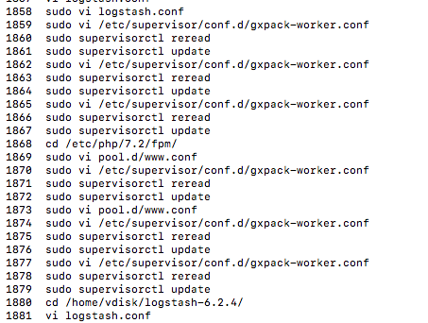

ps -ef | grep php-fpm | awk '{ print $2 }' | sudo xargs kill -9

nginx -t

1706 sudo vi /etc/nginx/sites-available/default

1707 sudo php-fpm restart

1708 service php-fpm

1709 sudo service php-fpm

1710 sudo systemctl status php-fpm

1711 sudo systemctl status php72-fpm

1712 lsof -i:9000

1713 sudo vi /etc/nginx/sites-available/default

1714 sudo systemctl status php7.2-fpm

1715 systemctl restart php7.2-fpm

1716 php7.2-fpm restart

1717 which php7.2-fpm

1718 cat /lib/systemd/system/php7.2-fpm.service

1719 sudo systemctl stop php7.2-fpm

1720 cd /etc/supervisor/conf.d/

1721 sudo vi php72-fpm.conf

1722 sudo supervisor reread

1723 sudo supervisorctl reread

1724 sudo supervisorctl update\

1725 sudo supervisorctl update

sudo supervisorctl restart php72-fpm

cat /etc/supervisor/supervisord.conf

sudo php7.2-fpm

sudo php-fpm7.2 --nodaemonize --fpm-config /etc/php/7.2/fpm/php-fpm.conf

which php-fpm7.2

php-fpm7.2 –t

php-fpm7.2 -i | grep conf

cd /etc/php/7.2/fpm/

sudo vi php-fpm.conf

## 安装Network包依赖包没完全下载

总结：

* 模块更新及自动升级设置导致了没√自动更新依赖包现在不完全
* 流量优化导致√了自动更新依赖包也下载不完全

上面还不是根本原因，最根本的原因在这里:

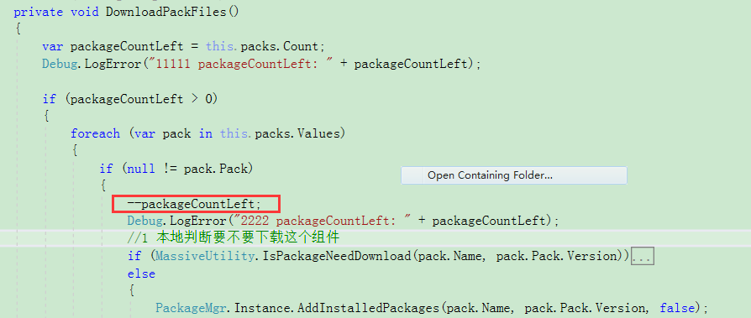

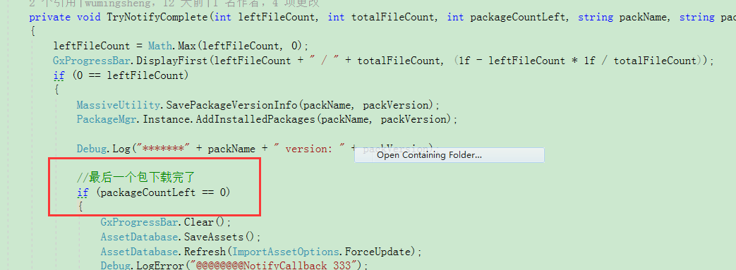

packageCountLeft很快就被减完了，，很多组件包还没下载完

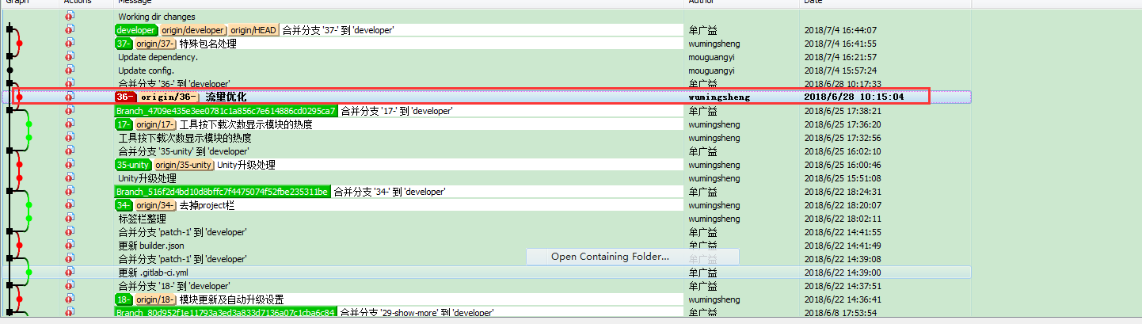

**XXX (这里√没√自动更新都有问题)**

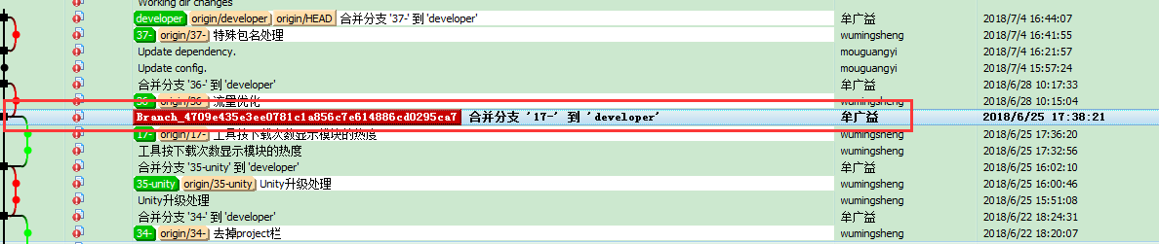XXX (这里√了自动更新是OK，没√才有问题)

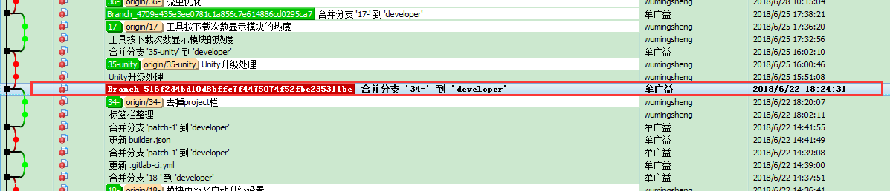

XXX (这里√了自动更新是OK，没√才有问题)

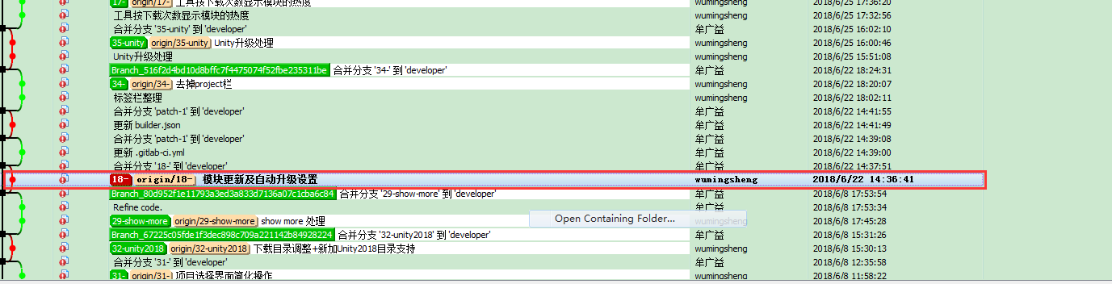

XXX (这里√了自动更新是OK，没√才有问题)

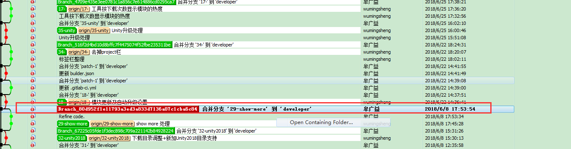

YYY

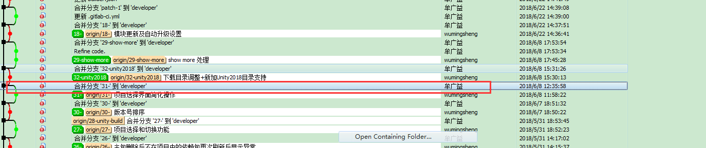 YYY

## 头像引起创建项目宕机

<li><a href="#todo"><img src="/imgs/face.png"/><span>{{ $member['user']['username'] }}</span></a></li>

## Resharper破解

<https://masuit.com/20>

<https://masuit.com/1191>

https://www.cnblogs.com/ahdung/p/9081603.html

LicenseServer不能用本机，端口是1337

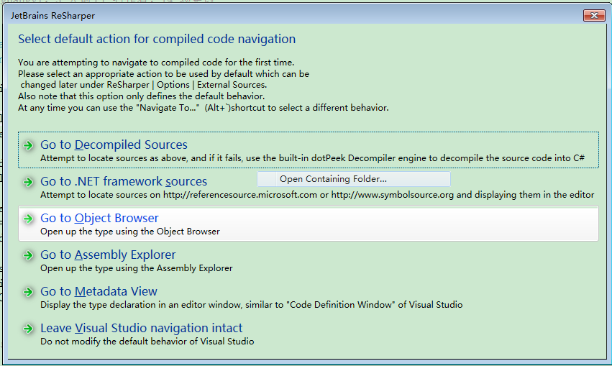

## IE和360登不了

npm install promise-polyfill --save

## 发送邮件报错

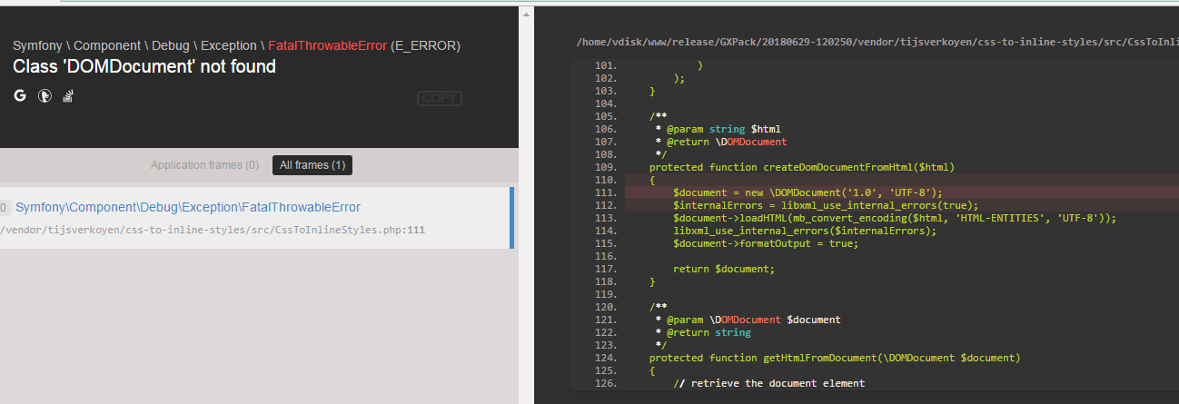

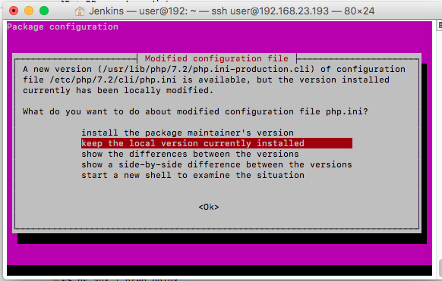

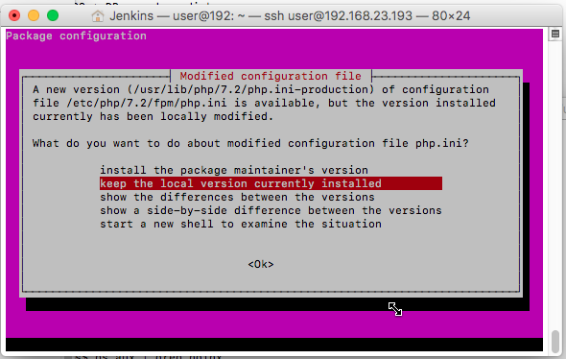

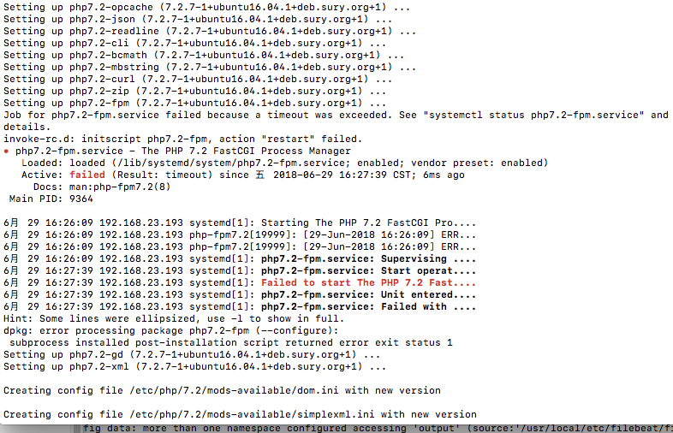

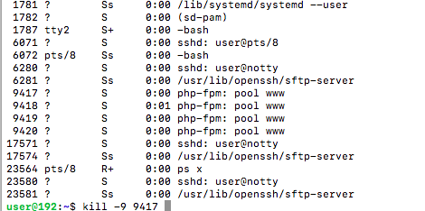

安装好php-xmlOK

## 什么时候该执行npm run dev

## [laravel Expected response code 250 but got code “530”](https://stackoverflow.com/questions/42574375/laravel-expected-response-code-250-but-got-code-530)

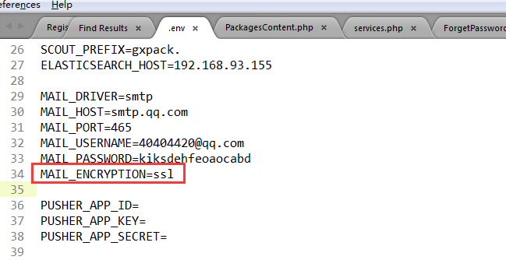

 replace your MAIL\_ENCRYPTION = null to MAIL\_ENCRYPTION = ssl

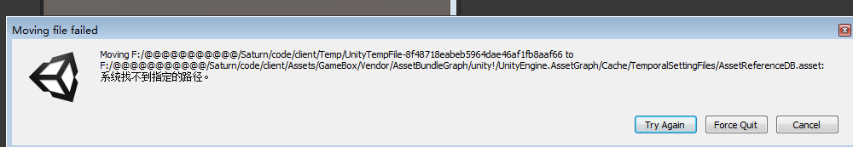

删除

Softdelete

## Cache:tags

public static function getPackageContent($packageId, $version = null)

return Cache::tags(['package\_content'])->remember("content:$packageId:".(is\_null($version) ? 'last' : $version), $expiresAt



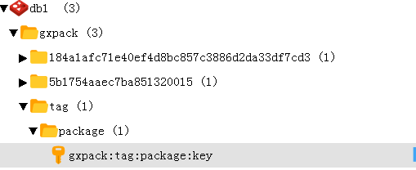



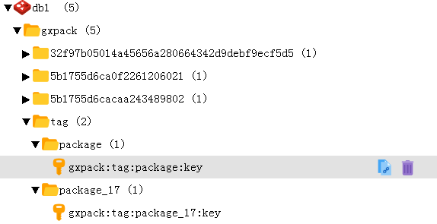

[a,b] a b是并列关系，就是把一个组同时打上a标签和b标签

Cache::tags(['package', 'package\_17'])->put('id:17', 'haha', $expiresAt);

Cache::tags(['package', 'package\_18'])->put('id:18', 'haha', $expiresAt);

flush()可以只带一个标签

Cache::tags('package\_18')->flush();

Has或者其它操作必须带全部标签：Cache::tags(['package', 'package\_18'])

(a,b,c)

Cache::tags('package', 'package\_17')->put('id:17', 'haha', $expiresAt);

Cache::tags('package', 'package\_18')->put('id:18', 'haha', $expiresAt);

用()而不是[]flush操作很诡异，比如Cache::tags('package', 'package\_17')->flush

会把Cache::tags('package', 'package\_18')也删了， 就是flush必须带根删除，也就是全部删除，不像[]那样可以部分删除，判断操作比如has也只判断第一个参数package,后面加多少参数都不影响判断。。。, \*\*\*\*\*最终发现，只有第一个参数’package’有意义，所以这种方式没用应用的必要\*\*\*\*\* 压根就是错误的写法

测试代码：

$expiresAt = Carbon::now()->addMinutes(60 \* 24 \* 7);

Cache::tags('package', 'package\_17')->put('id:17', 'haha', $expiresAt);

Cache::tags('package', 'package\_18')->put('id:18', 'haha', $expiresAt);

Cache::tags('package', 'package\_17')->forget('id:17');

if (Cache::tags('package', 'package\_18')->has('id:18'))

{

echo "has key has key has key111\n";

}else

{

echo "no key no key no key111\n";

}

if (Cache::tags('package', 'package\_17')->has('id:17'))

{

echo "has key has key has key222\n";

}else

{

echo "no key no key no key222\n";

}

// Cache::tags(['package', 'package\_17'])->put('id:17', 'haha', $expiresAt);

// Cache::tags(['package', 'package\_18'])->put('id:18', 'haha', $expiresAt);

// //Cache::tags(['package', 'package\_17'])->flush();

// if (Cache::tags(['package', 'package\_18'])->has('id:18'))

// {

// echo "has key has key has key111\n";

// }else

// {

// echo "no key no key no key111\n";

// }

// if (Cache::tags(['package', 'package\_17'])->has('id:17'))

// {

// echo "has key has key has key222\n";

// }else

// {

// echo "no key no key no key222\n";

// }

## 注释掉代码，执行删除tag的操作，等恢复代码后这个操作竟然自动执行了



所以webhook要用post测试，操作要快，恢复日志代码立刻postman操作, 完了会被队列；里的命令执行操作？？。。。

* 添加删除这里都有问题：



* 删除这里有问题：

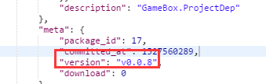

上面两个都是缓存同步的问题，数据库已经没有问题

## 无法加入项目组

ProjectsController.php.

ProjectTrait.php. joinInProjectWithInviteToken

## 发布新标签webhook不起作用

原因是Gitlab访问不了域名， 解决方案是webhook地址填ip,

然后在nginx配置里 配置代理proxy\_pass 又跳转成域名访问，（之前项目就是设置成只有指定域名才能访问）

## 数据库删除组件没效果

清理redis缓存

redis-cli

auth ztgame@123

flushall

## 访问phpmyadmin老是弹警告界面

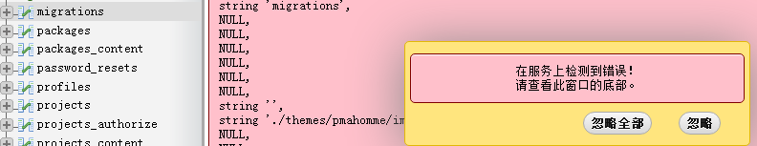

把php从7.2换成7.1就好了

## \*\*\*\*\*添加包出错\*\*\*\*\*

\*\*\*\*\*最终的问题竟然出在这里：

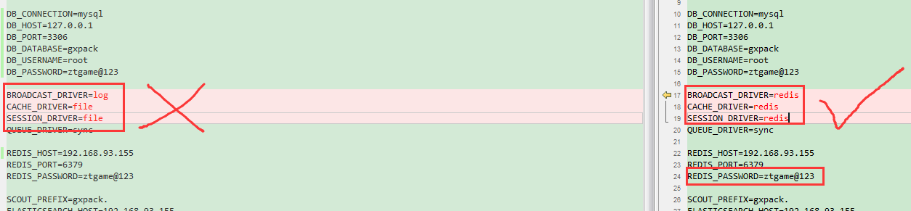

\*\*\*\*\*最终的问题出在.env的redis配置上

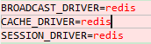

\*\*\*\*\*最终的问题出在.env的redis配置上



\*\*\*\*\*最终的问题出在.env的redis配置上



Gxpack目录

npm install

compose install

cd /d e:

elasticsearch 还没加

之前存在的问题：

### redis

用brew 起的redis有问题，杀掉后用sudo redis-server /etc/redis.conf直接启

配置修改：(/etc/redis.conf)

密码：



运行非本机访问：

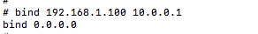

### rabbitmq

d:\Program Files\RabbitMQ Server\rabbitmq\_server-3.7.5\sbin>rabbitmq-plugins ena

ble rabbitmq\_management

<http://127.0.0.1:15672/#/users>

gxpack:gxpack

### phpmyadmin

<http://127.0.0.1:81/index.php>?

### .env

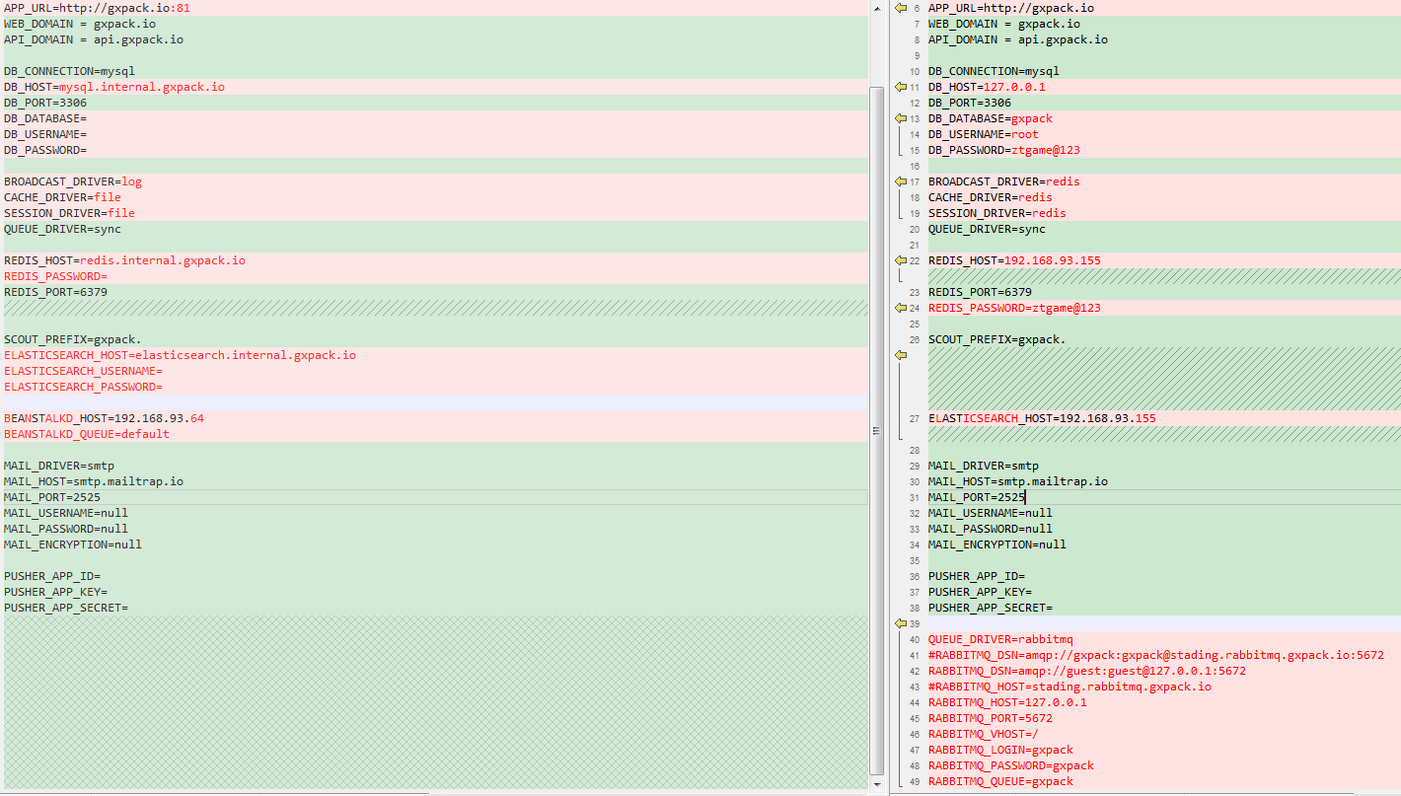

### nginx.conf

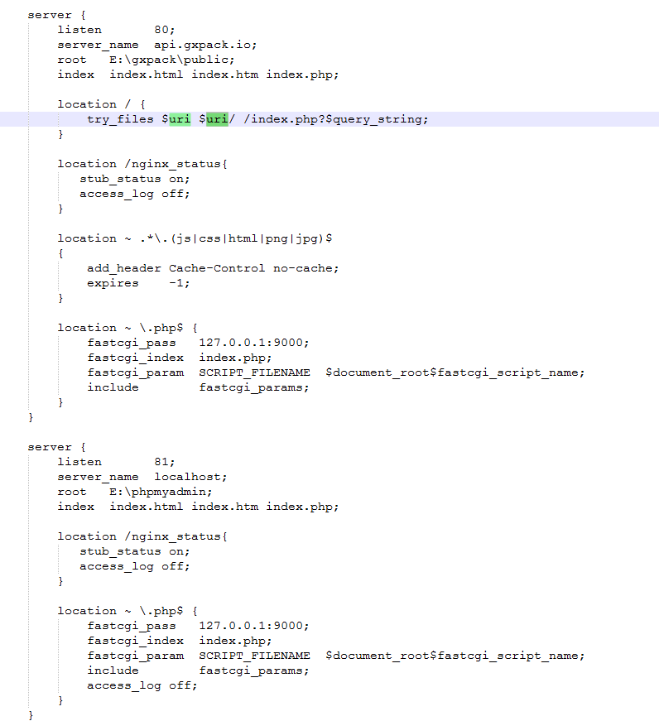

## 发布包出错

php artisan queue:listen

## 通过82端口访问phpmyadmin会造成ningx挂掉？

通过127.0.0.1:82可以正常访问

Nginx配置：

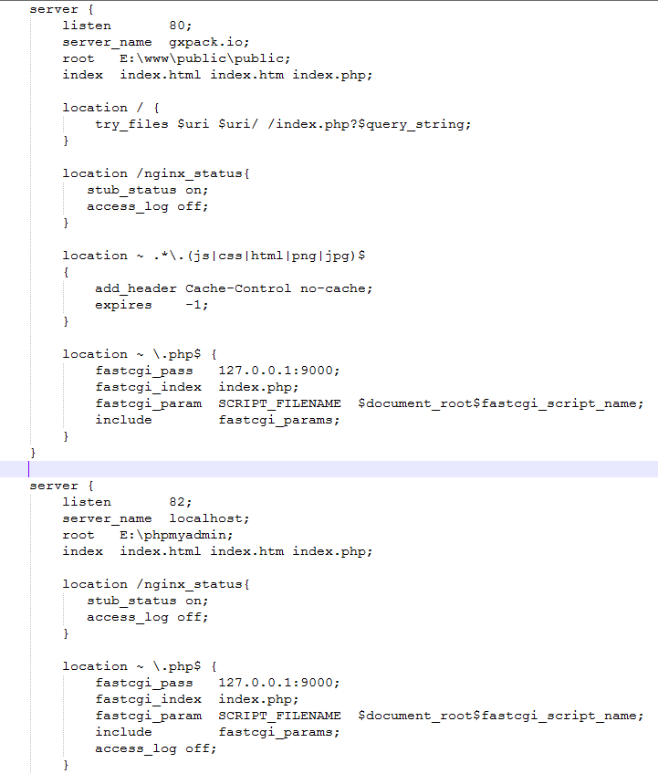

## Tommorow

http://gitlab.ztgame.com/api/v4/projects/tech%2FClient%2FGameBox.ThirdLib%2FReleases%2FAssetBundleGraph/repository/tree?&ref=v1.4.1&path=unity!/UnityEngine.AssetGraph/Editor/GUI/GraphicResources

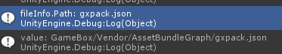

## Gitlab包空文件无限请求

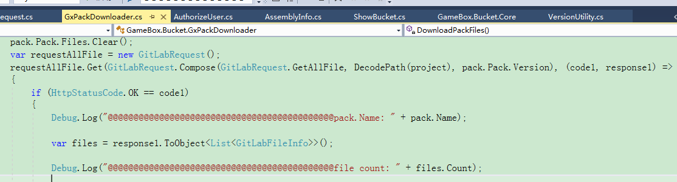

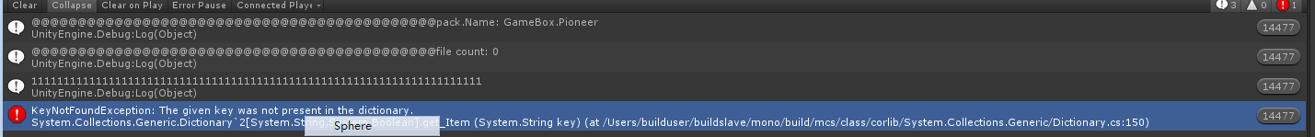

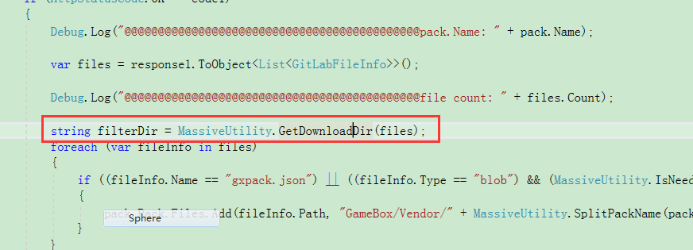

**上面函数里面报错竟然导致 整个代码段无限执行。。。**

**原因是出错的时候没调用：**

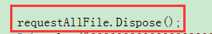

## Gitlab文件显示不全

<http://gitlab.ztgame.com/api/v4/projects/tech%2FClient%2FGameBox.ThirdLib%2FReleases%2FAssetBundleGraph/repository/tree?&ref=v1.4.1&recursive=true&per_page=1000000>

<https://docs.gitlab.com/ce/api/#pagination>

参数：

per\_page

page

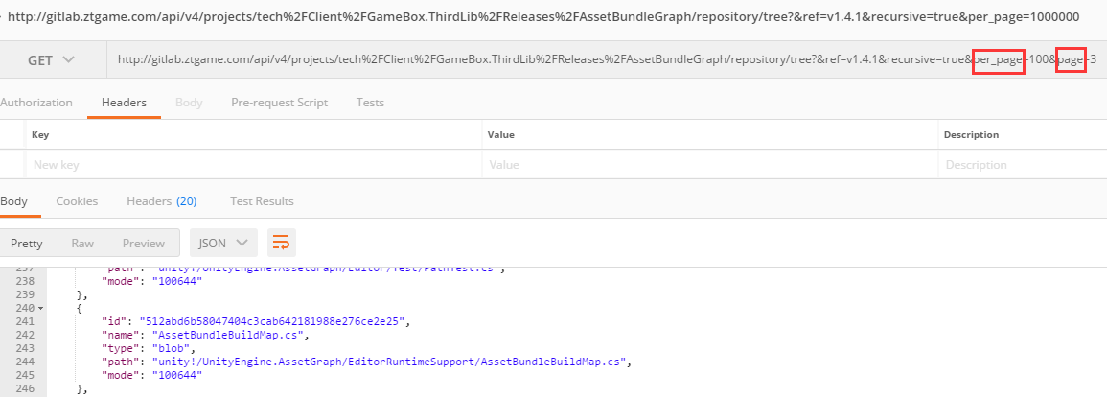

记录信息：

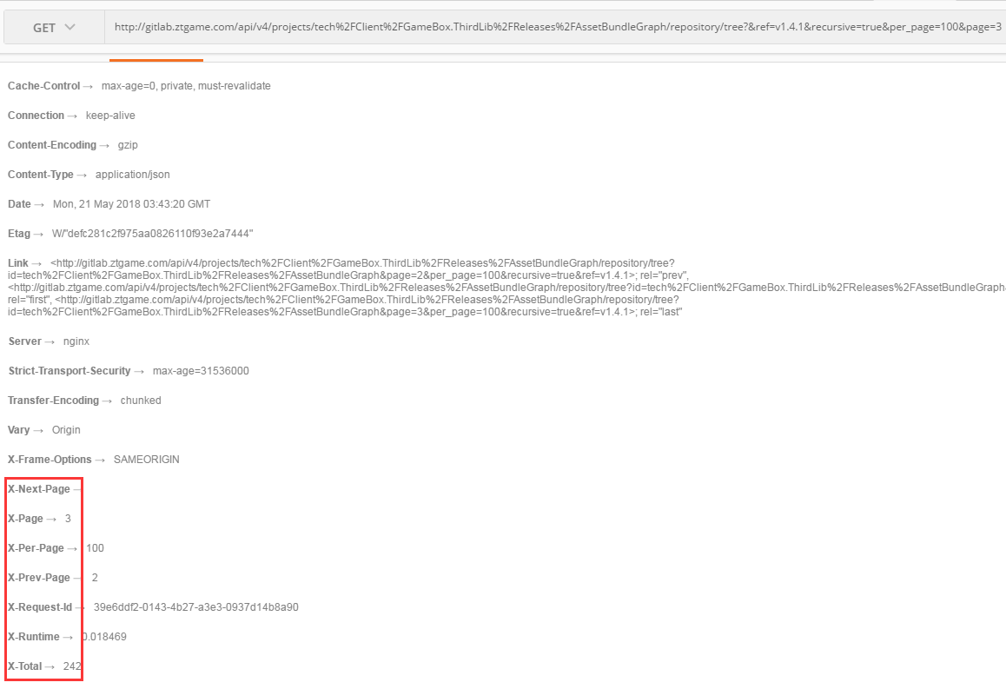

## 发布用的git仓库必须是public (不能private…)

## 一个客户端请求组件没返回。。。

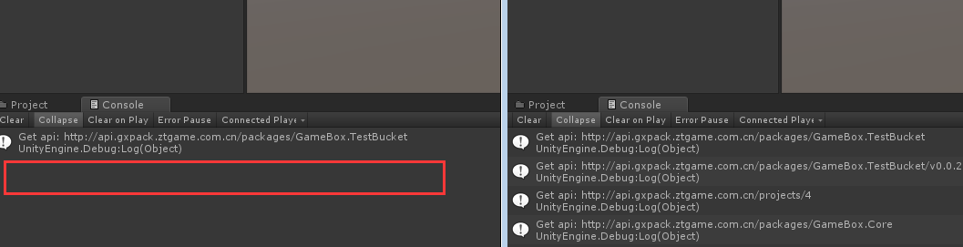

NewtonJson库必须放在同一个目录。。。。晕

## Mac下elasticsearch.yml配置文件在哪

brew info elasticsearch:

Data: /usr/local/var/lib/elasticsearch/elasticsearch\_jenkins/

Logs: /usr/local/var/log/elasticsearch/elasticsearch\_jenkins.log

Plugins: /usr/local/var/elasticsearch/plugins/

Config: /usr/local/etc/elasticsearch/

To have launchd start elasticsearch now and restart at login:

brew services start elasticsearch

Or, if you don't want/need a background service you can just run:

elasticsearch

## Mac下运行phpmyadmin（nginx）登录失败

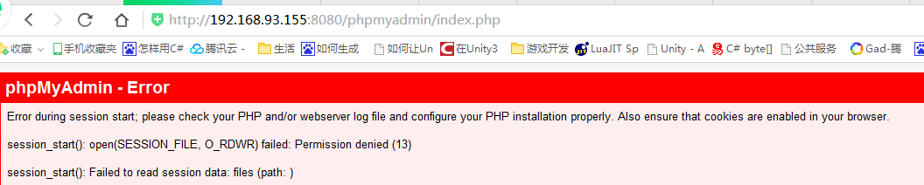

改了phpmyadmin的权限

还有改了nginx端口以及root路径就可以了

（后来又把nginx端口以及root改回之前有问题的时候，竟然还是正常访问了，真神奇…）

## Mac下运行phpmyadmin（apache）登录失败

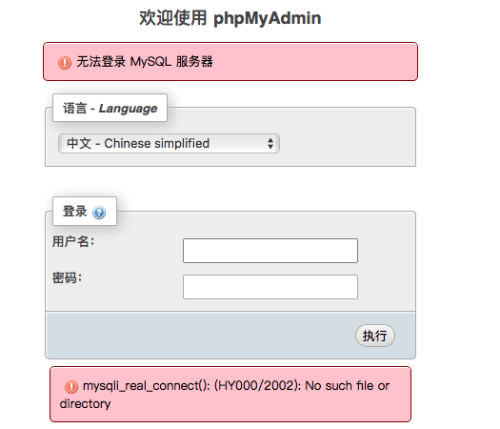

原本是起的php-fpm版本过低 (或者压根没启用)

解决：

新版php-fpm路径在这[/usr/local/opt/php@7.2/sbin/**php-fpm**](mailto:/usr/local/opt/php@7.2/sbin/php-fpm)

把这路径加入环境变量：

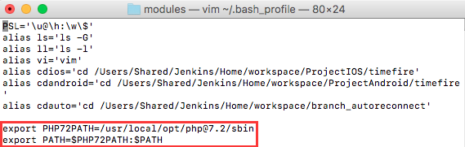

后启动php-fpm

php-fpm 或者

brew services start php

## Windows php运行

E:\downoad\gameboxrelated\php-7.2.4-Win32-VC15-x64>xxfpm "php-cgi.exe -c E:/downoad/gameboxrelated/php-7.2.4-Win32-VC15-

x64/php.ini" -n 2 -i 127.0.0.1 -p 9000



## Windows下访问phpmyadmin 提示缺少mysqli如下图：

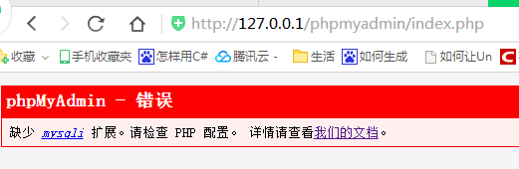

按如下改配置OK：

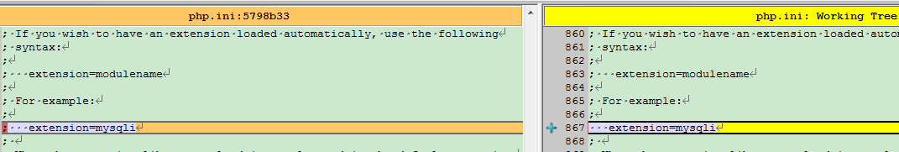

## Mac下只能通过127.0.0.1访问mysql



Bind-address改成0.0.0.0 OK

 show variables like '%data%'

## Gitlab返回的版本号排序有问题

比如 1.2.2会排在1.12.2的前面

## 不同平台不同版本的依赖包处理

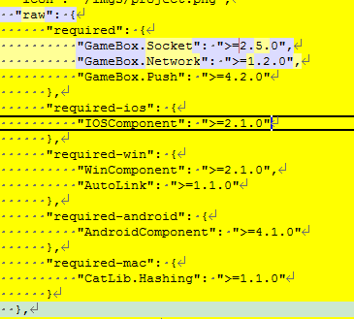

## Mac下mysql不能ip访问，只能通过localhost访问

## Phpmyadmin运行提示mysql报错

## 下载报错如下图：

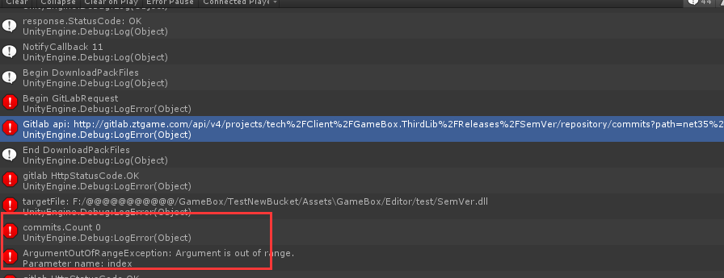

原因是依赖的GameBox.Bucket：需要v1.0.2, 但组件包本身的文件只有v1.0.0的 （没有v1.0.2这个tag）

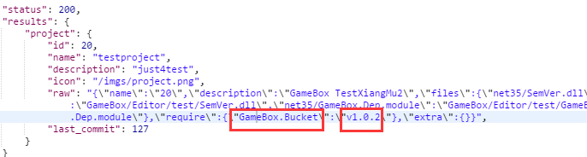

copy /Y "$(TargetPath)" "$(TargetDir)$(TargetName).dll"

copy /Y "$(TargetDir)$(TargetName).dll" F:\@@@@@@@@@@@\GameBox\TestNewBucket\Assets\Editor

copy /Y "$(TargetDir)$(TargetName).dll" F:\@@@@@@@@@@@\GameBox\TestNewBucket\Assets\GameBox\Editor\GameBox.Bucket

## 安装卸载信息更新不及时

两个工程合成一个就可以了

## 没下载完

## 界面不显示了

OnUpdate 执行到中途

OnGUI 压根不执行了

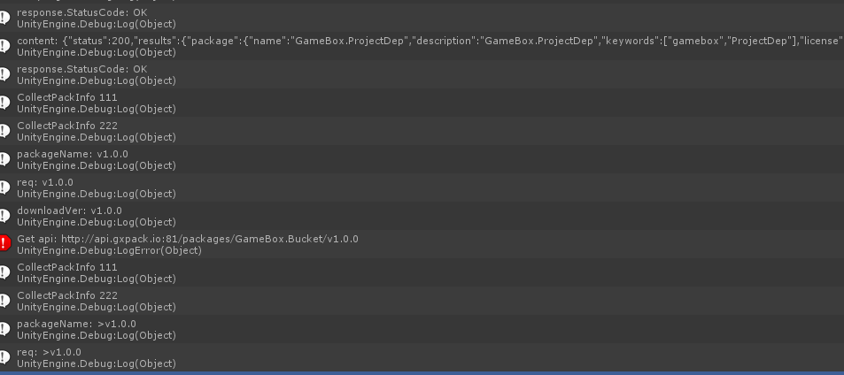

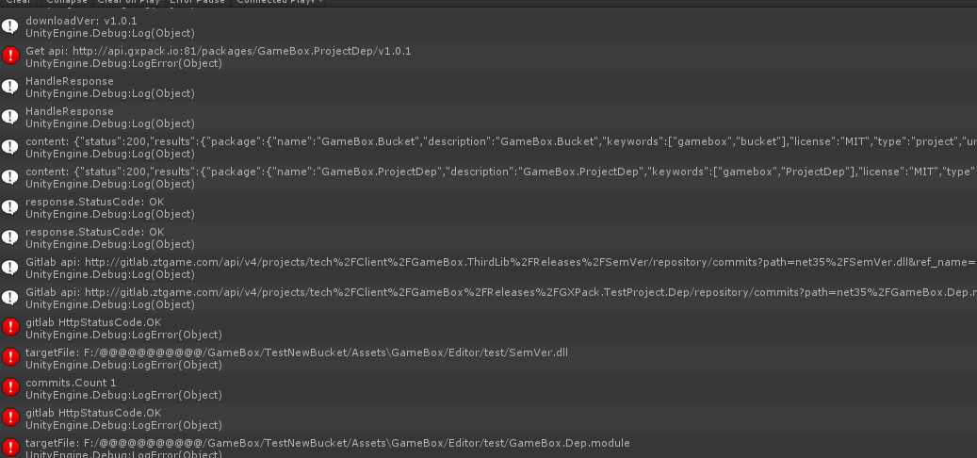

## 真正下载文件可能进行到一半卡主？

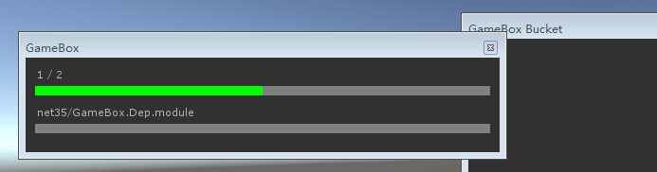

## TryUpdateMetaFile(commits[0], targetFile + ".json", out metafile 报错

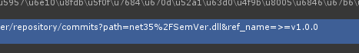

ref\_name有问题

## 字典操作各种报错

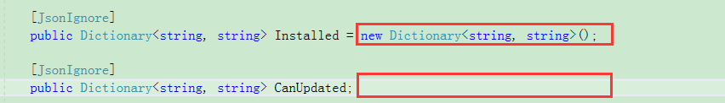

初始化。。。

## Dic traverse

<https://www.cnblogs.com/wangchao928/archive/2012/05/17/2505671.html>

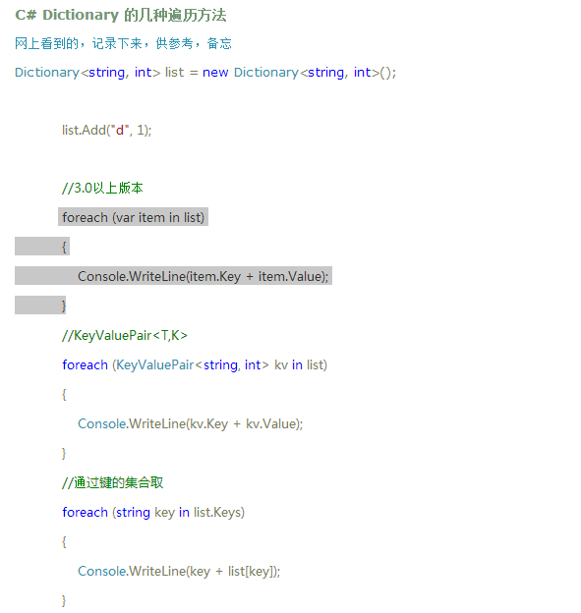

## 实际下载的地址





红框就是tag(版本号)

## 在资源管理器删除下载的DLL，

## 卸载再安装不成功，重新打开安装成龙

安装完直接卸载也不成功

\*\*\*\*\*原因是last\_commit没有更新

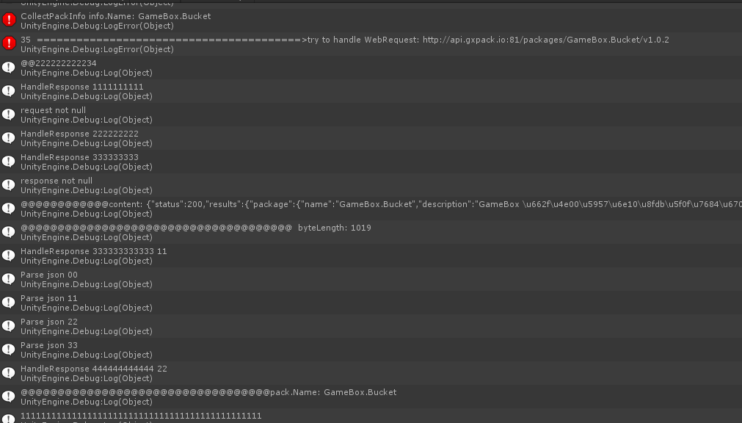

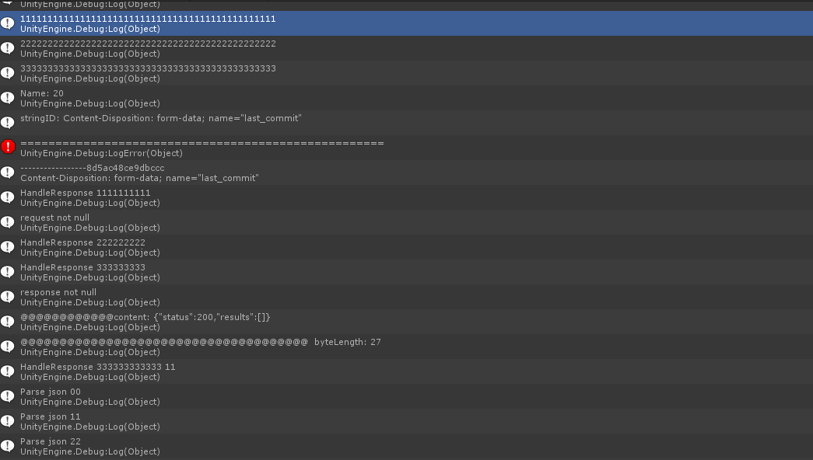

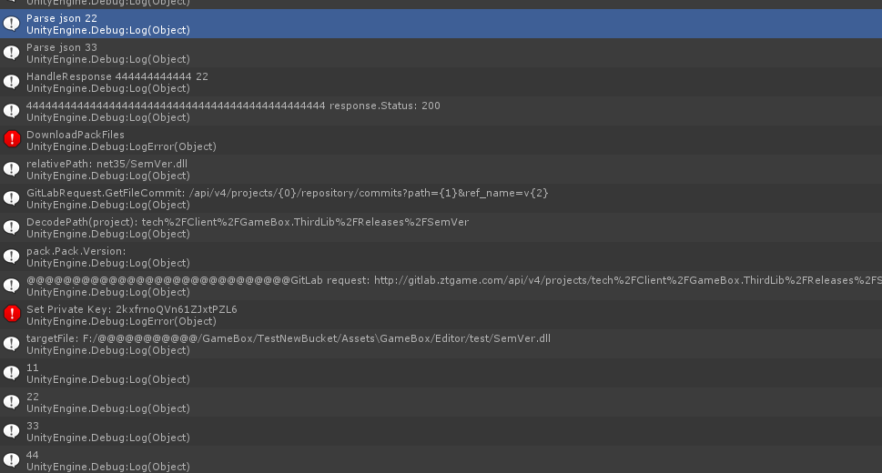

## 正常卸载

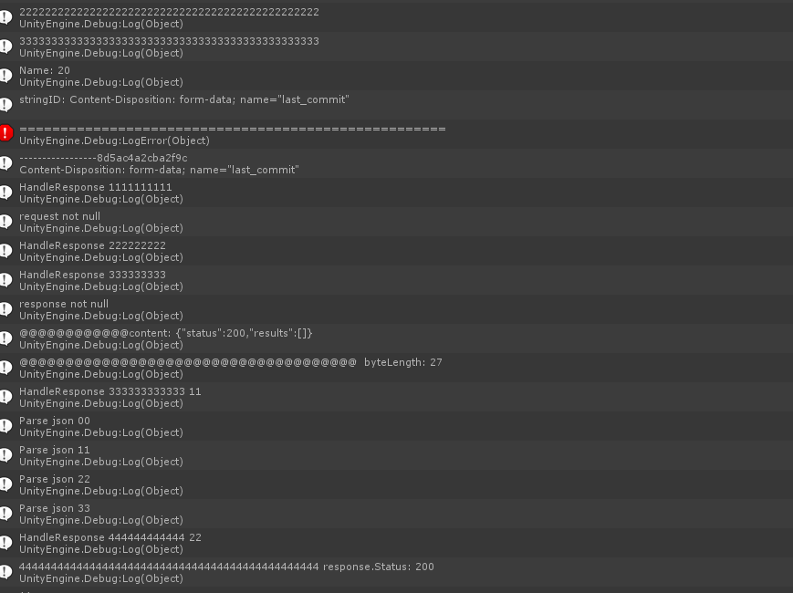

## Install、Uninstall区分

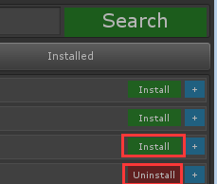



推荐的如果是这个项目需要的则显示 Uninstall ()

不是需要的则显示 Install

1什么时候安装呢？

2点Install Uninstall又做如何处理

## Projects只能用ID来访问吗？

## Json读取问题

info.Pack = response.ToObject<GxPackResult>("results").Package **不能用**

**可用：**

var packResult = response.ToObject<GxPackResult>("results");

info.Pack = packResult.Package;

## Json多重嵌套如何读取

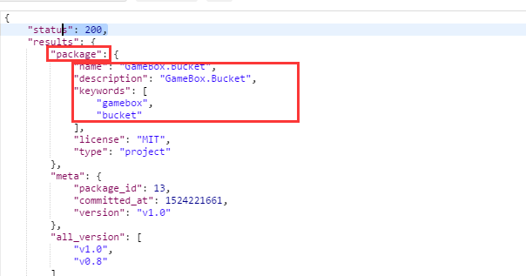

子字段加类：

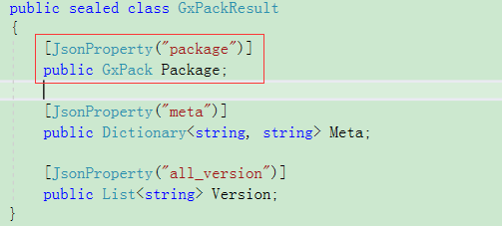

## 用正式的GXPack出错

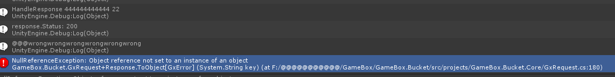

原因是配置文件用的status:200 按出错来处理:

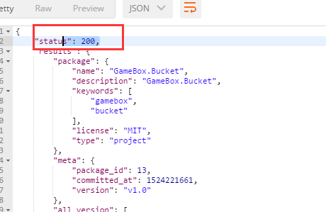

## Httpwebrequest访问返回没有数据流

实际上有流，只是Stream.length不能用

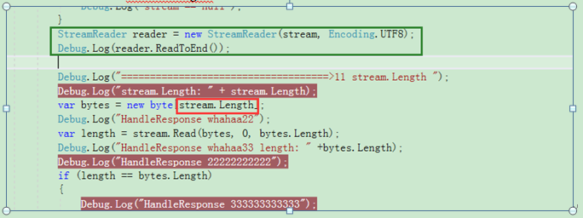

## 下载gitlab上的文件总是返回首页的html页

GitLabRequest 有个设置PrivateKey

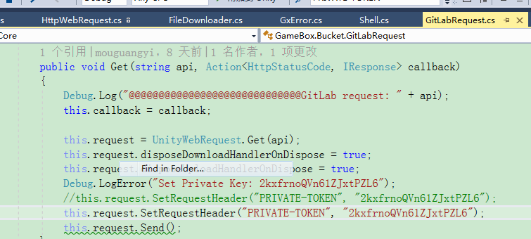

在下载类里也要加访问token:

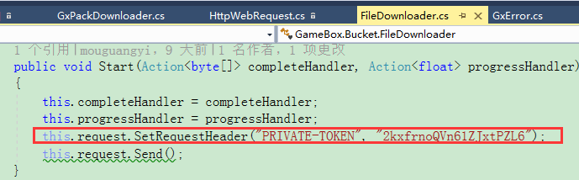

## mock环境不能正常弹出界面

下载的json解析出错了

# 俞斌

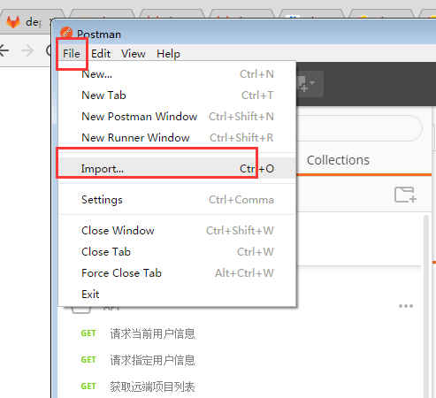

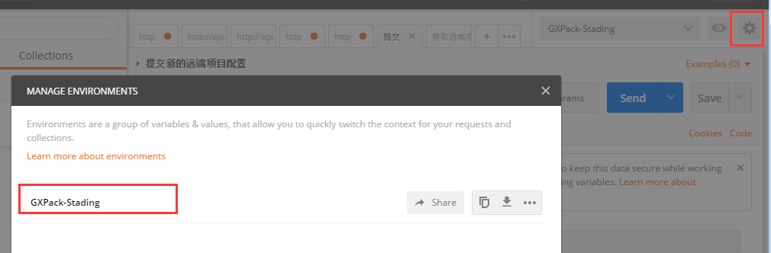

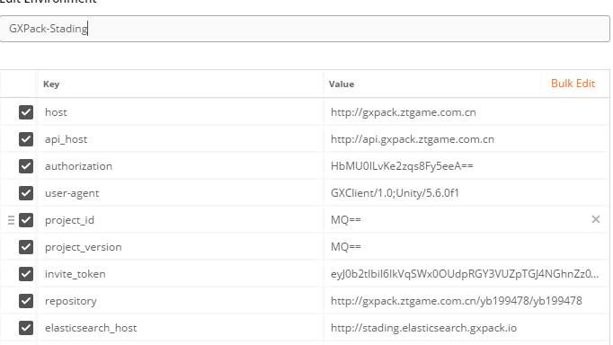

**确保对外暴露没有泛型**

## 走前交接

1 192上的Rabbitmq是没有守护进程的，必须手动重启

2 必须启动192 193上的supervisor (sudo supervisor start), supervisor会自动启动其它服务

3 192.168.23.193（弱鸡） 192.168.23.192 用户名 user 密码ztgame@123

4 macmini(现在ip 192.168.93.64, 如ip有变需要在自己host上做更改)上有三种服务断电后要启动(nginx(手动) php-fpm(手动) walle(不用管))

5 192 193所有服务都安装在/home/vdisk上面

**要关注的指标**：

1 \*\*\*\*\*\* failedjob < 1 (异常会打埋点，1分钟没掉下去会堆mysql)

2 Exception 不能有^

3 Response Code不能有502 (502指ftp不够了)

4 QPM < 1万

**代码：**

Mode目录下的代码基本上都有缓存(具体要看代码) ,要针对具体问题清理缓存(redis),（全部清理有可能击穿数据库）,一般缓存7天才失效

\*\*\*\*\*

同步模式测完要异步模式测试，请求访问者的信息这些信息在异步都是没有的

.env

QUEUE\_DRIVER=sync 🡺

QUEUE\_DRIVER=redis 或者rabbitmq

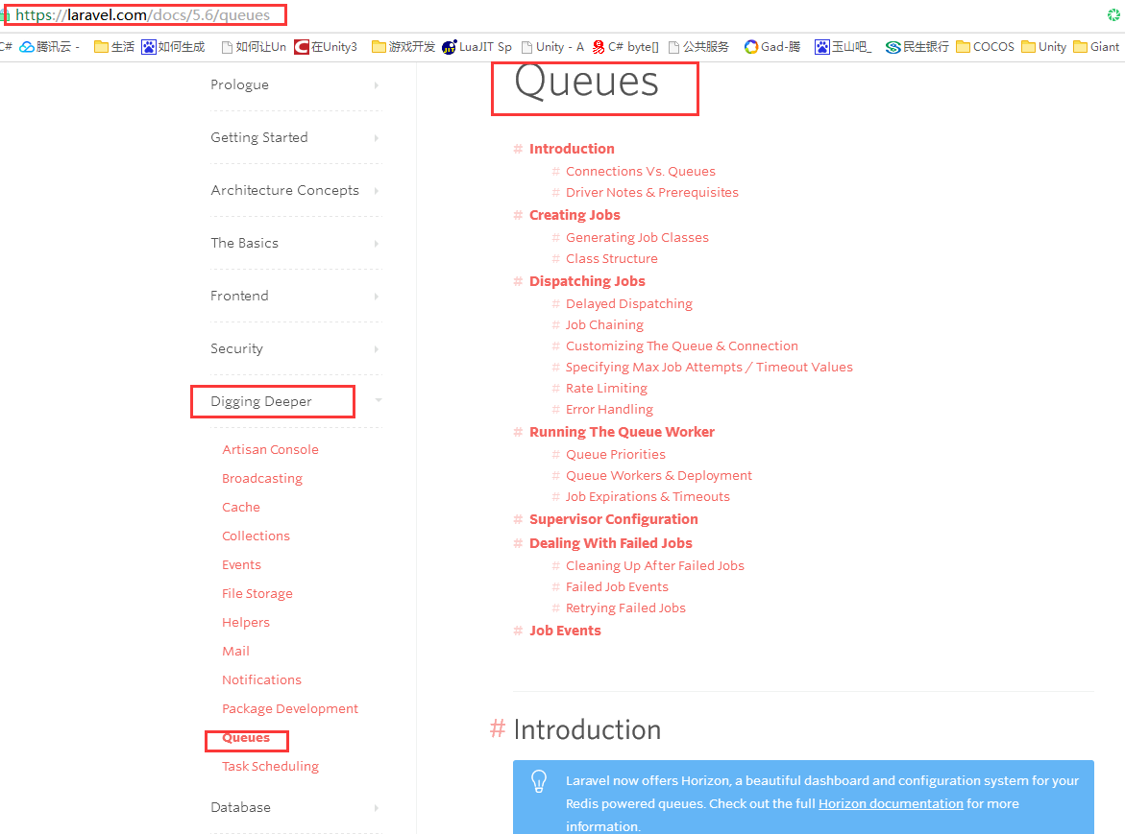

queue启动：

php artisan queue:listen --queue=gxpack-import,gxpack-download,gxpack-logs-exception,gxpack-logs-access,gxpack-buried,gxpack

开启上面的指令才会消费队列

6月中旬以后可以提问

## 剩下的问题

192.168.93.64 walle.gxpack.io

1无法加入项目

2 其它用户登录图片资源不显示

## json编码解析

http://www.bejson.com/

## Apache ab压力测试

**YiBKOjpDMISIWWf2TG7ylA==**

**YiBKOjpDMISIWWf2TG7ylA==**

## 资源修复？

## 下载的带点号的包名不能按其名字建一个文件，必须按点号隔开建立多个文件夹

比如包名gamebox.bucket 建立gamebox/bucket的层级

## gitlab版本号排的有问题

1.2.2 会排在1.12.3前面, 要注意这个坑

## download rule gitlab文件夹下载规则

net35 net46 (FrameWork层) netstandard20 unity53 unity56 unity2017.2 （应用层）

应用层优先、选取最接近自己的版本（选取的版本不能跨大版本）,如何没有合适的版本就从net35 net46里选

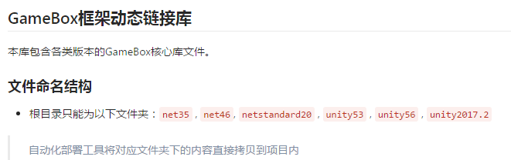

## 包依赖包的位置

Package :

{

Required:{}

}

## 下载输出规则

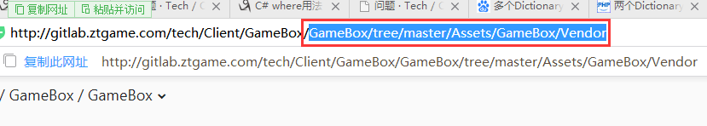

## 请求日志

## Phpcomposer

http://docs.phpcomposer.com/01-basic-usage.html#Package-Versions

## symfony

## phpMyAdmin

## Grafana

## kibana

Kibina garabana grabana grafana

## form-data

## WebHook接口调试

用Postman+ 三个参数 （其中一个是[hook\_token] => OW2C6uTx4KpfEMjSguw==

）

## Status Http状态码

## Postman

## 设置token webhook

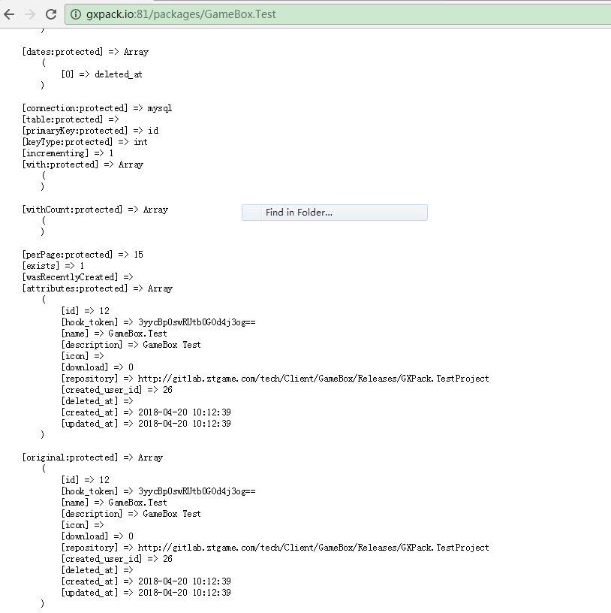

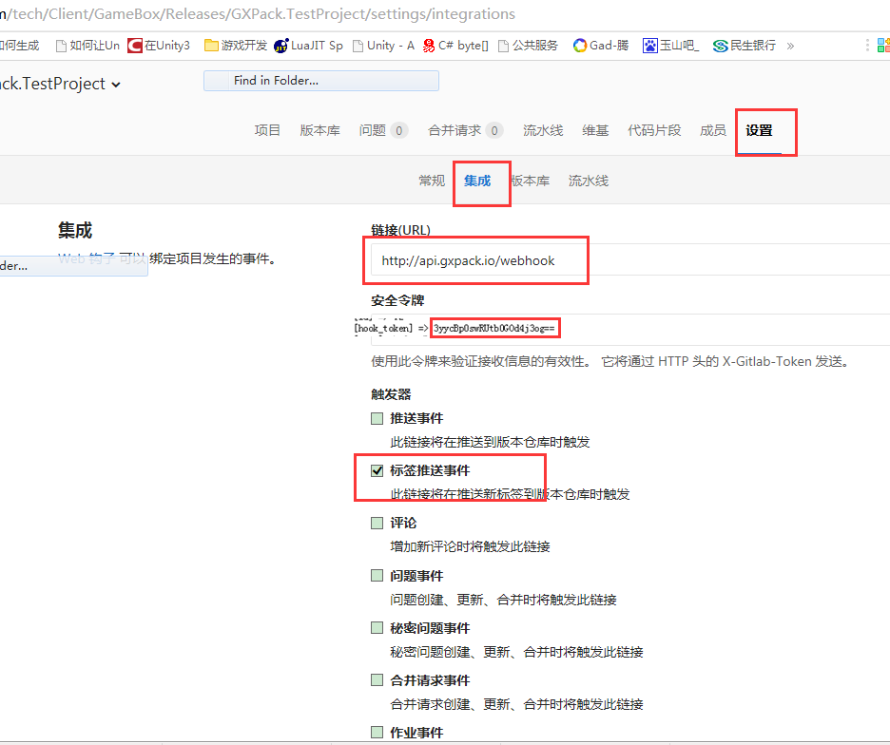

## 测试

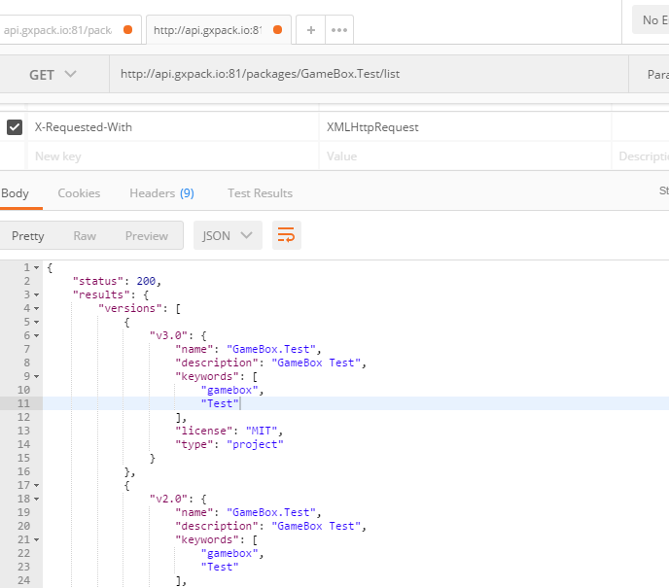

内容相似度

# 王辉

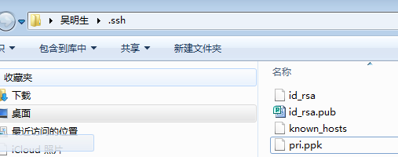

# 技术部

fairygui